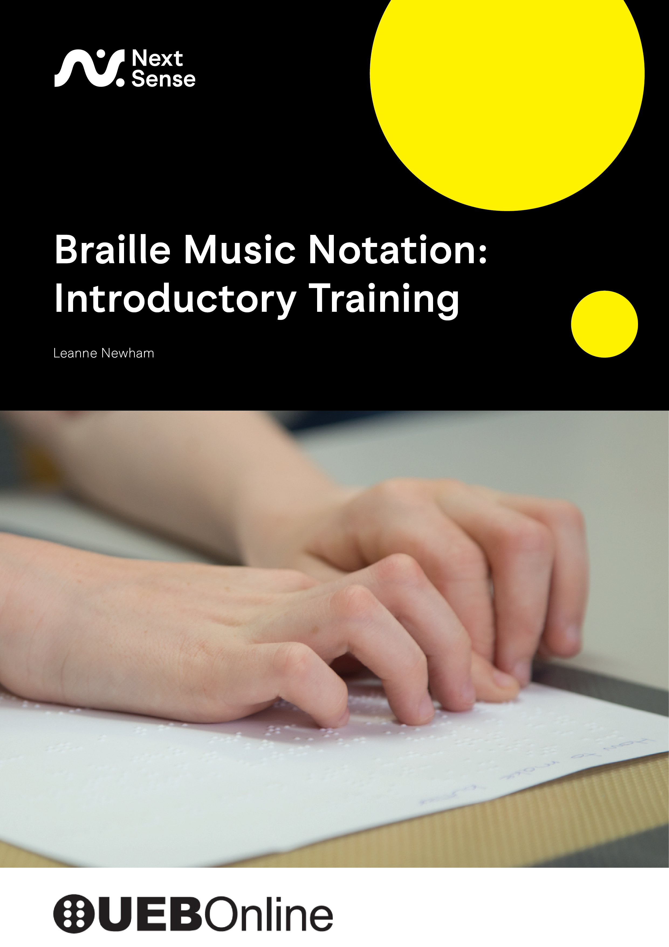
© North Rocks Press, 2026
Published by North Rocks Press, NextSense, 2 Gymnasium Road, Macquarie University,
Macquarie Park, NSW, 2113 Australia
https://www.nextsense.org.au/
Newham, L.
Braille Music Notation Introductory Training Program
Revision 2
ISBN – 978-0-949050-33-5
CC BY-NC
This work is licensed under the Creative Commons Attribution-Non-Commercial 4.0 International Licence. CC BY-NC includes the following elements:
- Attribution — You must give appropriate credit , provide a link to the license, and indicate if changes were made . You may do so in any reasonable manner, but not in any way that suggests the licensor endorses you or your use.

- NonCommercial — You may not use the material for commercial purposes .

To view a copy of this licence, visit https://creativecommons.org/licenses/by-nc/4.0/ or write to Creative Commons, 171 Second Street, Suite 300, San Francisco, California 94105 USA


NextSense Institute is Australia’s leading centre for research and professional studies in the field of education for children with sensory disabilities, offering webinars, short courses, and degree programs for parents, carers, educators, and health professionals. NextSense Institute is committed to providing high-quality teaching and learning opportunities. Our programs are conducted by national and international experts for education and health professionals who support people who are deaf, hard of hearing, blind, or have low vision.

Contents
Foreword 6
Introduction 8
Contributors 9
Lesson 1 Pitch 10
Exercise 1.1 11
Lesson 2 Duration 12
Note Values and Dual Meanings 12
Barlines (Measures) 12
Rests 13
Dotted Notes 14
Exercise 2.1 14
Exercise 2.2 15
Exercise 2.3 15
Exercise 2.4 16
Exercise 2.5 17
Exercise 2.6 17
Exercise 2.7 18
Exercise 2.8 19
Lesson 3 Octave Signs 21
Interval Practice 22
Octave Signs 23
The Rules for using Octave Signs 23
Exercise 3.1 26
Exercise 3.2 26
Exercise 3.3 27
Lesson 4 Time and Key Signatures and Grouping Notes 29
Time Signatures 29
Key Signatures/Accidentals 29
Changes of Time and Key Signatures 31
Grouping of Notes 33
Exercise 4.1 36
Exercise 4.2 36
Exercise 4.3 37
Exercise 4.4 38
Exercise 4.5 38
Lesson 5 Bar Numbering and Ties and Slurs 40
Bar Numbering 40
Ties 40
The Slur 42
Exercise 5.1 46
Exercise 5.2 47
Exercise 5.3 48
Lesson 6 Dynamics and Expressive Markings 50
Exercise 6.1 56
Exercise 6.2 57
Exercise 6.3 59
Lesson 7 Nuances and Ornaments 60
Nuances 60
Ornaments 63
Appoggiaturas 63
Trills 63
Turns (see table for signs) 64
Mordents (see table for signs) 64
Glissando 64
Exercise 7.1 68
Exercise 7.2 69
Exercise 7.3 70
Exercise 7.4 71
Lesson 8 Irregular Note Groupings 73
Triplets 73
Three or Four-cell sign for Irregular Groupings 75
Exercise 8.1 77
Exercise 8.2 78
Exercise 8.3 78
Lesson 9 Print Repeats 80
Beginning and End Repeats 80
Voltas 83
Exercise 9.1 87
Exercise 9.2 89
Exercise 9.3 90
Lesson 10 Braille Repeats 92
The Braille Repeat Sign 92
Braille Numeral Repeats 95
Backward-Numeral Repeats 95
Bar (Measure)-Number Repeats 98
Exercise 10.1 101
Exercise 10.2 103
Exercise 10.3 104
Exercise 10.4 105
Lesson 11 Tying It All Together 108
Exercise 11.1 109
Exercise 11.2 111
Exercise 11.3 112
Exercise 11.4 115
Exercise 11.5 118
Appendices 120
Appendix 1 121
Summary of Signs 121
Notes and Note Names 121
Octave Signs 122
Key and Time Signatures 123
Accidentals 123
Time Signatures 124
Barlines 124
Ties and Slurs 125
Dynamics and Expressive Markings 125
Irregular Note Groupings 125
Nuances that Precede the Note 126
Nuances that Follow the Note 127
Breath or Break Marks 128
Ornaments 128
Print Repeats 131
Braille Repeats 131

Foreword
When considering how to learn braille music, it can perhaps be daunting when confronted by the number of textbooks or manuals that teach the code. The New International Manual of Braille Music by Bettye Krolick (1996), the Introduction to Music Transcription by Mary Turner de Garmo (2005) or the BANA Music Braille Manual (2015) just to name the popular three. Which one is the definitive resource? A transcriber may feel in a vacuum while learning braille music in isolation from a manual when there isn’t access to a proficient braille music user readily available to proofread their practice exercises.
For several years, the idea of an online braille music course has been discussed by braille music specialists internationally. Discussions have presented Challenges such as deciding which methodology to use that will suit the majority of learners in as many countries as possible: should an existing method book be the basis of the course, or a new series of lessons be created? Also, the choice of platform to support course content. Then, in 2024, NextSense in New South Wales, Australia, put together a team of braille music specialists from around Australia and New Zealand to work on the project and thus, the online braille music course was born.
This training manual introduces a course that teaches braille music to a music teacher or braille transcriber who may not have a background in music. The course focuses solely on the braille music code, rather than teaching music concepts as would be taught when learning an instrument.
The braille music code is recognised internationally. While at the National Institute for Blind Youth in Paris in the early 1800s, Louis Braille invented literary braille. He also created the braille music code at the age of 19. He was a proficient organist and cellist and, with this considerable music knowledge, was able to test his new braille music system with his friends. Remarkably, this code is still in use today throughout the world. The signs for Quavers and crotchets in Australia are the same signs used in the UK, America and Europe. The formatting of braille music is not covered in this course because unlike the note values, formatting differs between countries. An example of these differences can be noticed in the positioning of bar numbers. In vocal music, Australia places bar numbers above the bar. This is just below the lyric line and above the music line. In the UK, bar numbers are placed within the music line before the bar itself. Excluding formatting eradicates the need to differentiate the course for each country and provides a much more flexible learning experience to a wider variety of learners. Formatting can be studied later by referring to the individual country’s guidelines.
Accessibility has been built into the course from the ground up and testing was conducted by braille music users during its development. Screen reader and braille users can now complete this course with adequate speech and braille feedback. When a braille display is present, the music examples to be brailled will appear correctly in words as well as spoken by the screen reader. The course uses friendly language, so there shouldn’t be too much music jargon for those new to the subject.
By the end of this introductory course, you will be brailling melodies encompassing all note values, and some piano and multipart music too. I invite you to explore braille music in this friendly accessible method and commend NextSense for making this valuable online resource available to learners everywhere. I am personally very excited by the opportunities this course will provide on a global scale.
Jordie Howell
Classical Soprano Music and Technology Teacher; Braille Music Transcriber
Australia

Introduction
The Braille Music Notation Introductory Training Program is designed for sighted and blind educators, music teachers, braille transcribers, parents/caregivers, and anyone wishing to develop foundational knowledge of braille music notation.
The program comprises 11 sequential lessons that introduce the essential concepts of braille music. Each lesson builds on the skills and knowledge of the previous one, culminating in a final lesson that consolidates all concepts learned throughout the program.
This manual presents the lesson content and accompanying exercises in a single, accessible reference document. The program itself is delivered online via the NextSense-operated UEB Online learning platform: https://uebonline.org/.
To complete the exercises, please register for an account at https://uebonline.org/ and enrol in the Braille Music Notation Introductory Training Program. Existing UEB Online users will find the program listed among the available training options.
Further information about navigating the online course, completing the exercises, and accessing additional tutorial resources is available on the UEB Online website.
The NextSense Project Design Team gratefully acknowledges the valuable contributions of the Project Advisory Group, who reviewed and refined each iteration of the training program. Members include Christine Casey, Tristan Clare, Ben Clare, Scott Erikson, Fiona Greenfell, Chantelle Griffiths, Jordie Howell, Vanessa Ransley, Lee Strickland, and Cathy Wiltshire.

Trudy Smith, Frances Gentle, Craig Cashmore and Leanne Newham,
NextSense Project Design Team.

Contributors
Author: Leanne Newham
Leanne Newham has been an educator with the New South Wales Department of Education since 1994. She began her career as a music teacher after earning a Bachelor of Music and Bachelor of Education from the University of New South Wales. In 2010, she completed a Master of Special Education (Sensory Disability – Vision), which led to her role as an Itinerant Support Teacher for Vision (ISTV).
Leanne further specialised in music braille through training at Renwick (now NextSense), and has since provided invaluable support to students, teachers, and fellow ISTVs in this area. Following her retirement from full-time teaching, she continues to contribute her expertise through music braille transcription and proofreading for the Department of Education, as well as transcribing examination papers for the Australian Music Examinations Board.
UEB Online Developer: Craig Cashmore
B. Eng. (Hons) - UTS
Craig holds an Engineering Degree in Telecommunications and has over 30 years’ experience in software development. Craig has held positions in senior software design, software architecture and technical management in companies including Jtec, Ericsson and LongReach Networks.
In 2010 Craig founded PeppaCode, a web and app development business focused on 'out-of-the-ordinary' strategic web and software development for small business, start-ups and educational institutions. Some of Craig's achievements at PeppaCode include the successful launch of UEB Online for NextSense Institute and development of a membership system for SPEVI (South Pacific Educators in Vision Impairment).
Craig continues to work on new and innovative projects using modern web technologies.

Lesson 1 Pitch
The music braille cell is designed to show both the pitch (the note name) and duration (the length of time the note is held). The pitch is indicated by using dots 1, 2, 4 and 5 in various combinations – for example, to represent notes such as C, D, E and so on. The duration of the note is shown by using dots 3 and/or 6 to the pitch sign. We will explore this in more detail in the next lesson. The diagram below provides a visual representation of how the cell is divided to represent pitch and duration.

Note (Pitch)

Rhythm (Duration)

We will begin by learning the seven music note names in braille. These are named after the first seven letters of the alphabet: A through G. Below are notes with their braille equivalent in braille music notation. Please note that braille music uses a different system from literary braille. For example, the braille sign for the music note C is not the same as the braille literary letter C. In music braille, dots 1 and 4 have a completely different meaning. We will learn more about this in a later lesson. The first note is shown is a C, because music octaves start on C not A.

C | d | Dots 1 4 5
D | E | Dots 1 5
E | F | Dots 1 2 4
F | G | Dots 1 2 4 5
G | H | Dots 1 2 5
A | I | Dots 2 4
B | j | Dots 2 4 5

Exercise 1.1
Let’s practise writing these seven notes. Braille each exercise on a new line. Leave a space between each group of four notes. Do not leave a space at the end of the line.
- CCCC DDDD EEEE FFFF
- CCDD EEFF DDCC FFEE
- CDCD EFEF DCDC FEFE
- FCFC DEDE DFDF ECEC
- CDEF FEDC CEFD EFCD
- GGGG AAAA BBBB
- GGAA BBAA GGBB
- BAAA GBBB AGGG
- GBGB AGAG BABA
- GAAB BAGA BGGA

Lesson 2 Duration
Every note in music has a value, also called duration. This means how long a note is held. In braille music, the length of the note is shown by using dots 3 and 6, placed under the pitch symbol in the braille cell (as mentioned in the first lesson). The four main note values we will learn first:
- Quaver ♪ (Eighth note) no dots in positions 3 or 6
- Crotchet q (Quarter note) add dot 6
- Minim h (Half note) add dot 3
- Semibreve w (Whole note) add dots 3 and 6
Examples:
To braille a G crotchet: use dots 1-2-5 for the G and add dot 6 for the crotchet - \
To braille a B minim: use dots 2-4-5 for the B and add dot 3 for the minim - t
To braille a C semibreve: use dots 1 4 5 for the C and add dots 3 6 for the semibreve - Y
All the notes you wrote in Exercise 1.1 were quavers, because no dots were added in positions 3 or 6.

Note Values and Dual Meanings
In braille music, each symbol can sometimes represent a smaller note value. For example: a semibreve (whole note) is also a semiquaver (sixteenth note). A minim may also represent a demisemiquaver (thirty-second note). How do we know which value is correct? It depends on how many beats (counts) are in each bar (measure).
Example:
If a bar has 4 beats, and there is only one note – say dots 1-3-4-5-6 (C semibreve/semiquaver) – it must be a semibreve, because one semibreve equals four beats. It cannot be a semiquaver, because it is only worth ¼ of a beat, and would not fill the bar.

Barlines (Measures)
A bar or measure is a group of beats, shown between vertical lines in print music called barlines. In braille music, we represent a barline by leaving one blank cell between bars.

Rests
Rests represent silences in music. Just like every note has a duration, every note value has a matching rest that shows how long the silence lasts. Below are the four most common rests and their braille music symbols.
Semibreve (whole note)/Semiquaver (16th note) | M | dots 1 3 4
Minim (half note)/32nd note | U | dots 1 3 6
Crotchet (quarter note)/64th note | V | dots 1 2 3 6
Quaver (8th note)/128th note | x | dots 1 3 4 6

The table below is a good reference of the note values and rests to help you complete Exercise 2.1.
Name | Symbol | Rests |  | C | D | E | F | G | A | B
Quaver (8th note) or  Semihemidemisemiquaver (128th note) | e  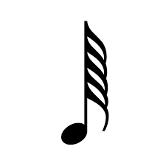 |  | x | D | E | F | G | H | I | j
Crotchet (quaver note) or  Hemidemisemiquaver (64th note) | q  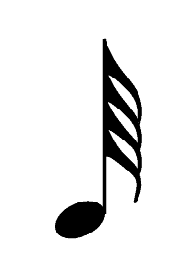 |  | V | ? | : | $ | ] | \ | [ | w
Minim (half note) or  Demisemiquaver (32nd note) | h   |  | U | N | O | P | Q | R | S | t
Semibreve (whole note) or  Semiquaver (16th note) | w  s |  | M | Y | Z | & | = | ( | ! | )

Dotted Notes
To add variety to rhythms, music sometimes uses dotted notes. A dotted note is created by placing a dot after a note, which increases its length. The dot adds half the value of the original note.
For example: a crotchet (quarter note) is worth 1 beat. A dotted crotchet is worth 1 + ½ = 1 ½ beats. You can have dotted quavers, dotted minims, and so on.
In braille music, a dotted note is written by adding dot 3 immediately after the note cell. Since rests also have note values, rests can be dotted too. To do this in braille, simply place a dot 3 immediately after the rest cell using the same rule. For example:
- a dotted C crotchet ( j) is: ?' (dots 1 4 5 6 dot 3)
- a dotted G minim (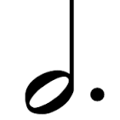 ) is: r' (dots 1 2 3 5 dot 3)
- a dotted crotchet rest ( J) is: v' (dots 1 2 3 6 dot 3)
- a dotted minim rest (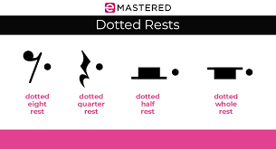 ) is: u'(dots 1 3 6 dot 3)

Exercise 2.1
Let’s practise writing notes and adding note values.
Braille each of the notes below as crotchets (quarter notes).
CCDD EEFF CDCD EFEF
GGAA BBCC GAGA BCBC
GBED FCGA CDEF GABC
ABCD FGAF GABC DEDG

Exercise 2.2
Braille the notes shown on the stave below. All notes are crotchets (quarter notes). Braille both bars on each staff as one braille line. Press return (Enter) at the end of the second bar. Use a blank cell between the two bars to show the barline. Only braille the musical notes – do not include the clef.
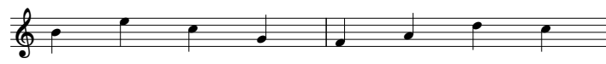

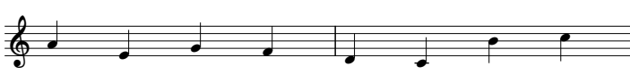

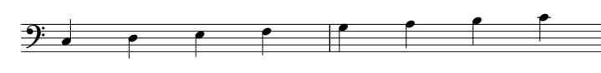

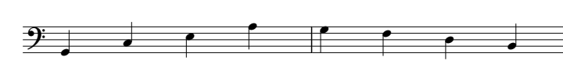

Image description:
Bar 1: BECG
Bar 2: FADC
Bar 3: AEGF
Bar 4: DCBC
Bar 5: CDEF
Bar 6: GABC
Bar 7: GCEA
Bar 8: GFDB

Exercise 2.3
Braille the notes below making them minims (half notes):
CC GG AA BB DD FF EE GG
DE GA EF BC BA GF ED CC
AB DC EF AG FD EC DE FG
CE GE GB FA BA GF ED BC

Exercise 2.4
Braille the notes on the stave below. All notes are minims (half notes). Braille the four bars on each staff as one braille line. Press return (Enter) at the end of the fourth bar. Use one blank cell between the bars to show the barline. Only braille the musical notes – do not include the clef.
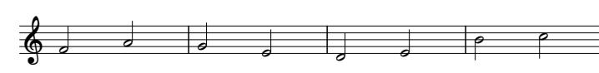

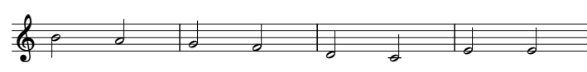

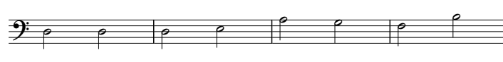

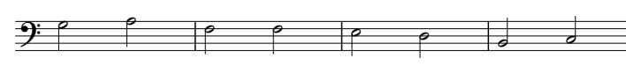

Image description:
Bar 1: FA
Bar 2: GE
Bar 3: DE
Bar 4: BC
Bar 5: BA
Bar 6: GF
Bar 7: DC
Bar 8: EE
Bar 9: DD
Bar 10: DE
Bar 11: AG
Bar 12: FB
Bar 13: GA
Bar 14: FF
Bar 15: ED
Bar 16: BC

Exercise 2.5
Braille the notes below making them semibreves (whole notes):
C E F A
G D B C
D G E B
C D B A

Exercise 2.6
Braille the notes on the stave below. All notes are semibreves (whole notes). Braille the 4 bars on each staff on one braille line. Press return (Enter) at the end of the fourth bar. Use one blank cell between each bar to indicate the barline. Braille only the musical notes – do not include the clefs.
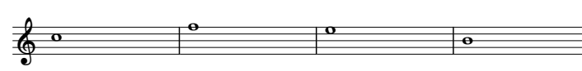

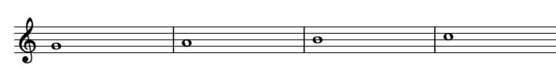

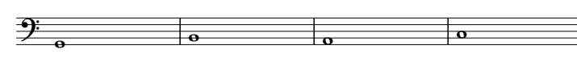

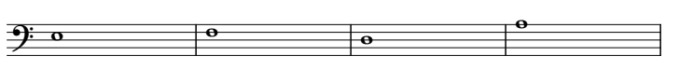

Image description:
Bar 1: C
Bar 2: F
Bar 3: E
Bar 4: B
Bar 5: G
Bar 6: A
Bar 7: B
Bar 8: C
Bar 9: G
Bar 10: B
Bar 11: A
Bar 12: C
Bar 13: E
Bar 14: F
Bar 15: D
Bar 16: A

Exercise 2.7
Braille each line of the notes and rests below (do not put a space between notes and rests).
C crotchet, D dotted crotchet, quaver rest, G crotchet
B quaver, C quaver, F dotted minim, semibreve rest
G minim, B crotchet, D quaver, A quaver, F crotchet, crotchet rest
G quaver, F quaver, A dotted crotchet, B quaver, C quaver, E crotchet, minim rest
A minim, dotted D minim, minim rest, crotchet rest
G dotted quaver, A semiquaver, dotted crotchet rest, E minim, semibreve rest
Dotted minim rest, C crotchet, D semibreve, semibreve rest

Exercise 2.8
Braille the notes on the stave below. Braille the bars on each line on one braille line. Press return (Enter) at the end of the last bar. Use one blank cell between each bar to indicate the barline. Braille only the musical notes – do not include the clefs.
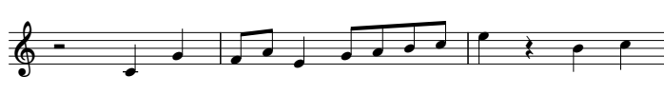

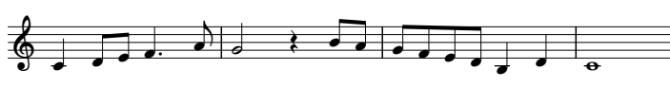

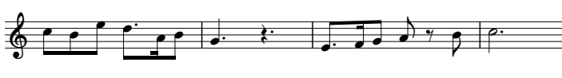

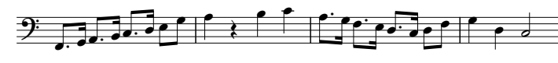

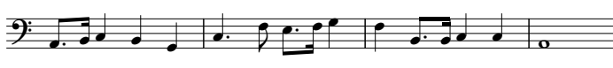

Image description:
Bar 1: Minim rest, C crotchet, G crotchet
Bar 2: F quaver A quaver, E crotchet, G quaver A quaver B quaver C quaver
Bar 3: E crotchet, crotchet rest, B crotchet, C crotchet
Bar 4: C crotchet, D quaver E quaver, F dotted crotchet, A quaver
Bar 5: G minim, crotchet rest, B quaver A quaver
Bar 6: G quaver F quaver E quaver D quaver, B crotchet, D crotchet
Bar 7: C semibreve
Bar 8: C quaver, B quaver, E quaver, D dotted quaver, A semiquaver, B quaver
Bar 9: G dotted crotchet, dotted crotchet rest
Bar 10: E dotted quaver, F semiquaver, G quaver, A quaver, quaver rest, B quaver
Bar 11: C dotted minim
Bar 12: F dotted quaver, G semiquaver, A dotted quaver, B semiquaver, C dotted quaver, D semiquaver, E quaver, G quaver
Bar 13: A crotchet, crotchet rest, B crotchet, C crotchet
Bar 14: A dotted quaver, G semiquaver, F dotted quaver, E semiquaver, D dotted quaver, C semiquaver, D quaver, F quaver
Bar 15: G crotchet, D crotchet, C minim
Bar 16: A dotted quaver, B semiquaver, C crotchet, B crotchet, G crotchet
Bar 17: C dotted crotchet, F quaver, E dotted quaver, F semiquaver, G crotchet
Bar 18: F crotchet, B dotted quaver, B semiquaver, C crotchet, C crotchet
Bar 19: A semibreve

Lesson 3 Octave Signs
Octave signs indicate pitch in music braille not clef signs. While there are braille equivalents for the treble and bass clef they are rarely used in transcriptions unless the braille needs to be an exact copy of the print, a facsimile copy.
An important step in knowing when to use an octave sign before a note is determining what the distance or interval is between two notes.
To determine an interval between two notes, count the number of steps (lines and spaces) from the note you are on to the next note. Don’t forget to count the note you are on as 1.
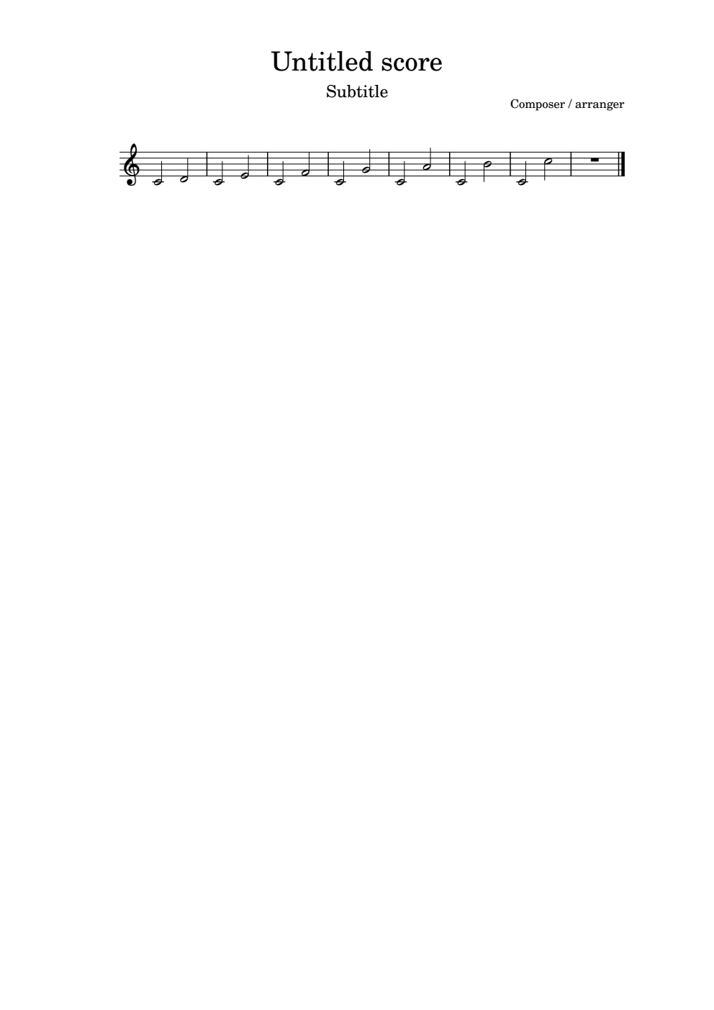

2nd 3rd 4th 5th 6th 7th Octave
Image Description:
Middle C up to D is a 2nd
Middle C up to E is a 3rd
Middle C up to F is a 4th
Middle C up to G is a 5th
Middle C up to A is a 6th
Middle C up to B is a 7th
Middle C up to C is an octave

Examples of intervals:
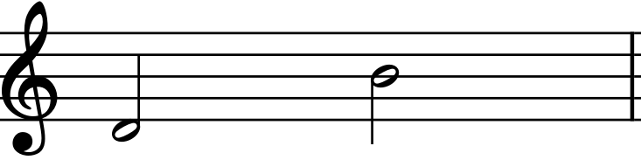 | 4th octave D to 4th octave B | 6th
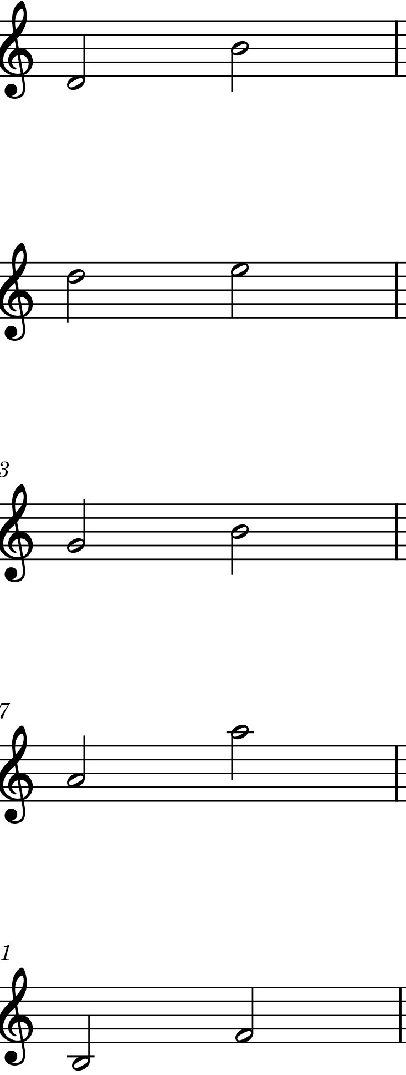 | 5th octave D to 5th octave E | 2nd
 | 4th octave G to 4th octave B | 3rd
 | 4th octave A to 5th octave A | octave
 | 3rd octave B to 4th octave F | 5th

Interval Practice
It is your turn. In the melody below there are 8 slurs (curved line between 2 notes of different pitch). Name each of these intervals. The answers are at the end of this lesson.
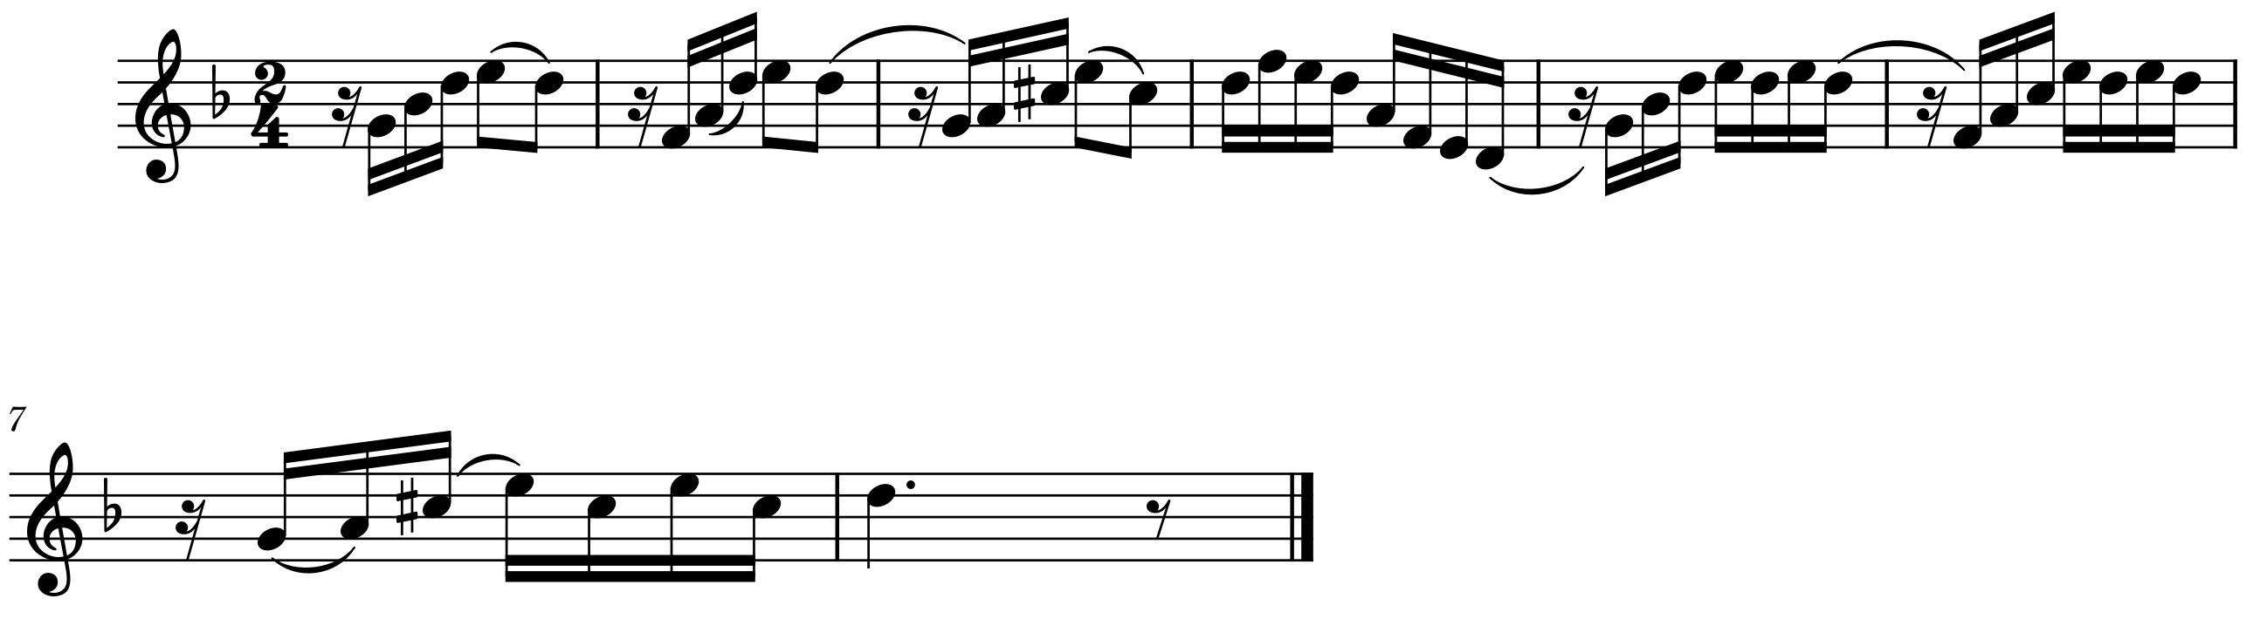
Image description:
Melody is in 2 4 time and has one flat B.
Bar 1: semiquaver rest, 4th octave G semiquaver, 4th octave B semiquaver, 5th octave D semiquaver, 5th octave E quaver, slur, 5th octave D quaver
Bar 2: semiquaver rest, 4th octave F semiquaver, 4th octave A semiquaver, slur, 5th octave D semiquaver, 5th octave E quaver, 5th octave D quaver, slur
Bar 3: semiquaver rest, 4th octave G semiquaver, 4th octave A semiquaver, 5th octave C sharp semiquaver, 5th octave E quaver, slur, 5th octave C
Bar 4: 5th octave D semiquaver, 5th octave F semiquaver, 5th octave E semiquaver, 5th octave D semiquaver, 4th octave A semiquaver, 4th octave F semiquaver, 4th octave E semiquaver, 4th octave D semiquaver, slur
Bar 5: semiquaver rest, 4th octave G semiquaver, 4th octave B semiquaver, 5th octave D semiquaver, 5th octave E semiquaver, 5th octave D semiquaver, 5th octave E semiquaver, 5th octave D semiquaver, slur
Bar 6: semiquaver rest, 4th octave F semiquaver, 4th octave A semiquaver, 5th octave C semiquaver, 5th octave E semiquaver, 5th octave D semiquaver, 5th octave E semiquaver, 5th octave semiquaver
Bar 7: semiquaver rest, 4th octave G semiquaver, slur, 4th octave A semiquaver, 5th octave C sharp semiquaver, slur, 5th octave E semiquaver, 5th octave C semiquaver, 5th octave E semiquaver, 5th octave C semiquaver
Bar 8: 5th octave D dotted crotchet, quaver rest, double bar line.

Octave Signs
There are 7 octaves as indicated in the table below. The first octave starts on the lowest C on the piano to the next B. The 4th octave starts on middle C which is shown in the treble and bass clefs.

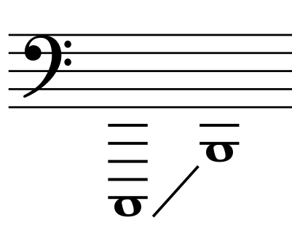 | 1st Octave | @ | dot 4
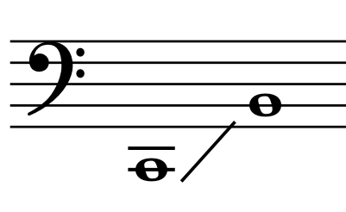 | 2nd Octave | ^ | dots 4, 5
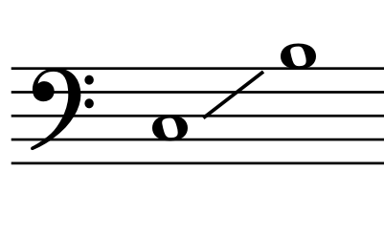 | 3rd Octave | _ | dots 4, 5, 6
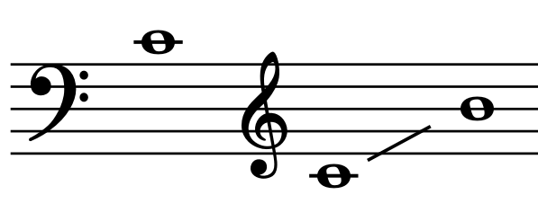 | 4th Octave | " | dot 5
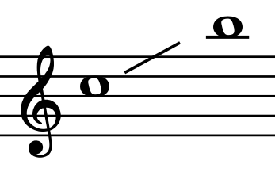 | 5th Octave | . | dot 4, 6
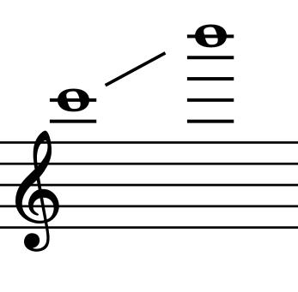 | 6th Octave | ; | dots 5, 6
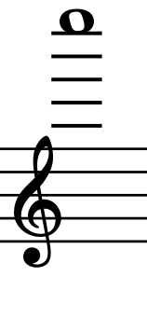 | 7th Octave | , | dot 6

The Rules for using Octave Signs
When and how to use octave signs is important. They tell the reader the direction of the melody, so it is important that octave signs are used correctly.
- The first note of a piece of music and the first note of every new line must be preceded by an octave sign. If a rest is on the first count of a new line, then the octave sign is placed before the first note on that line not the rest as a rest does not have pitch.
- Seconds or thirds do not need an octave sign even if they are in different octaves.
- Fourth and fifths only receive an octave sign if they are in different octaves.
- Sixths, sevenths and octaves must always have their own octave mark.
So, in summary:
- 2nd or 3rd, never.
- 4th or 5th, sometimes. (Only if it should leave the octave.)
- 6th or more, always.
One last rule for octave signs. Nothing comes between an octave sign and its note. If a note needs an octave sign, then it will immediately precede the note that needs it. More about this will be covered in other lessons.
Below is the first 8 bars of Ode to Joy by Beethoven in print and then in braille. Note that the first note of the melody has a 4th octave sign in front of it. The melody is moving in steps, in this case 2nds, so there are no more octave signs are required. However, bar 8 starts on a new braille line so the first note must have an octave sign.
The piece below is Ode to Joy by Beethoven. At the end of the excerpt you will notice that there is a double barline showing the end of the piece of music. The braille symbol for the double barline is: <k (dots 1 2 6, dots 1 3).
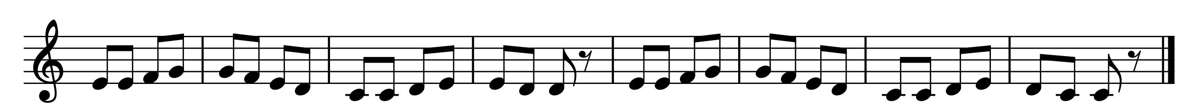
Image description:
All note values are quavers.
Bar 1: 4th octave E, 4th octave E, 4th octave F, 4th octave G
Bar 2: 4th octave G, 4th octave F, 4th octave E, 4th octave D
Bar 3: 4th octave C, 4th octave C, 4th octave D, 4th octave E
Bar 4: 4th octave E, 4th octave D, 4th octave D, quaver rest.
Bar 5: 4th octave E, 4th octave E, 4th octave F, 4th octave G
Bar 6: 4th octave G, 4th octave F, 4th octave E, 4th octave D
Bar 7: 4th octave C, 4th octave C, 4th octave D, 4th octave E
Bar 8: 4th octave D, 4th octave C, 4th octave C, quaver rest, double bar line.

"ffgh hgfe ddef feex ffgh hgfe ddef "eddx<k
Below is another example in print and braille demonstrating the use of octave signs. This melody has wider jumps in the melody, so more octave signs are required. The first note has a 3rd octave sign, but the next note jumps a 6th and also moves to a different octave, so according to the rules it must have its own octave sign so the reader knows which direction the melody is moving. In the next bar, the distance between the A crotchet and the B crotchet is a 7th so the B must have an octave sign.
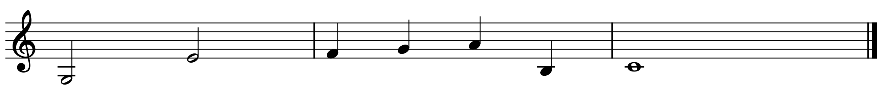
Image description:
Bar 1: 3rd octave G minim, 4th octave E minim
Bar 2: 4th octave F crotchet, 4th octave G crotchet, 4th octave A crotchet, 3rd octave B crotchet
Bar 3: 4th octave C semibreve, double bar line.

_r"p ]\[_w y<k

To show the importance of octave signs, the melody above would be interpreted like this if the E in bar 1 did not have a 4th octave sign before it.
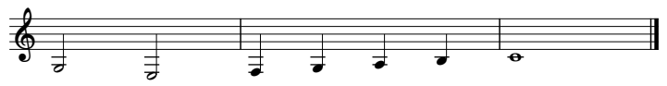
Image description:
Bar 1: 3rd octave G minim, 3rd octave E minim
Bar 2: 3rd octave F crotchet, 3rd octave G crotchet, 3rd octave A crotchet, 3rd octave B crotchet
Bar 3: 4th octave C semibreve, double barline.

Answers to the Interval Practice:
1. 2nd 2. 4th 3. 5th 4. 3rd 5. 4th 6. 6th 7. 2nd 8. 3rd

Exercise 3.1
Put the following melody into braille making sure to put octave signs as needed. To start a new bar, do a space and don’t forget the double bar line at the end.
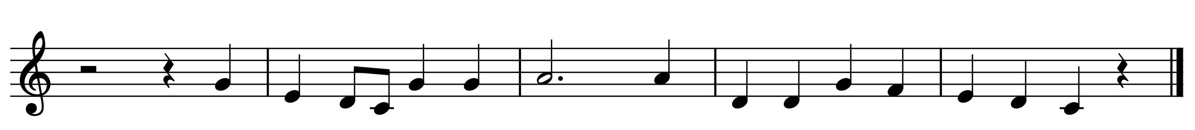
Image description:
Bar 1: minim rest, crotchet rest, 4th octave G crotchet
Bar 2: 4th octave E crotchet, 4th octave D quaver, 4th octave C quaver, 4th octave G crotchet, 4th octave G crotchet
Bar 3: 4th octave A dotted minim, 4th octave A crotchet
Bar 4: 4th octave D crotchet, 4th octave D crotchet, 4th octave G crotchet, 4th octave F crotchet
Bar 5: 4th octave E crotchet, 4th octave D crotchet, 4th octave C crotchet, crotchet rest, double bar line.

Exercise 3.2
Put the following melody into braille making sure to put octave signs as needed. To start a new bar, do a space and don’t forget the double bar line at the end.
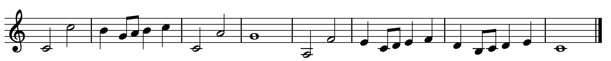
Image description:
Bar 1: 4th octave C minim, 5th octave C minim
Bar 2: 4th octave B crotchet, 4th octave G quaver, 4th octave A quaver, 4th octave B crotchet, 5th octave C crotchet
Bar 3: 4th octave C minim, 4th octave A minim
Bar 4: 4th octave G semibreve
Bar 5: 3rd octave A minim, 4th octave F minim
Bar 6: 4th octave E crotchet, 4th octave C quaver, 4th octave D quaver, 4th octave E crotchet, 4th octave F crotchet
Bar 7: 4th octave D crotchet, 3rd octave B quaver, 4th octave C quaver, 4th octave D crotchet, 4th octave E crotchet
Bar 8: 4th octave C semibreve, double bar line.

Exercise 3.3
The melody below is called Aloha ‘Oe by Queen Lili’oukalani (Hawaii). Put it into braille making sure to put octave signs as needed. Music braille does not follow the print music in the number of bars to a line. If a whole bar will not fit on the one braille line, then move the whole bar to a new line. Remember, to start a new bar, do a space and do not forget the double bar line at the end.
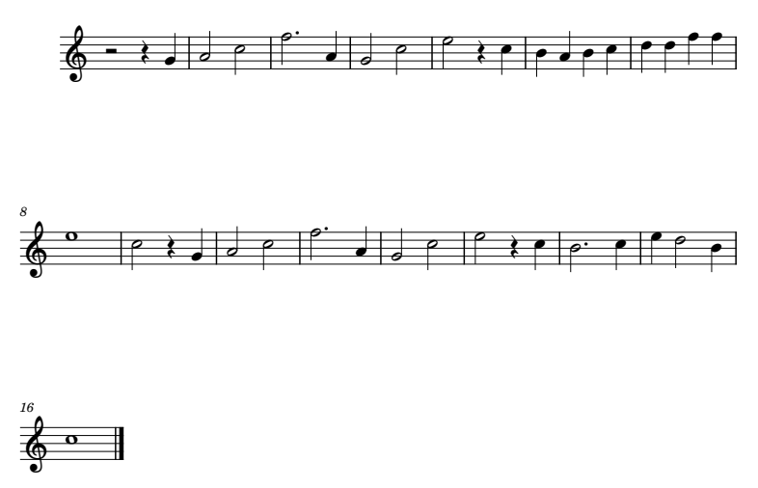

Image description:
Bar 1: minim rest, crotchet rest, 4th octave G crotchet
Bar 2: 4th octave A minim, 5th octave C minim
Bar 3: 5th octave F dotted minim, 4th octave A crotchet
Bar 4: 4th octave G minim, 5th octave C minim
Bar 5: 5th octave E minim, crotchet rest, 5th octave C crotchet
Bar 6: 4th octave B crotchet, 4th octave A crotchet, 4th octave B crotchet, 5th octave C crotchet
Bar 7: 5th octave D crotchet, 5th octave D crotchet, 5th octave F crotchet, 5th octave F crotchet
Bar 8: 5th octave E semibreve
Bar 9: 5th octave C minim, crotchet rest, 4th octave G crotchet
Bar 10: 4th octave A minim, 5th octave C minim
Bar 11: 5th octave F dotted minim, 4th octave A crotchet
Bar 12: 4th octave G minim, 5th octave C minim
Bar 13: 5th octave E minim, crotchet rest, 5th octave C crotchet
Bar 14: 4th octave B dotted minim, 5th octave C crotchet
Bar 15: 5th octave E crotchet, 5th octave D minim 4th octave B crotchet
Bar 16: 5th octave C semibreve, double bar line.

Lesson 4 Time and Key Signatures and Grouping Notes
This lesson will demonstrate how to braille time signatures, key signatures, and accidentals, as well as grouping notes.

Time Signatures
A time signature (or meter signatures) is found at the beginning of a piece of print music with the key signature. In braille music a time signature is centred on its own line above the piece of music. To write a time signature, braille a number sign, then the top number of the time signature is brailled next in the top part of the cell then the bottom number is brailled next in the lower part of the cell. A standard time signature will be three cells. An example of a time signature in a piece of music is shown at the end of this lesson.
Examples of how to braille different time signatures:
# | #c4 | Dots 3 4 5 6, dots 1 4, dots 2 5 6
^ | #f4 | Dots 3 4 5 6, dots 1 2 4, dots 2 5 6
L | #c2 | Dots 3 4 5 6, dots 1 4, dots 2 3
P | #f8 | Dots 3 4 5 6, dots 1 2 4, dots 2 3 6

Two other common time signatures are common and cut common time which looks like the letter C.
Common time c .c (dots 4 6, dots 1 4)
Cut common time C _c (dots 4 5 6, dots 1 4)

Key Signatures/Accidentals
Accidentals are sharps, flats, and naturals put before a note to change its pitch. The table below shows the braille cells for each accidental.
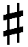  Sharp | % | dots 1 4 6
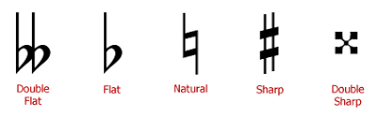  Double Sharp | %% | dots 1 4 6 dots 1 4 6
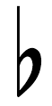  Flat | < | dots 1 2 6
Double Flat | << | dots 1 2 6 dots 1 2 6
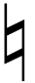  Natural | * | dots 1 6

Key signatures are made up of sharps or flats and are found at the beginning of each new stave in print music. In braille, however, the key signature, like the time signature, is only written once at the beginning of a piece before the time signature, centred on their own line. If the key signature only has up to three sharps or flats, then the corresponding number of sharps or flats are used. If the key signature has four or more sharps or flats, then a numeric indicator with the number of sharps or flats there is, is brailled before the sharp or flat sign. Below are examples of how to braille different numbers of sharps and flats.
Examples of key signatures:
2 sharps | %% | Dots 1 4 6, dots 1 4 6
3 flats | <<< | Dots 1 2 6, dots 1 2 6, dots 1 2 6
5 sharps | #e% | Dots 3 4 5 6, dots 1 5, dots 1 4 6
4 flats | #d< | Dots 3 4 5 6, dots 1 4 5, dots 1 2 6

There are two examples of how to braille key and time signatures. The first example has 2 flats and a time signature of #. Note that the key and time signature have their own line and that there is no space between the key and time signature.
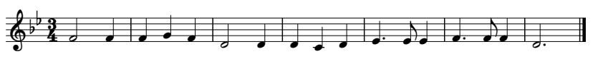

Image description:
Key signature: 2 flats
Time signature: 3 4
Bar 1: 4th octave F minim, 4th octave F crotchet
Bar 2: 4th octave F crotchet, 4th octave G crotchet, 4th octave F crotchet
Bar 3: 4th octave D minim, 4th octave D crotchet
Bar 4: 4th octave D crotchet, 4th octave C crotchet, 4th octave D crotchet
Bar 5: 4th octave E dotted crotchet, 4th octave E quaver, 4th octave E crotchet
Bar 6: 4th octave F dotted crotchet, 4th octave F quaver, 4th octave F crotchet
Bar 7: 4th octave D dotted minim, double bar line.

<<#c4
"q] ]\] o: :?: $'f$ ]'g] o'<k

In this second example the key signature has 4 sharps so a numeric sign has been used.
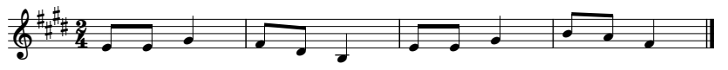

Image description:
Key signature: 4 sharps
Time signature: 2 4
Bar 1: 4th octave E quaver, 4th octave E quaver, 4th octave G crotchet
Bar 2: 4th octave F quaver, 4th octave D quaver, 3rd octave B crotchet
Bar 3: 4th octave E quaver, 4th octave E quaver, 4th octave G crotchet
Bar 4: 4th octave B quaver, 4th octave A quaver, 4th octave F crotchet
#d%#b4
"ff\ gew "ff\ ji]<k

Changes of Time and Key Signatures
Changes of time and/or key signatures can occur within a piece of music. Any change to a time signature or key signature is placed in the line of music wherever it occurs in the print and it will have a space on either side. It is preferable to braille it on the same line as the bar it effects. The first note following a time or key signature change must have an octave sign.

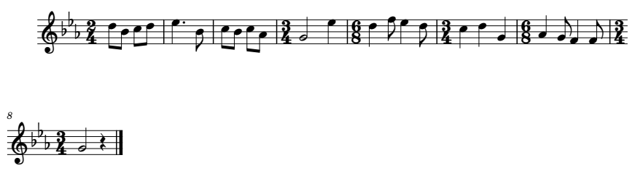

Image description:
Key signature: 3 flats
Time signature: 2 4
Bar 1: 5th octave D quaver, 4th octave B quaver, 5th octave C quaver, 5th octave D quaver
Bar 2: 5th octave E dotted crotchet, 4th octave B quaver
Bar 3: 5th octave C quaver, 4th octave B quaver, 5th octave C quaver, 4th octave C quaver
Bar 4: Time signature change to 3 4, 4th octave G minim, 5th octave E crotchet
Bar 5: Time signature change to 6 8, 5th octave D crotchet, 5th octave F quaver, 5th octave E crotchet, 5th octave D quaver
Bar 6: Time signature change to 3 4, 5th octave C crotchet, 5th octave D crotchet, 4th octave G crotchet
Bar 7: Time signature change to 6 8, 4th octave A crotchet, 4th octave G quaver, 4th octave F crotchet, 4th octave F quaver
Bar 8: Time signature change to 3 4, 4th octave G minim, crotchet rest, double bar line.

<<<#b4
.ejde $'"j djdi #c4 "r.$ #f8 .:g$e
#c4 .?:"\ #f8 "[h]g #c4 "rv<k

Key Signature changes within a piece of music are written in braille similar to Time Signature changes. However, key signature changes will usually happen after a sectional double barline. A sectional double barline is 2 thin lines which denotes the end of a section. The sectional double barline is brailled up against the last note of the bar and it is followed by a space. The note following a sectional double barline must have an octave sign. Below is an example of how to braille a sectional double barline with a change of key signature.
Sectional Double barline ± <k' (dots 1 2 6, dots 1 3, dot 3)
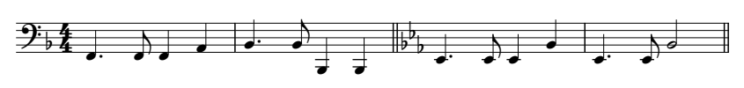

Image description:
Key signature: 1 flat
Time signature: 4 4
Bar 1: 2nd octave F dotted crotchet, 2nd octave F quaver, 2nd octave F crotchet, 2nd octave A crotchet
Bar 2: 2nd octave B dotted crotchet, 2nd octave B quaver, 1st octave B crotchet, 1st octave B crotchet, sectional double barline
Bar 3: key signature change to 3 flats, 2nd octave E dotted crotchet, 2nd octave E quaver, 2nd octave E crotchet, 2nd octave B crotchet
Bar 4: 2nd octave E dotted crotchet, 2nd octave E quaver, 2nd octave B minim, sectional double barline.
<#d4
^]'g][ w'j@ww<k' <<< ^$'f$w $'ft<k'

Grouping of Notes
In print, notes are shown grouped together with beams. Beams are not possible in braille but notes smaller than an eighth can be grouped together when there are three or more. This is done by writing the first note of the group as its true value and the remaining notes are written as eighths.
The example below is 2 bars from Beethoven’s Violin Sonata, Op. 24 showing how semiquavers are grouped in braille.
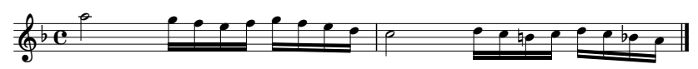

Image description:
Key signature: 1 flat
Time signature: common time
Bar 1: 5th octave A minim, group of 4 semiquavers 5th octave G, 5th octave F, 5th octave E, 5th octave F, group of 4 semiquavers 5th octave G, 5th octave F, 5th octave E, 5th octave D
Bar 2: 5th octave C minim, group of 4 semiquavers 5th octave D, 5th octave C, 4th octave natural B, 4th octave C, group of 4 semiquavers 5th octave D, 5th octave C, 4th octave flat B, 4th octave A, double barline.

<.c
.s(gfg(gfe nzd*jdzd<ji<k
Notes cannot be grouped when:
- they are not in the same beat,
- the group cannot be completed on the line on which it begins,
- the group is followed in the same bar (measure) by quavers (eighth notes) or dotted quavers or a quaver rest (see example 1),
- a rest of equal value occurs in any place other than the beginning of the group (see example 2), or
- the group is interrupted by a music hyphen (this sign will be covered in later lessons).
Example 1
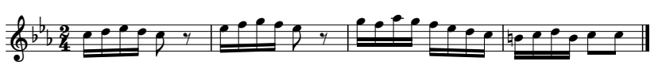

Image description:
Key signature: 3 flats
Time signature: 2 4
Bar 1: group of 4 semiquavers 5th octave C, 5th octave D, 5th octave E, 5th octave D, 5th octave C quaver, quaver rest.
Bar 2: group of 4 semiquavers 5th octave E, 5th octave F, 5th octave G, 5th octave F, 5th octave E quaver, quaver rest
Bar 3: group of 4 semiquavers 5th octave G, 5th octave F, 5th octave A, 5th octave G, group of 4 semiquavers 5th octave F, 5th octave E, 5th octave D, 5th octave C
Bar 4: group of 4 semiquavers 4th octave natural B, 5th octave C, 5th octave D, 4th octave B, 5th octave C quaver, 5th octave C quaver, double barline.

<<<#b4
.yz&zdx &=(=fx (gih=fed *)yz)dd<k

Example 2
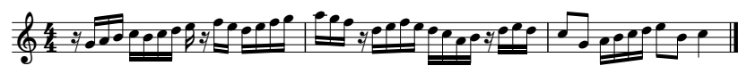

Image description:
Key signature: no sharps or flats
Time signature: 4 4
Bar 1: semiquaver rest, 4th octave G semiquaver, 4th octave A semiquaver, 4th octave B semiquaver, group of 4 semiquavers 5th octave C, 4th octave B, 5th octave C, 5th octave D, 5th octave E semiquaver, semiquaver rest, 5th octave F semiquaver, 5th octave E semiquaver, group of 4 semiquavers 5th octave D, 5th octave E, 5th octave F, 5th octave G
Bar 2: 5th octave A semiquaver, 5th octave G semiquaver, 5th octave F semiquaver, semiquaver rest, group of 4 semiquavers 5th octave D, 5th octave E, 5th octave F, 5th octave E, group of 4 semiquavers 5th octave D, 5th octave C, 4th octave A, 4th octave B, semiquaver rest, 5th octave D semiquaver, 5th octave E semiquaver, 5th octave D semiquaver
Bar 3: 5th octave C quaver, 4th octave G quaver, group of 4 semiquavers 4th octave A, 4th octave B, 5th octave C, 5th octave D, 5th octave E quaver, 4th octave B quaver, 5th octave C crotchet, double barline.
#d4
mhijyjde&m=&zfgh !(=mzfgfzdijmefe
.d"h!)yzf"j?<k

Exercise 4.1
The excerpt below is from Symphonie no. 101 in D Major by Haydn. Braille the piece of music remembering to centre the key and time signatures.
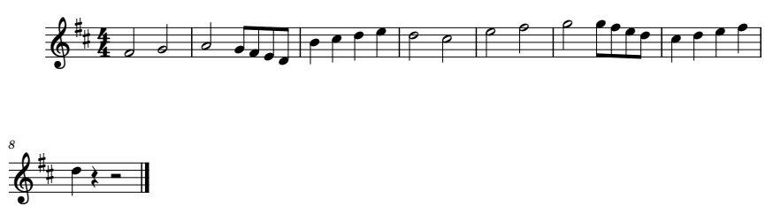

Image description:
Key Signature: 2 sharps
Time Signature: 4 4
Bar 1: 4th octave F minim, 4th octave G minim
Bar 2: 4th octave A minim, 4th octave G quaver, 4th octave F quaver, 4th octave E quaver, 4th octave D quaver
Bar 3: 4th octave B crotchet, 5th octave C crotchet, 5th octave D crotchet, 5th octave E crotchet
Bar 4: 5th octave D minim, 5th octave C minim
Bar 5: 5th octave E minim, 5th octave F minim
Bar 6: 5th octave G minim, 5th octave G quaver, 5th octave F quaver, 5th octave E quaver, 5th octave D quaver
Bar 7: 5th octave C crotchet, 5th octave D crotchet, 5th octave E crotchet, 5th octave F crotchet
Bar 8: 5th octave D crotchet, crotchet rest, minim rest, double barline.

Exercise 4.2
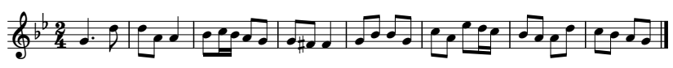
Braille this piece of music. Remember to centre the key and time signatures on their own line and don’t forget the accidental.

Image description:
Key signature: 2 flats
Time signature: 2 4
Bar 1: 4th octave G dotted crotchet, 5th octave D quaver
Bar 2: 5th octave D quaver, 4th octave A quaver, 4th octave A crotchet
Bar 3: 4th octave B quaver, 5th octave C semiquaver, 4th octave B semiquaver, 4th octave A quaver, 4th octave G quaver
Bar 4: 4th octave G quaver, 4th octave sharp F quaver, 4th octave F crotchet
Bar 5: 4th octave G quaver, 4th octave B quaver, 4th octave B quaver, 4th octave G quaver
Bar 6: 5th octave C quaver, 4th octave A quaver, 5th octave E quaver, 5th octave D semiquaver, 5th octave C semiquaver
Bar 7: 4th octave B quaver, 4th octave A quaver, 4th octave A quaver, 5th octave D quaver
Bar 8: 5th octave C quaver, 4th octave B quaver, 4th octave A quaver, 4th octave G quaver, double barline.

Exercise 4.3
Put the music below into braille. Remember to centre the key and time signatures, use octave signs where needed, and be aware of the sectional double barline and change of key signature.
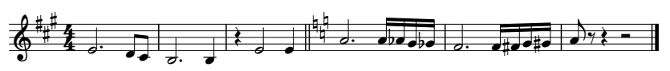

Image description:
Key signature: 3 sharps
Time signature: 4 4
Bar 1: 4th octave E dotted minim, 4th octave D quaver, 4th octave C quaver
Bar 2: 3rd octave B dotted minim, 3rd octave B crotchet
Bar 3: crotchet rest, 4th octave E minim, 4th octave E crotchet, sectional double barline
Bar 4: change of key signature to 3 naturals, 4th octave A dotted minim, group of 4 semiquavers 4th octave A, 4th octave flat A, 4th octave G, 4th octave flat G
Bar 5: 4th octave F dotted minim, group of 4 semiquavers 4th octave F, 4th octave sharp F, 4th octave G, 4th octave sharp G
Bar 6: 4th octave A quaver, quaver rest, crotchet rest, minim rest, double barline.

Exercise 4.4
Put the piece below into braille. Remember to centre the key and time signatures use octave signs where needed and be aware of the changes in time signatures.
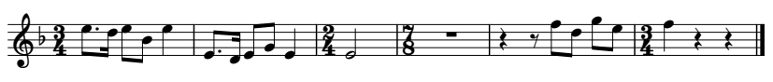

Image description:
Key signature: 1 flat
Time signature: 3 4
Bar 1: 5th octave E dotted quaver, 5th octave D semiquaver, 5th octave E quaver, 4th octave B quaver, 5th octave E crotchet
Bar 2: 4th octave E dotted quaver, 4th octave D semiquaver, 4th octave E quaver, 4th octave G quaver, 4th octave E crotchet
Bar 3: change of time signature to 2 4, 4th octave E minim
Bar 4: change of time signature to 7 8, whole bar rest
Bar 5: crotchet rest, quaver rest, 5th octave F quaver, 5th octave D quaver, 5th octave G quaver, 5th octave E quaver
Bar 6: change of time signature to 3 4, 5th octave F crotchet, crotchet rest, crotchet rest, double barline.

Exercise 4.5
The piece below is called Ballade Pour Adeline. Put it into braille and group the semiquavers. In bars 2 and 6 where the semiquaver group starts with a semiquaver rest, remember the rule where the semiquaver rest sets the value for the group and the semiquaver notes following may be shown as quavers.
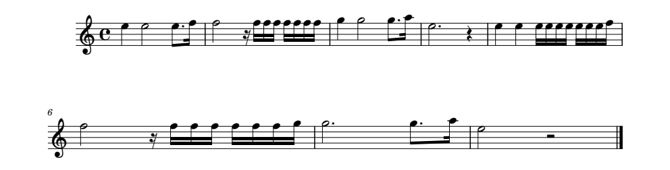
Image description:
Key signature: no sharps or flats
Time signature: common time
Bar 1: 5th octave E crotchet, 5th octave E minim, 5th octave E dotted quaver, 5th octave F semiquaver
Bar 2: 5th octave F minim, semiquaver rest, 5th octave F semiquaver, 5th octave F semiquaver, 5th octave F semiquaver, group of 4 semiquavers all 5th octave F
Bar 3: 5th octave G crotchet, 5th octave G minim, 5th octave G dotted quaver, 5th octave A semiquaver
Bar 4: 5th octave E dotted minim, crotchet rest
Bar 5: 5th octave E crotchet, 5th octave E crotchet, group of 4 semiquavers all 5th octave E, group of 4 semiquaver 5th octave E, 5th octave E, 5th octave E, 5th octave F
Bar 6: 5th octave F minim, semiquaver rest, 5th octave F semiquaver, 5th octave F semiquaver, 5th octave F semiquaver, group of 4 semiquavers 5th octave F, 5th octave F, 5th octave F, 5th octave G
Bar 7: 5th octave G dotted minim, 5th octave G dotted quaver, 5th octave A semiquaver
Bar 8: 5th octave E minim, minim rest, double barline.

Lesson 5 Bar Numbering and Ties and Slurs

Bar Numbering
Numbering bars is an important guide for braille readers. Bars are numbered in instrumental music regardless of whether the bar numbers are shown in print. Numbers are placed in cell 1 of the braille line without a number sign. An anacrusis or upbeat to bar 1, is numbered as bar 0. Examples of how to use bar numbers will be demonstrated in the examples shown in this lesson.

Ties
A tie in print music is a curved line that joins two notes of the same pitch. Notes that are tied are played as one note. A tie in braille is: @c (dot 4, dot 1 4).
Examples of how ties are used.
Example 1: The piece below is called Oh, My Lovin’ Brother and shows ties over the bar.
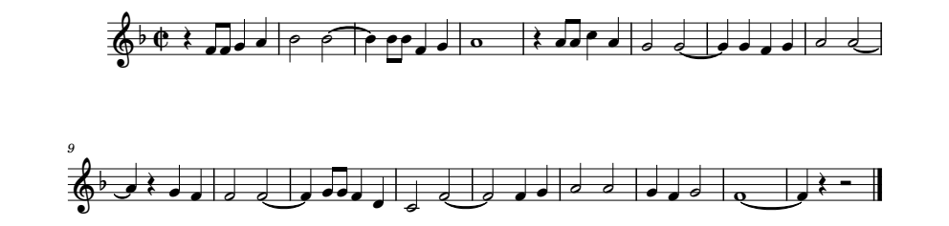
Image description:
Key Signature: 1 flat
Time Signature: Cut common time
Bar 1: crotchet rest, 4th octave F quaver, 4th octave F quaver, 4th octave G crotchet, 4th octave A crotchet.
Bar 2: 4th octave B minim, 4th octave B minim, tie
Bar 3: 4th octave B crotchet, 4th octave B quaver, 4th octave B quaver, 4th octave F crotchet, 4th octave G crotchet
Bar 4: 4th octave A semibreve
Bar 5: crotchet rest, 4th octave A quaver, 4th octave A quaver, 5th octave C crotchet, 4th octave A crotchet
Bar 6: 4th octave G minim, 4th octave G minim, tie
Bar 7: 4th octave G crotchet, 4th octave G crotchet, 4th octave F crotchet, 4th octave G crotchet
Bar 8: 4th octave A minim, 4th octave A minim, tie
Bar 9: 4th octave A crotchet, crotchet rest, 4th octave G crotchet, 4th octave F crotchet
Bar 10: 4th octave F minim, 4th octave F minim, tie
Bar 11: 4th octave F crotchet, 4th octave G quaver, 4th octave G quaver, 4th octave F crotchet, 4th octave D crotchet
Bar 12: 4th octave C minim, 4th octave F minim, tie
Bar 13: 4th octave F minim, 4th octave F crotchet, 4th octave G crotchet
Bar 14: 4th octave A minim, 4th octave A minim
Bar 15: 4th octave G crotchet, 4th octave F crotchet, 4th octave G minim
Bar 16: 4th octave F semibreve, tie
Bar 17: 4th octave F crotchet, crotchet rest, minim rest, double barline.

<_c
a v"gg\[ tt@c wjj]\ ! vii?[ rr@c \\]\
h "ss@c [v\] qq@c ]hh]: nq@c q]\ ss \]r af "=@c ]vu<k

Example 2: The piece below is called Little Brown Jug and it shows the use of ties within a bar.
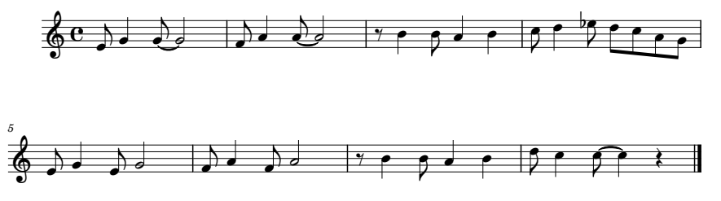
Image description:
Key Signature: no sharps or flats
Time Signature: Common time
Bar 1: 4th octave E quaver, 4th octave G crotchet, 4th octave G quaver, tie, 4th octave G minim
Bar 2: 4th octave F quaver, 4th octave A crotchet, 4th octave A quaver, tie, 4th octave A minim
Bar 3: quaver rest, 4th octave B crotchet, 4th octave B quaver, 4th octave A crotchet, 4th octave B crotchet
Bar 4: 5th octave C quaver, 5th octave D crotchet, 5th octave flat E quaver, 5th octave D quaver, 5th octave C quaver, 4th octave A quaver, 4th octave G quaver
Bar 5: 4th octave E quaver, 4th octave G crotchet, 4th octave E quaver, 4th octave G minim
Bar 6: 4th octave F quaver, 4th octave A crotchet, 4th octave F quaver, 4th octave A minim
Bar 7: quaver rest, 4th octave B crotchet, 4th octave B quaver, 4th octave A crotchet, 4th octave B crotchet
Bar 6: 5th octave D quaver, 5th octave C crotchet, 5th octave C quaver, tie, 5th octave C crotchet, crotchet rest, double barline.
.c
a "f\h@cr g[i@cs xwj[w d:<fedih f\fr
f "g[gs xwj[w e?d@c?v<k

The Slur
The tie and slur in print use the same sign. The purpose of a slur is to indicate that notes are to be played smoothly, show phrasing and in vocal music, give a correlation between notes and syllables.
The single slur c (dots 1 4) is used to connect two to four notes. It is placed after the each note except for the last note. For slurs four notes or longer the single slur can be doubled after the first note. To conclude the slur a single slur sign is placed before the last to be slurred.
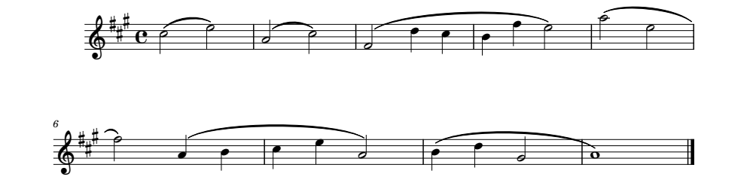
Below is an example showing the use of the single and double slur. Note the slur in bar 8 to 9. As 4 notes are being slurred a double slur can be used. Single slurs have been used in this circumstance, as the use of a double slur does not save any cells. In this instance, the use of either the double slur or single slur is correct.

Image description:
Key signature: 3 sharps
Time signature: common time
Bar 1: 5th octave C minim, slur, 5th octave E minim
Bar 2: 4th octave A minim, slur, 5th octave C minim
Bar 3: 4th octave F minim, slur, 5th octave D crotchet, slur, 5th octave C crotchet, slur
Bar 4: 4th octave B crotchet, slur, 5th octave F crotchet, slur, 5th octave E minim
Bar 5: 5th octave A minim, slur, 5th octave E minim, slur
Bar 6: 5th octave F minim, 4th octave A crotchet, slur, 4th octave B crotchet, slur
Bar 7: 5th octave C crotchet, slur, 5th octave E crotchet, slur, 4th octave A minim
Bar 8: 4th octave B crotchet, slur, 5th octave D crotchet, slur, 4th octave G minim, slur
Bar 9: 4th octave A semibreve, double barline.

%%%.c
a .ncp "scn "qcc:? w"]cp scpc q"[ccw
g .?$c"s wc:c"rc !<k

Another common slur is the bracket slur: ;b ^2 (Opening bracket dots 5 6, dots 1 2. Closing bracket dots 4 5, dots 2 3). It can be used instead of the double slur, but it is commonly used to show phrases especially in keyboard and instrumental music. The bracket slur is also employed when a piece uses layered slurs.
Example of the bracket slur.
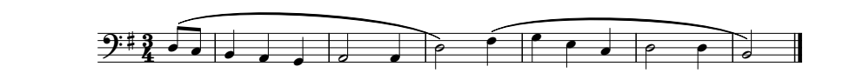
Image description:
Key Signature: 1 sharp
Time Signature: 3 4
Bar 0: open bracket slur, 3rd octave D quaver, 3rd octave C quaver
Bar 1: 2nd octave B crotchet, 2nd octave A crotchet, 2nd octave G crotchet
Bar 2: 2nd octave A minim, 2nd octave A crotchet
Bar 3: 3rd octave D minim, closed bracket slur, open bracket slur, 3rd octave F crotchet
Bar 4: 3rd octave G crotchet, 3rd octave E crotchet, 3rd octave C crotchet
Bar 5: 3rd octave D minim, 3rd octave D crotchet
Bar 6: 2nd octave B minim, closed bracket slur, double barline.

%#c4
j ;b_ed w[\ s[ _o^2;b] \$? o: t^2<k

Example of the use of bracket slurs when slurs are layered in the music.
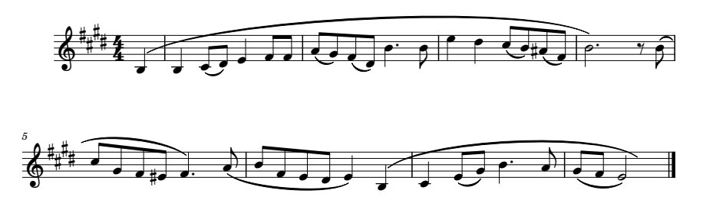

Image description:
Key signature: 4 sharps
Time signature: 4 4
Bar 0: open bracket slur, 3rd octave B crotchet
Bar 1: 3rd octave B crotchet, 4th octave C quaver, slur, 4th octave D quaver, 4th octave E crotchet, 4th octave F quaver, 4th octave F quaver
Bar 2: 4th octave A quaver, slur, 4th octave G quaver, 4th octave F quaver, slur, 4th octave D quaver, 4th octave B dotted crotchet, 4th octave B quaver
Bar 3: 5th octave E crotchet, 5th octave D crotchet, 5th octave C quaver, slur, 4th octave B quaver, 4th octave sharp A quaver, slur, 4th octave F quaver
Bar 4: 4th octave B dotted minim, closed bracket slur, quaver rest, 4th octave B quaver, slur
Bar 5: 5th octave C quaver, slur, 4th octave G quaver, slur, 4th octave F quaver, slur, 4th octave sharp E quaver, slur, 4th octave F dotted crotchet, 4th octave A quaver slur
Bar 6: 4th octave B quaver, slur, 4th octave F quaver, slur, 4th octave E quaver, slur, octave D quaver, slur, 4th octave E crotchet, open bracket slur 3rd octave B crotchet
Bar 7: 4th octave C crotchet, 4th octave E quaver, slur, 4th octave G quaver, 4th octave B dotted crotchet, 4th octave A quaver
Bar 8: 4th octave G quaver, slur, 4th octave F quaver, slur, 4th octave E minim, closed bracket slur, double barline.

#d%#d4
j ;b_w wdce$gg ichgce"w'j .$:dcj%icg
d "t'^2xjcc d"hg%fc]'icc jgfec$;b_w
g "?fchw'i hcgcp^2<k

Exercise 5.1
Put Air from Water Music by Handel into braille. Make sure to add bar numbers on the margin of each line and most importantly, don’t forget to use octave signs.
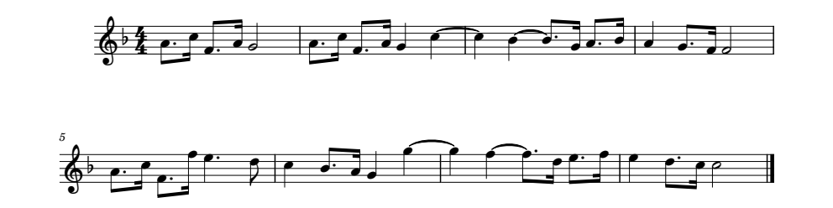
Image description:
Key Signature: 1 flat
Time Signature: 4 4
Bar 1: 4th octave A dotted quaver, 5th octave C semiquaver, 4th octave F dotted quaver, 4th octave A semiquaver, 4th octave G minim
Bar 2: 4th octave A dotted quaver, 5th octave C semiquaver, 4th octave F dotted quaver, 4th octave A semiquaver, 4th octave G crotchet, 5th octave C crotchet, tied
Bar 3: 5th octave C crotchet, 4th octave B crotchet, tied, 4th octave B dotted quaver, 4th octave G semiquaver, 4th octave A dotted quaver, 4th octave B semiquaver
Bar 4: 4th octave A crotchet, 4th octave G dotted quaver, 4th octave F semiquaver, 4th octave F minim
Bar 5: 4th octave A dotted quaver, 5th octave C semiquaver, 4th octave F dotted quaver, 5th octave F semiquaver, 5th octave E dotted crotchet, 5th octave D quaver
Bar 6: 5th octave C crotchet, 4th octave B dotted quaver, 4th octave A semiquaver, 4th octave G crotchet, 5th octave G crotchet, tied
Bar 7: 5th octave G crotchet, 5th octave F crotchet, tied, 5th octave F dotted quaver, 5th octave D semiquaver, 5th octave E dotted quaver, 5th octave F semiquaver
Bar 8: 5th octave E crotchet, 5th octave D dotted quaver, 5th octave C semiquaver, 5th octave C minim, double barline.

Exercise 5.2
Put the piece below into braille. Be careful to identify the difference between a tie and a slur. Make sure to show bar numbers at the beginning of each new line and add appropriate octave signs.
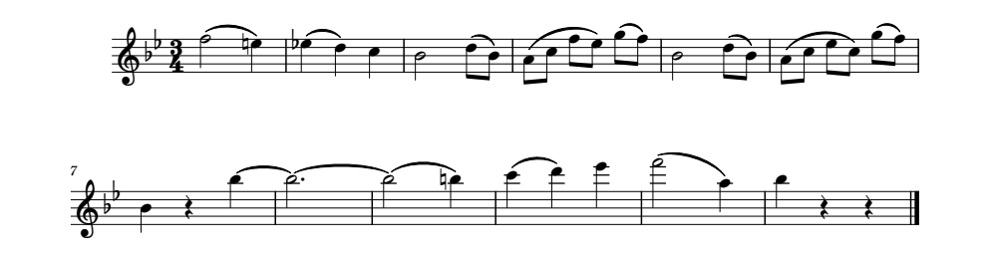
Image description:
Key signature: 2 flats
Time signature: 3 4
Bar 1: 5th octave F minim, slur, 5th octave natural E crotchet
Bar 2: 5th octave flat E crotchet, slur, 5th octave D crotchet, 5th octave C crotchet
Bar 3: 4th octave B minim, 5th octave D quaver, slur, 4th octave B quaver
Bar 4: 4th octave A quaver, slur, 5th octave C quaver, slur, 5th octave F quaver, slur, 5th octave E quaver, 5th octave G quaver, slur, 5th octave F quaver
Bar 5: 4th octave B minim, 5th octave D quaver, slur, 4th octave B quaver
Bar 6: 4th octave A quaver, slur, 5th octave C quaver, slur, 5th octave E quaver, slur, 5th octave C quaver, 5th octave G quaver, slur, 5th octave F quaver
Bar 7: 4th octave B crotchet, crotchet rest, 5th octave B crotchet, tied
Bar 8: 5th octave B dotted minim, tied
Bar 9: 5th octave B minim, slur, 5th octave natural B crotchet
Bar 10: 6th octave C crotchet, slur, 6th octave D crotchet, 6th octave E crotchet
Bar 11: 6th octave F minim, slur, 5th octave A crotchet
Bar 12: 5th octave B crotchet, crotchet rest, crotchet rest, double barline.

Exercise 5.3
Put the piece below into braille. Be careful to use the correct slur sign. Make sure to number the bars at the beginning of each new line and add the appropriate octave signs.
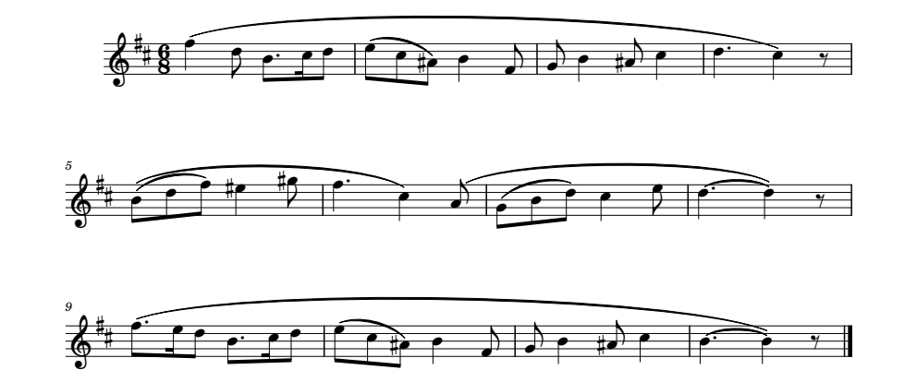
Image description:
Key signature: 2 sharps
Time signature: 6 8
Bar 1: open bracket slur, 5th octave F crotchet, 5th octave D quaver, 4th octave B dotted quaver, 5th octave C semiquaver, 5th octave D quaver
Bar 2: 5th octave E quaver, slur, 5th octave C quaver, slur, 4th octave sharp A quaver, 4th octave B crotchet, 4th octave F quaver
Bar 3: 4th octave G quaver, 4th octave B crotchet, 4th octave sharp A quaver, 5th octave C crotchet
Bar 4: 5th octave D dotted crotchet, 5th octave C crotchet, close bracket slur, quaver rest
Bar 5: open bracket slur, 4th octave B quaver, slur, 5th octave D quaver, slur, 5th octave F quaver, 5th octave sharp E crotchet, 5th octave sharp G quaver
Bar 6: 5th octave F dotted crotchet, 5th octave C crotchet, close bracket slur, open bracket slur, 4th octave A quaver
Bar 7: 4th octave G quaver, slur, 4th octave B quaver, slur, 5th octave D quaver, 5th octave C crotchet, 5th octave E quaver
Bar 8: 5th octave D dotted crotchet, tied, 5th octave D crotchet, close bracket slur, quaver rest
Bar 9: open bracket slur, 5th octave F dotted quaver, 5th octave E semiquaver, 5th octave D quaver, 4th octave B dotted quaver, 5th octave C semiquaver, 5th octave D quaver
Bar 10: 5th octave E quaver, slur, 5th octave C quaver, slur, 4th octave sharp A quaver, 4th octave B crotchet, 4th octave F quaver
Bar 11: 4th octave G quaver, 4th octave B crotchet, 4th octave sharp A quaver, 5th octave C crotchet
Bar 12: 4th octave B dotted crotchet, tied, 4th octave B crotchet, close bracket slur, quaver rest, double barline.

Lesson 6 Dynamics and Expressive Markings
Dynamics (eg. f, p, mf, mp, cresc and descresc) and expressive markings (moderato, rit, poco, lento etc) are usually words or letters. This lesson will show how to put words and letters into a piece of braille music and also show how to add titles and composers if the piece has them.
When adding words to braille music it is done in uncontracted braille (letter by letter, no contractions). Throughout this lesson, and subsequent lessons, uncontracted braille will be used. If you are unsure of this code a document can be found under Resources to help you. Grade 1 Braille may not necessarily be used in every country, so it is advised that you check with the Braille Authority of your country when creating your own music braille.
All words in the line of music are preceded by a word sign > (dots 3 4 5).
Care must be taken on the placement of an expression marking in braille music. It is important to get the order of signs correct. In print a new tempo marking for a bar may be placed in different positions depending on the editor and when written with a dynamic marking it may be shown after, above or below the stave. In music braille the tempo marking would be brailled first and then the dynamic marking before the note as the dynamic marking directly affects the note. For example, a tempo indication can be placed before a rest, but a dynamic marking must be placed before a note – rests cannot be loud or soft, but they can be fast or slow.
Rules for when writing words within the stave:
- words are written in uncontracted braille in the applicable literary code
- no capitals are used
- literary punctuation can be used except for dot 3 which is a period and the special parenthesis sign which is 7 (dots 2 3 5 6)
- an octave sign is required for the next note.
- the word must be followed by a dot 3 if the next cell contains dots 1 2 or 3. For example, if the next note is preceded by a sharp then the sharp sign must be brailled before the octave sign which means there would be a dot 1 so a dot 3 would be required after the word. The exceptions are if it is the last sign of the bar (measure), the following sign is a word sign or a dot 3 (representing a period) is already present.
Note: The use of a period (or full stop) after a word or abbreviation in this training program will follow the published music score. If there is a period present on the score, it will be brailled as a dot 3. If it is not present on the score then we will not braille a period (dot 3) unless it is required as per rule 5 above.
The example below is called Trumpet Voluntary by Jeremiah Clark. Titles and composers are brailled on their own lines centred above the music. This piece also has a tempo marking – moderato. A tempo marking found above the first bar of music is brailled on the same line as, but before, the key and time signature and it is followed by a full stop (dots 2 5 6).
The excerpt also uses the cresc (crescendo) dynamic marking. The abbreviation of cr is always used regardless of how it is abbreviated in print. The same goes for decrescendo, it is abbreviated to decr and diminuendo is abbreviated to dim.
Dynamic markings like mf, crescendos etc are always brailled before the note they affect. For example, in Trumpet Voluntary the first note F has mf underneath it. Therefore, the first bar will start with a word sign, then the mf and then the octave sign for the first note.
Not every dynamic sign can be covered in these lessons, but they all follow the same rules and a more comprehensive table of dynamic markings can be found in Appendix 1 to help you with this lesson.
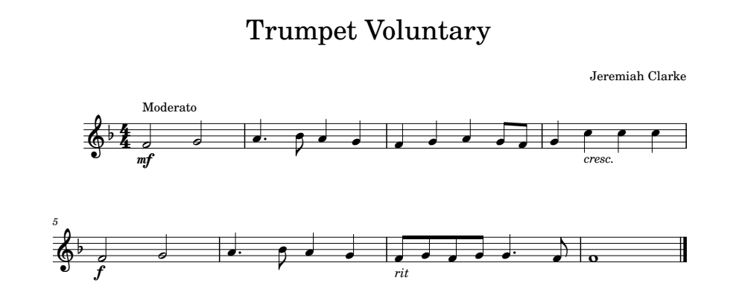
Image description:
Title: Trumpet Voluntary
Composer: Jeremiah Clarke
Tempo Marking: Moderato
Key Signature: 1 flat
Time Signature: 4 4
Bar 1: mf, 4th octave F minim, 4th octave G minim
Bar 2: 4th octave A dotted crotchet, 4th octave B quaver, 4th octave A crotchet, 4th octave G crotchet
Bar 3: 4th octave F crotchet, 4th octave G crotchet, 4th octave A crotchet, 4th octave G quaver, 4th octave F quaver
Bar 4: 4th octave G crotchet, cresc., 5th octave C crotchet, 5th octave C crotchet, 5th octave C crotchet
Bar 5: f, 4th octave F minim, 4th octave G minim
Bar 6: 4th octave A dotted crotchet, 4th octave B quaver, 4th octave A crotchet, 4th octave G crotchet
Bar 7: rit, 4th octave F quaver, 4th octave G quaver, 4th octave F quaver, 4th octave G quaver, 4th octave G dotted crotchet, 4th octave F quaver
Bar 8: 4th octave F semibreve, double barline.

,trumpet ,voluntary
,jeremiah ,clarke
,moderato4 <#d4
a >mf"qr ['j[\ ]\[hg \>cr'.??? >f"qr
f "['j[\ >rit"ghgh\'g =<k

Another common dynamic marking is the hairpin (2 lines that converge – decrescendo or diverge – crescendo). This marking may require a terminator if the hairpin is not followed by another dynamic marking, a long rest or a double barline ending the piece. Where a terminator is required, it is brailled after the effected note. If there are other signs on that note like a slur or tie the terminator should be brailled after these signs.

crescendo >c terminator >3

descrescendo >d terminator >4

Vocalise by Sieber demonstrates the use of the hairpin crescendo and decrescendo and termination sign.
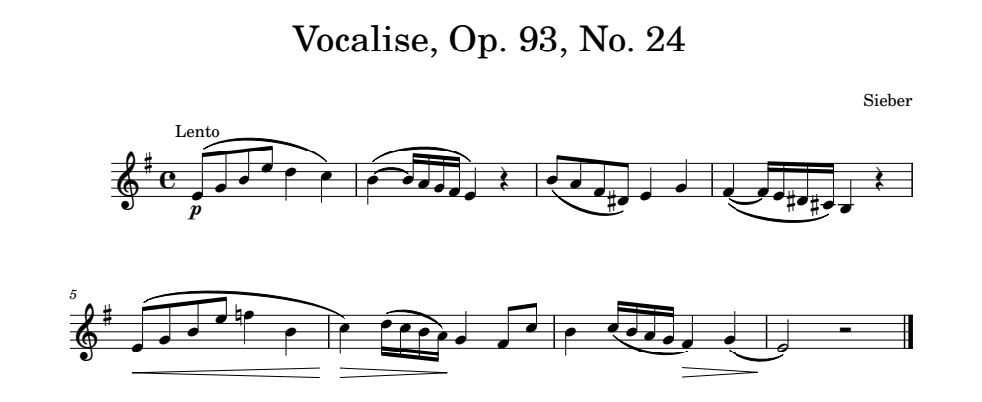
Image description:
Title: Vocalise, Op. 93, No. 24
Composer: Sieber
Tempo Marking: Lento
Key Signature: 1 sharp
Time Signature: Common time
Bar 1: p, 4th octave E quaver, slur, 4th octave G quaver, slur, 4th octave B slur, 5th octave E quaver, slur, 5th octave D crotchet, slur, 5th octave C crotchet
Bar 2: 4th octave B crotchet, tie, 4th octave B semiquaver, slur, 4th octave A semiquaver, slur, 4th octave G semiquaver, slur, 4th octave F semiquaver, slur, 4th octave E crotchet, crotchet rest
Bar 3: 4th octave B quaver, slur, 4th octave A quaver, slur, 4th octave F quaver, slur, 4th octave sharp D quaver, 4th octave E crotchet, 4th octave G crotchet
Bar 4: 4th octave F crotchet, tie, 4th octave F semiquaver, slur, 4th octave E semiquaver, slur, 4th octave sharp D semiquaver, slur, 4th octave sharp C semiquaver, 3rd octave B crotchet, crotchet rest
Bar 5: hairpin crescendo, 4th octave E quaver, slur, 4th octave G quaver, slur, 4th octave B quaver, slur, 5th octave E quaver, 5th octave natural F crotchet, slur, 4th octave B crotchet, slur, end hairpin
Bar 6: hairpin decrescendo, 5th octave C crotchet, 5th octave D semiquaver, slur, 5th octave C semiquaver, slur, 4th octave B semiquaver, slur, 4th octave A semiquaver, end hairpin, 4th octave G crotchet, 4th octave F quaver, 5th octave C quaver
Bar 7: 4th octave B crotchet, 5th octave C semiquaver, slur, 4th octave B semiquaver, slur, 4th octave A semiquaver, slur, 4th octave G semiquaver, slur, hairpin decrescendo, 4th octave F crotchet, 4th octave G crotchet, slur, end hairpin
Bar 8: 4th octave E minim, minim rest, double barline.

,vocalise1 ,op4 #ic1 ,no4 #bd
,sieber
,lento4 %.c
a >p"fcchj.f:c? w@c)ccihgc$v jcicgc%e$\
d "]@c=cfc%ec%dwv >c"fcchj.f*]"wc
f >d.?zcdcjci>4"\g.d wyccjihc>d"]\c>4
h "pu<k
Longer expressions, that is, an expression consisting of two or more words, as in a tempo in bar 9, is enclosed between a pair of word signs and must be preceded and followed by a space.
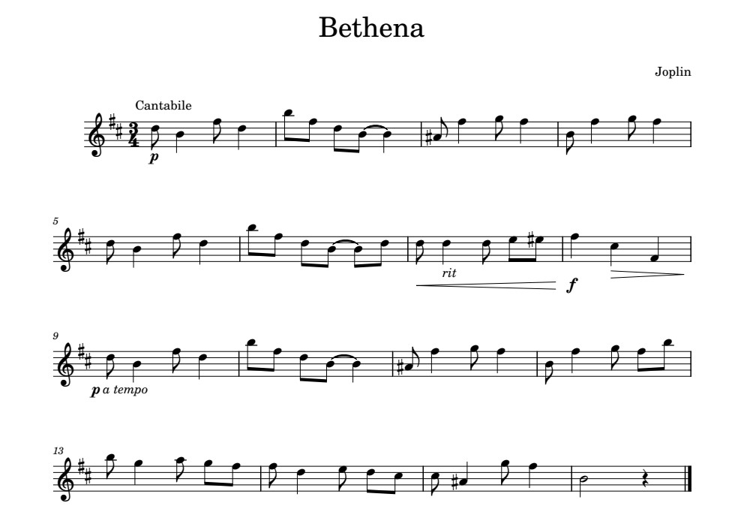

Image description:
Title: Bethena
Composer: Joplin
Tempo Marking: Cantabile
Key Signature: 2 sharps
Time Signature: 3 4
Bar 1: p, 5th octave D quaver, 4th octave B crotchet, 5th octave F quaver, 5th octave D crotchet
Bar 2: 5th octave D quaver, 5th octave F quaver, 5th octave D quaver, 4th octave B quaver, tie, 4th octave B crotchet
Bar 3: 4th octave sharp A quaver, 5th octave F crotchet, 5th octave G quaver, 5th octave F crotchet
Bar 4: 4th octave B quaver, 5th octave F crotchet, 5th octave G quaver, 5th octave F crotchet
Bar 5: 5th octave D quaver, 4th octave B crotchet, 5th octave F quaver, 5th octave D crotchet
Bar 6: 5th octave B quaver, 5th octave F quaver, 5th octave D quaver, 4th octave B quaver, tie, 4th octave B quaver, 5th octave D quaver
Bar 7: hairpin crescendo, 5th octave D quaver, rit, 5th octave D crotchet, 5th octave D quaver, 5th octave E quaver, 5th octave sharp E quaver
Bar 8: f, 5th octave F crotchet, hairpin decrescendo, 5th octave C crotchet, 4th octave F crotchet
Bar 9: a tempo, p, 5th octave D quaver, 4th octave B crotchet, 5th octave F quaver, 5th octave D crotchet
Bar 10: 5th octave B quaver, 5th octave F quaver, 5th octave D quaver, 4th octave B quaver, tie, 4th octave B crotchet
Bar 11: 4th octave sharp A quaver, 5th octave F crotchet, 5th octave G quaver, 5th octave F crotchet
Bar 12: 4th octave B quaver, 5th octave F crotchet, 5th octave G quaver, 5th octave F quaver, 5th octave B quaver
Bar 13: 5th octave B quaver, 5th octave G crotchet, 5th octave A quaver, 5th octave G quaver, 5th octave F quaver
Bar 14: 5th octave F quaver, 5th octave D crotchet, 5th octave E quaver, 5th octave D quaver, 5th octave C quaver
Bar 15: 5th octave C quaver, 4th octave sharp A crotchet, 5th octave G quaver, 5th octave F crotchet
Bar 16: 4th octave B minim, crotchet rest, double barline.

,bethena
,joplin
,cantabile4 %%#c4
a >p.ew.g: .jgej@cw %i.]h] "j.]h] ew.g:
f .jgej@cje >c.e>rit.:ef%f >f.]>d.?"]
i >a tempo> >p.ew.g: .jgej@cw %i.]h]
ab "j.]hgj j\ihg g:fed d%[.h] "tv<k

Exercise 6.1
Put the piece below into braille. Remember to centre the heading and subhead, use the word sign for the dynamic markings and most importantly don’t forget to use octave signs where needed.
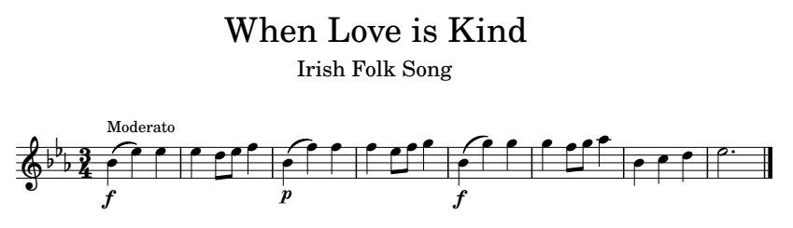

Image description:
Title: When Love is Kind
Subtitle: Irish Folk Song
Tempo Marking: Moderato
Key Signature: 3 flats
Time Signature: 3 4
Bar 1: f, 4th octave B crotchet, slur, 5th octave E crotchet, 5th octave E crotchet
Bar 2: 5th octave E crotchet, 5th octave D quaver, 5th octave E quaver, 5th octave F crotchet
Bar 3: p, 4th octave B crotchet, slur, 5th octave F crotchet, 5th octave F crotchet
Bar 4: 5th octave F crotchet, 5th octave E quaver, 5th octave F quaver, 5th octave G crotchet
Bar 5: f, 4th octave B crotchet, slur, 5th octave G crotchet, 5th octave G crotchet
Bar 6: 5th octave G crotchet, 5th octave F quaver, 5th octave G quaver, 5th octave A crotchet
Bar 7: 4th octave B crotchet, 5th octave C crotchet, 5th octave D crotchet
Bar 8: 5th octave E dotted minim, double barline.

Exercise 6.2
Below is a theme from Finlandia by Sibelius. Make sure to use hairpin terminators where needed. Also, the word express is under the stave so it will be written in the line of music and not with the key and time signatures. Although the mf comes first in the print, express will be brailled first as it is not specific to the note as the mf dynamic is.
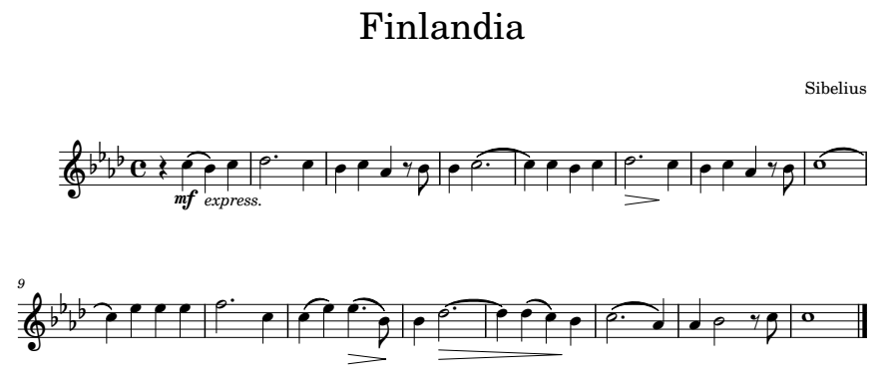

Image description:
Title: Finlandia
Composer: Sibelius
Key Signature: 4 flats
Time Signature: Common time
Bar 1: crotchet rest, express., mf, 5th octave C crotchet, slur, 4th octave B crotchet, 5th octave C crotchet
Bar 2: 5th octave D dotted minim, 5th octave C crotchet
Bar 3: 4th octave B crotchet, 5th octave C crotchet, 4th octave A crotchet, quaver rest, 4th octave B quaver
Bar 4: 4th octave B crotchet, 5th octave C dotted minim, tie
Bar 5: 5th octave C crotchet, 5th octave C crotchet, 4th octave B crotchet, 5th octave C crotchet
Bar 6: hairpin decrescendo, 5th octave D dotted minim, end hairpin, 5th octave C crotchet
Bar 7: 4th octave B crotchet, 5th octave C crotchet, 4th octave A crotchet, quaver rest, 4th octave B quaver
Bar 8: 5th octave C semibreve, tie
Bar 9: 5th octave C crotchet, 5th octave E crotchet, 5th octave E crotchet, 5th octave E crotchet
Bar 10: 5th octave F dotted minim, 5th octave C crotchet
Bar 11: 5th octave C crotchet, slur, 5th octave E crotchet, hairpin decrescendo, 5th octave E dotted crotchet, slur, 4th octave B quaver, end hairpin
Bar 12: 4th octave B crotchet, hairpin decrescendo, 5th octave D dotted minim, tie
Bar 13: 5th octave D crotchet, 5th octave D crotchet, slur, 5th octave C crotchet, end hairpin, 4th octave B crotchet
Bar 14: 5th octave C dotted minim, slur, 4th octave A crotchet
Bar 15: 4th octave A crotchet, 4th octave B minim, quaver rest, 5th octave C quaver
Bar 16: 5th octave C semibreve, double barline.

Exercise 6.3
Below is the last 7 bars of the Bassoon part from the Peer Gynt Suite by Grieg for you to put into Braille. There are a lot of dynamic changes and a tempo change. Remember that dynamics always come before the note they affect unless it is a hairpin terminator which comes after the note and slur or tie. For Bars 1 and 2 use double slurs to save cells.
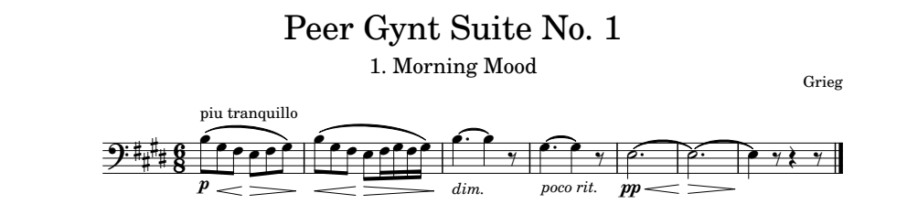
Image description:
Title: Peer Gynt Suite No. 1
Subtitle: 1. Morning Mood
Composer: Grieg
Tempo Marking: piu tranquillo
Key Signature: 4 sharps
Time Signature: 6 8
Bar 1: p, 3rd octave B quaver, slur, hairpin crescendo, 3rd octave G quaver, slur, 3rd octave F quaver, slur, hairpin decrescendo, 3rd octave E quaver, slur, 3rd octave F quaver, slur, 3rd octave G quaver
Bar 2: hairpin crescendo, 3rd octave B quaver, slur, 3rd octave G quaver, slur, 3rd octave F quaver, slur, hairpin decrescendo, 3rd octave E quaver, slur, 3rd octave F semiquaver, slur, 3rd octave G semiquaver, slur, 3rd octave F semiquaver, slur, 3rd octave G semiquaver
Bar 3: dim., 3rd octave B dotted crotchet, tie, 3rd octave B crotchet, quaver rest
Bar 4: poco rit., 3rd octave G dotted crotchet, tie, 3rd octave G crotchet, quaver rest
Bar 5: pp, hairpin crescendo, 3rd octave E dotted minim, tie
Bar 6: hairpin decrescendo, 3rd octave E dotted minim, tie, end hairpin
Bar 7: 3rd octave E crotchet, quaver rest, crotchet rest, quaver rest, double barline.

Lesson 7 Nuances and Ornaments
There are many signs used in music that must be brailled if they are in the print. This lesson will give you a cross section of signs that precede and follow a note and show you how to braille them. As there are too many to show individually, a comprehensive table of signs is available through the link.

Nuances
Articulations represented by symbols, for example staccato, accent and arpeggios, are placed before the notes affected. The note following these signs does not require an octave sign. Sometimes two or more of these signs may be used on the same note. They should be placed in the following order: arpeggio, staccato or staccatissimo, accent, tenuto.
Except for the swell, these nuances can be doubled if there are four or more successive notes. Doubling at the bottom of the braille page before the turnover must have four or more affected notes before the turnover. The doubling should be restated at the top of the next braille page only if there are four or more notes affected by the doubling.
Nuances that follow a note are breath or break marks and fermata markings.
Below are the opening four bars of Beethoven’s Fidelio Overture. It demonstrates the use of the staccato 8 (dots 2 3 6) and fermata <l which is a two cell sign (dots 1 2 6, dots 1 2 3).
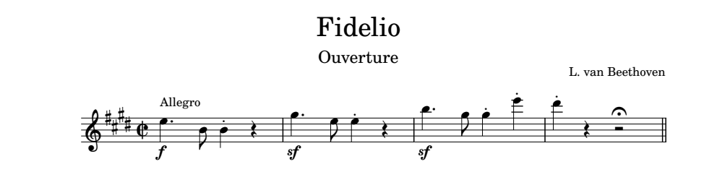
Image description:
Title: Fidelio
Subtitle: Ouverture
Composer: L. van Beethoven
Tempo Marking: Allegro
Key Signature: 4 sharps
Time Signature: cut common
Bar 1: f, 5th octave E dotted crotchet, 4th octave B quaver, staccato 4th octave B crotchet, crotchet rest
Bar 2: sf, 5th octave G dotted crotchet, 5th octave E quaver, staccato 5th octave E crotchet, crotchet rest
Bar 3: sf, 5th octave B dotted crotchet, 5th octave G quaver, staccato 5th octave G crotchet, staccato 6th octave E crotchet
Bar 4: staccato 6th octave D crotchet, crotchet rest, minim rest fermata, sectional double barline.

,fidelio
,ouverture
,l4 van ,beethoven
,aiegro4 #d%_c
a >f.$'"j8wv >sf.\'f8$v >sf.w'h8\8;$
d 8;:vu<l<k'

The excerpt below is played by the flute in Carmen by Bizet. All the notes are to be played staccato, so when putting this excerpt into braille the doubling rule can be used.
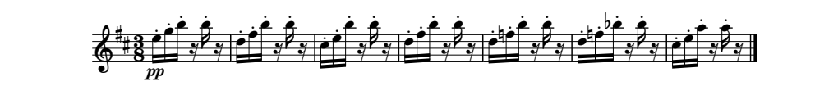
Image description:
Key signature: 2 sharps
Time signature: 3 8
All notes in excerpt are semiquavers and played staccato.
Bar 1: pp, 5th octave E, 5th octave G, 5th octave B, semiquaver rest, 5th octave B, semiquaver rest
Bar 2: 5th octave D, 5th octave F, 5th octave B, semiquaver rest, 5th octave B, semiquaver rest
Bar 3: 5th octave C, 5th octave E, 5th octave B, semiquaver rest, 5th octave B, semiquaver rest
Bar 4: 5th octave D, 5th octave F, 5th octave B, semiquaver rest, 5th octave B, semiquaver rest
Bar 5: 5th octave D, 5th octave natural F, 5th octave B, semiquaver rest, 5th octave B, semiquaver rest
Bar 6: 5th octave D, 5th octave natural F, 5th octave flat B, semiquaver rest, 5th octave B, semiquaver rest
Bar 7: 5th octave C, 5th octave E, 5th octave A, semiquaver rest, 5th octave A, semiquaver rest, double barline.

%%#c8
a >pp'88.&()m)m .z=)m)m .y&)m)m .z=)m)m
e .z*=)m)m .z*=<)m)m .y&!m8!m<k

Below is a D major scale and arpeggio showing different articulations. Bar 1 has the mezzo-staccato "8 (dot 5 dots 2 3 6), bar 2 has the accent .8 (dots 4 6 dots 2 3 6) and bar 3 has the tenuto _8 (dots 4 5 6 dot 2 3 6). The final note has a swell *' (dots 1 6 dot 3) and a fermata.
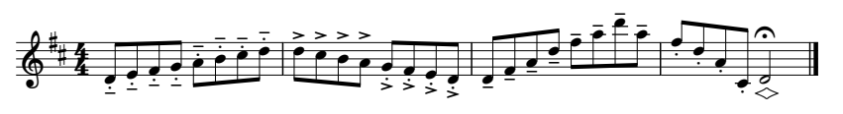

Image description:
Key Signature: 2 sharps
Time Signature: 4 4
Bar 1: all notes are played mezzo-staccato and are quavers, 4th octave D, E, F, G, A, B, C, D
Bar 2: all notes are quavers, first 4 notes are accented, 5th octave D, C, B, A, next four notes are played with a staccato accent, 4th octave G, F, E, D
Bar 3: all notes are quavers and played tenuto, 4th octave D, F, A, 5th octave D, F, A, 6th octave D, 5th octave A
Bar 4: first four notes are quavers played staccato, 5th octave F, D, 4th octave A, 4th octave C, swell 4th octave D minim, fermata, double barline.
%%#d4
a "8"8"efghijd"8e .8.8edji88hgf8.8e
c _8_8"egi.egi;e_8.i 8g8e8"i8"d*'o<l<k

Ornaments
There are many different ornament symbols. Throughout music history the same symbol may be known by different names and even be interpreted differently depending on the composer and time. It is recommended that when transcribing music into braille to look at the appearance of the symbol when deciding which braille sign to use.
There are too many ornaments to mention in this lesson. Like nuances there is a more comprehensive list for your reference which can be found though the link.

Appoggiaturas
An appoggiatura is a small note printed before a note. A short appoggiatura has a slash through the stem while a long appoggiatura does not. The appoggiatura sign is brailled before the small note and before an accidental and/or octave sign. If an appoggiatura is a group of semiquavers, braille grouping is never used. However, as an appoggiatura is not included as a beat in a bar or measure grouping of semiquavers can still be done. The appoggiatura sign can be doubled if there are four or more consecutive appoggiaturas.
Short appoggiatura 5 (dots 2 6)
Long appoggiatura "5 (dot 5 dots 2 6)

Trills
A trill sign, 6 (dot 2 3 5), is placed immediately before the affected note or accidental or octave sign. If a trill is shown with an accidental, usually written above, then the accidental is written before the trill sign. The trill sign may also be doubled if there is a series of four or more trills. A trill affected by an accidental is considered an interruption to the series of four notes.

If a trill appears with a wavy line over two or more consecutive notes, as in tied notes, then a line of continuation, indicated by 2 dot 3s, is used and it is terminated after the last affected note by >' (dots 3 4 5, dot 3).

Turns (see table for signs)
A turn sign is written before the affected note regardless of its position in print. If a turn symbol is printed directly above or below the note, then that is represented by preceding the sign with a dot 6. Turns can be affected by accidentals and can be written above or below the turn and both positions have significant meaning to the performer. If an accidental sign is above a turn, then the accidental is written first followed by the turn. If an accidental is below the turn, then a dot 6 is placed before the accidental. If an accidental is written above and below a turn then the upper accidental is written first, followed by the lower accidental which is preceded by dot 6 and then the turn sign.

Mordents (see table for signs)
Mordents follow the same rules as turns. It is brailled before the affected note. A mordent affected by an accidental, which can be shown above or below a mordent symbol, is brailled before the mordent symbol.

Glissando
A glissando, @a (dot 4 dot 1), can be represented by a wavy or straight line between two notes in print. The glissando symbol is placed after the first note. If the word “glissando” is written on the music, it is not necessary to show it in braille. The exception being if the braille is a facsimile or exact copy.
Below is an excerpt from the Peer Gynt Suite by Greig. These four bars from the violin line at figure A, show the use of dynamics, accent, slur, and appoggiatura.
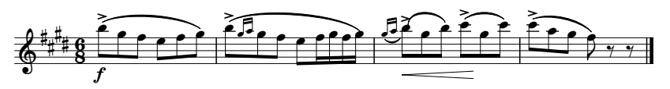

Key Signature: 4 sharps
Time Signature: 6 8
Bar 1: f, accent, 5th octave B quaver, slur, 5th octave G quaver, slur, 5th octave F quaver, slur, 5th octave E quaver, slur, 5th octave F quaver, slur, 5th octave G quaver
Bar 2: accent, 5th octave B quaver, slur, long appoggiatura 5th octave G semiquaver, long appoggiatura 5th octave A semiquaver, 5th octave G quaver, slur, 5th octave F quaver, slur, 5th octave E quaver, slur, 5th octave F semiquaver, slur, 5th octave G semiquaver, slur, 5th octave F semiquaver, slur, 5th octave G semiquaver
Bar 3: long appoggiatura 5th octave G semiquaver, slur, long appoggiatura 5th octave A semiquaver, slur, hairpin crescendo, accent 5th octave B quaver, slur, 5th octave G quaver, slur, 5th octave B quaver, accent, 5th octave C quaver, slur, hairpin terminator, 5th octave G quaver, slur, 5th octave C quaver
Bar 4: accent, 6th octave C quaver, slur, 5th octave A quaver, slur, 5th octave G quaver, slur, 5th octave F quaver, quaver rest, quaver rest, double barline.

#d%#f8
a >f.8.jcchgfgch .8jcc"5("5!hgf=(=c(
c "5.(c"5!c>c.8.jchcj.8dc>3.hc;d
d .8;dcichcgxx<k

The excerpt below is from the opening violin line from Rondo in A für Klavier und Orchester, KV 386 by Mozart. The upside down triangle on the first beat of bar 1, 2 and 6 is a staccatissimo. The braille symbol is ,8 (dot 6, dot 2 3 6).
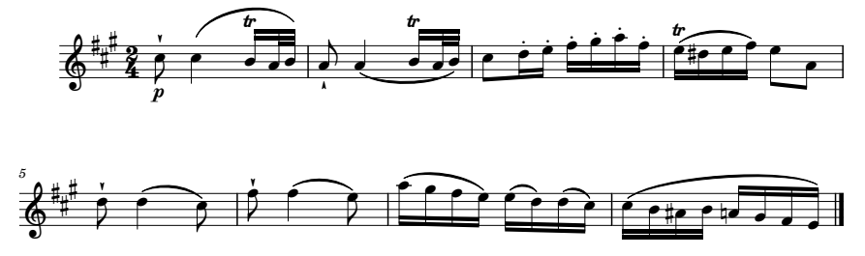

Image description:
Key signature: 3 sharps
Time signature: 2 4
Bar 1: p, staccatissimo, 5th octave C quaver, 5th octave C crotchet, slur, trill, 4th octave B semiquaver, slur, 4th octave A demisemiquaver, slur, 4th octave B demisemiquaver
Bar 2: staccatissimo, 4th octave A quaver, 4th octave A crotchet, slur, trill, 4th octave B semiquaver, slur, 4th octave A demisemiquaver, slur, 4th octave B demisemiquaver
Bar 3: 5th octave C quaver, 5th octave staccato D semiquaver, 5th octave staccato E semiquaver, 5th octave staccato F semiquaver, 5th octave staccato G semiquaver, 5th octave staccato A semiquaver, 5th octave staccato F semiquaver
Bar 4: trill 5th octave E semiquaver, slur, 5th octave sharp D semiquaver, slur, 5th octave E semiquaver, slur, 5th octave F semiquaver, 5th octave E quaver, 4th octave A quaver
Bar 5: staccatissimo, 5th octave D quaver, 5th octave D crotchet, slur, 5th octave C quaver
Bar 6: staccatissimo, 5th octave F quaver, 5th octave F crotchet, slur, 5th octave E quaver
Bar 7: 5th octave A semiquaver, slur, 5th octave G semiquaver, slur, 5th octave F semiquaver, slur, 5th octave E semiquaver, 5th octave E semiquaver, slur, 5th octave D semiquaver, 5th octave D semiquaver, slur, 5th octave C semiquaver
Bar 8: 5th octave C semiquaver, slur, 4th octave B semiquaver, slur, 4th octave sharp A semiquaver, slur, 4th octave B semiquaver, slur, 4th octave natural A semiquaver, slur, 4th octave G semiquaver, slur, 4th octave F semiquaver, slur, 4th octave E semiquaver, double barline.

%%%#b4
a >p,8.d?c6)csct ,8i[c6)csct d88z&=hi8g
d 6.&c%zc&c=f"i ,8.e:cd ,8g]cf
g .!chcgcf&ceecd yccj%ij*!hgcf<k

This next short excerpt is from The Golden Sonata for Recorder by Purcell. It demonstrates the use of a mordent and break mark. As a transcriber an interpretation of the score and composer’s intent may be necessary. The mark in bar 3 before the A quaver is interpreted as a break mark rather than a breath mark. Firstly, because of its position in the music and secondly because it looks like a stroke rather than a comma or tick which are more associated as breath marks.
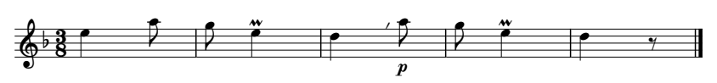

Image description:
Key Signature: 1 flat
Time Signature: 3 8
Bar 1: 5th octave E crotchet, 5th octave A quaver
Bar 2: 5th octave G quaver, upper mordent 5th octave E crotchet
Bar 3: 5th octave D crotchet, break mark, p, 5th octave A quaver
Bar 4: 5th octave G quaver, upper mordent, 5th octave E crotchet
Bar 5: 5th octave D crotchet, quaver rest, double barline.

<#c8
a .$i h"6$ :,/>p.i h"6$ :x<k

This next excerpt is from a Gigue by Couperin. In these 3 short bars he uses a turn, grace notes before and after the note and an upper and lower mordent.
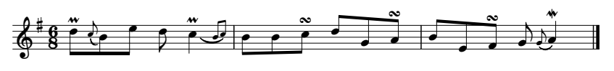

Image description:
Key Signature: 1 sharp
Time Signature: 6 8
Bar 1: upper mordent, 5th octave D quaver, long appoggiatura 5th octave C quaver, slur, 4th octave B quaver, 5th octave E quaver, 5th octave D quaver, upper mordent, 5th octave C crotchet, slur, long appoggiatura 4th octave B quaver, slur, long appoggiatura 5th octave C quaver
Bar 2: 4th octave B quaver, 4th octave B quaver, turn above note 5th octave C quaver, 5th octave D quaver, 4th octave G quaver, turn above note 4th octave A quaver
Bar 3: 4th octave B quaver, 4th octave E quaver, turn above note 4th octave F quaver, 4th octave G quaver, long appoggiatura 4th octave G quaver, slur, lower mordent, 4th octave A crotchet, double barline.
%#f8
a "6.e"5dcj.fe"6?c"5jc"5d jj,4de"h,4i
c "jf,4gh"5hc"6l[<k
The example below is of a glissando. Even though the word gliss is printed on the line indicating the glissando it is not necessary to include the word in braille.
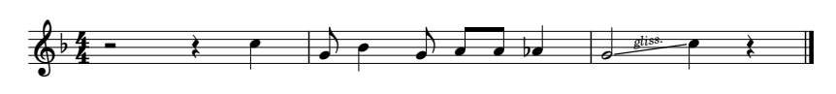

Image description:
Key signature: 1 flat
Time signature: 4 4
Bar 1: minim rest, crotchet rest, 5th octave C crotchet
Bar 2: 4th octave G quaver, 4th octave B crotchet, 4th octave G quaver, 4th octave A quaver, 4th octave A quaver, 4th octave flat A crotchet
Bar 3: 4th octave G minim, glissando, 5th octave C crotchet, crotchet rest.

<#d4
a uv.? "hwhii<[ r@a.?v<k

Exercise 7.1
Put the piece Tom Dooley into braille. Remember to centre the heading and number the bars.
Beware the first bar as it starts with a dynamic marking and the first note has a flat.
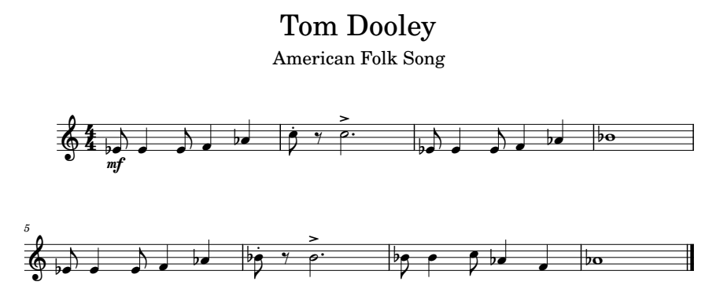

Image description:
Title: Tom Dooley
Subtitle: American Folk Song
Key Signature: no sharps or flats
Time Signature: 4 4
Bar 1: mf, 4th octave flat E quaver, 4th octave E crotchet, 4th octave E quaver, 4th octave F crotchet, 4th octave flat A crotchet
Bar 2: staccato 5th octave C quaver, quaver rest, accent 5th octave C dotted minim
Bar 3: 4th octave flat E quaver, 4th octave E crotchet, 4th octave E quaver, 4th octave F crotchet, 4th octave flat A crotchet
Bar 4: 4th octave flat B semibreve
Bar 5: 4th octave flat E quaver, 4th octave E crotchet, 4th octave E quaver, 4th octave F crotchet, 4th octave flat A crotchet
Bar 6: staccato 4th octave flat B quaver, quaver rest, accent 4th octave B dotted minim
Bar 7: 4th octave flat B quaver, 4th octave B crotchet, 5th octave C quaver, 4th octave flat A crotchet, 4th octave F crotchet
Bar 8: 4th octave flat A semibreve

Exercise 7.2
Put the below excerpt from Haydn Sonata in Ab major into braille. Remember to group the semiquavers and number the bars.
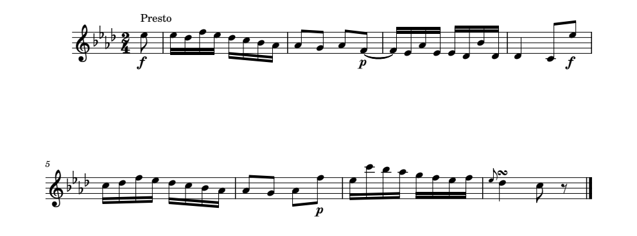
Image description:
Tempo Marking: Presto
Key Signature: 4 flats
Time Signature: 2 4
Bar 0: f, 5th octave E quaver
Bar 1: group of 4 semiquavers 5th octave E, 5th octave D, 5th octave F, 5th octave E, group of 4 semiquavers 5th octave D, 5th octave C, 4th octave B, 4th octave A
Bar 2: 4th octave A quaver, 4th octave G quaver, 4th octave A quaver, p, 4th octave F quaver, tie
Bar 3: group of 4 semiquavers 4th octave F, 4th octave E, 4th octave A, 4th octave E, group of 4 semiquavers 4th octave E, 4th octave D, 4th octave B, 4th octave D
Bar 4: 4th octave D crotchet, 4th octave C quaver, f, 5th octave E quaver
Bar 5: group of 4 semiquavers 5th octave C, 5th octave D, 5th octave F, 5th octave E, group of 4 semiquavers 5th octave D, 5th octave C, 4th octave B, 4th octave A
Bar 6: 4th octave A quaver, 4th octave G quaver, 4th octave A quaver, p, 5th octave F quaver
Bar 7: group of 4 semiquavers 5th octave E, 6th octave C, 5th octave B, 5th octave A, group of 4 semiquavers 5th octave G, 5th octave F, 5th octave E, 5th octave F
Bar 8: long appoggiatura 5th octave E quaver, turn above note, 5th octave D crotchet, 5th octave C quaver, quaver rest, double barline

Exercise 7.3
The excerpt below is from a Menuet by Handel. Put it into braille and be careful to use the correct mordent sign.
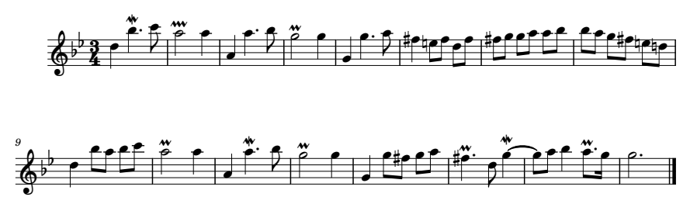

Image description:
Key Signature: 2 flats
Time Signature: 3 4
Bar 1: 5th octave D crotchet, lower mordent, 5th octave B dotted crotchet, 6th octave C quaver
Bar 2: Extended upper mordent, 5th octave A minim, 5th octave A crotchet
Bar 3: 4th octave A crotchet, 5th octave A dotted crotchet, 5th octave B quaver
Bar 4: Upper mordent, 5th octave G minim, 5th octave G crotchet
Bar 5: 4th octave G crotchet, 5th octave G dotted crotchet, 5th octave A quaver
Bar 6: 5th octave sharp F crotchet, 5th octave natural E quaver, 5th octave F quaver, 5th octave D quaver, 5th octave F quaver
Bar 7: 5th octave sharp F quaver, 5th octave G quaver, 5th octave G quaver, 5th octave A quaver, 5th octave A quaver, 5th octave B quaver
Bar 8: 5th octave B quaver, 5th octave A quaver, 5th octave G quaver, 5th octave sharp F quaver, 5th octave natural E quaver, 5th octave natural D quaver
Bar 9: 5th octave D crotchet, 5th octave B quaver, 5th octave A quaver, 5th octave B quaver, 6th octave C quaver
Bar 10: Upper mordent, 5th octave A minim, 5th octave A crotchet
Bar 11: 4th octave A crotchet, lower mordent, 5th octave A dotted crotchet, 5th octave B quaver
Bar 12: Upper mordent, 5th octave G minim, 5th octave G crotchet
Bar 13: 4th octave G crotchet, 5th octave G quaver, 5th octave sharp F quaver, 5th octave G quaver, 5th octave A quaver
Bar 14: Upper mordent, 5th octave sharp F dotted crotchet, 5th octave D quaver, lower mordent, 5th octave G crotchet, tie
Bar 15: 5th octave G quaver, 5th octave A quaver, 5th octave B crotchet, upper mordent, 5th octave A dotted quaver, 5th octave G semiquaver
Bar 16: 5th octave G dotted minim, double barline.

Exercise 7.4
This short excerpt is from the Classical Symphony, Op. 25 by Prokofiev. Be mindful of the order of signs in bars 2 and 6, an ornament comes before an expression eg accent.
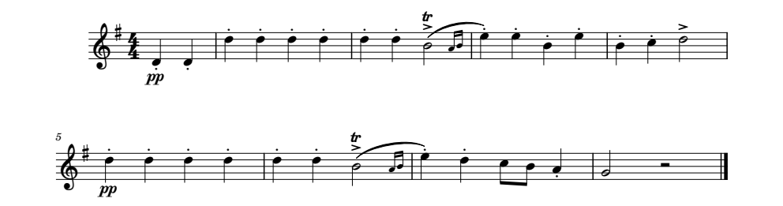

Image description:
Key Signature: 1 sharp
Time Signature: 4 4
Bar 0: pp, staccato, 4th octave D crotchet, staccato, 4th octave D crotchet
Bar 1: staccato, 5th octave D crotchet – 4 times
Bar 2: staccato, 5th octave D crotchet, staccato, 5th octave D crotchet, trill, accent, 4th octave B minim, slur, long appoggiatura 4th octave A semiquaver, slur, long appoggiatura 4th octave B semiquaver, slur
Bar 3: staccato 5th octave E crotchet, staccato 5th octave E crotchet, staccato 4th octave B crotchet, staccato 5th octave E crotchet
Bar 4: staccato 4th octave B crotchet, staccato 5th octave C crotchet, accent 5th octave D minim
Bar 5: pp, staccato, 5th octave D crotchet – 4 times
Bar 6: staccato 5th octave D crotchet, staccato 5th octave D crotchet, trill, accent, 4th octave B minim, slur, long appoggiatura 4th octave A semiquaver, slur, long appoggiatura 4th octave B semiquaver, slur
Bar 7: staccato 5th octave E crotchet, staccato 5th octave D crotchet, 5th octave C quaver, 4th octave B quaver, staccato 4th octave A crotchet
Bar 8: 4th octave G minim, minim rest, double barline.

Lesson 8 Irregular Note Groupings

Triplets
Triplets are a rhythmic device where three notes are played in the time of two, for example, 3 quavers played in the time of 2 quavers or 3 crotchets played in the time of 2 crotchets. Triplets are the most common irregular note grouping. A triplet of any value is indicated by 2 (dots 2 3) and placed before the first note of the triplet. This sign can be double when there are four or more consecutive triplets of the same value.
These two bars from Beethoven’s Symphony No. 6 in F demonstrate the use of the triplet sign.
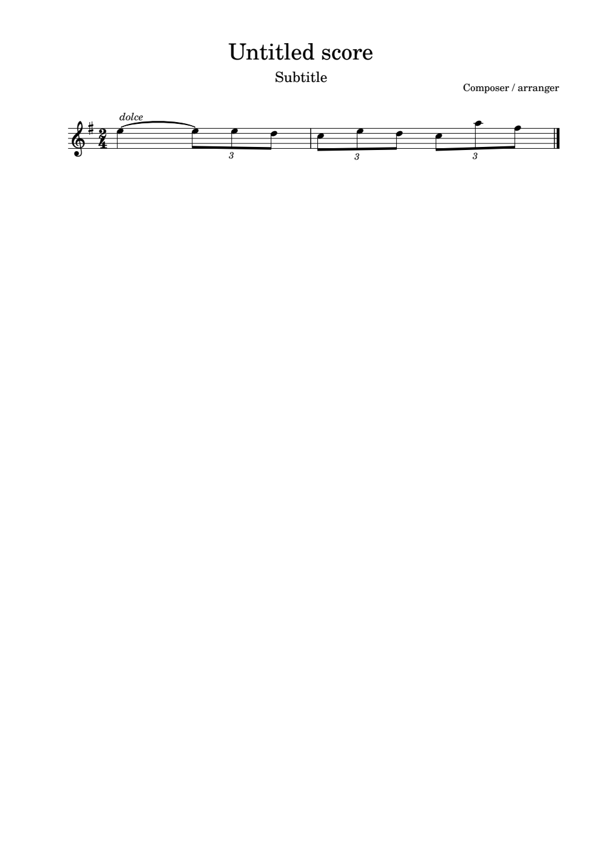

Image description:
Key signature: 1 sharp
Time signature: 2 4
Bar 1: dolce, 5th octave E crotchet, tie, triplet, 5th octave E quaver, 5th octave E quaver, 5th octave D quaver
Bar 2: triplet, 5th octave C quaver, 5th octave E quaver, 5th octave D quaver, triplet, 5th octave C quaver, 5th octave A quaver, 5th octave F quaver, double barline.

%#b4
a >dolce.$@c2ffe 2dfe2d.ig<k

The example below from Clarinet Quintet in B flat by Weber shows doubling of the triplet sign. To terminate the doubled triplet, a triplet sign is placed before the last triplet in the sequence. As the triplets are semiquavers the first semiquaver of each group of three shows the value except in bar 4 - 7 where a triplet is followed by a quaver.

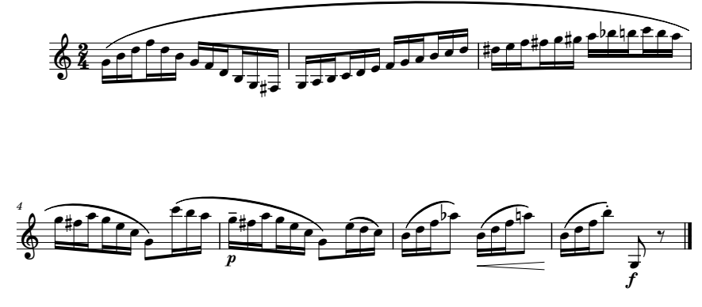

Image description:
Key signature: no sharps or flats
Time signature: 2 4
Bar 1: open bracket slur, triplet sign doubled and all triplets are semiquavers, 4th octave G, 4th octave B, 5th octave D, 5th octave F, 5th octave D, 4th octave B, 4th octave G, 4th octave F, 4th octave D, 3rd octave B, 3rd octave G, 3rd octave sharp F
Bar 2: 3rd octave G, 3rd octave A, 3rd octave B, 4th octave C, 4th octave D, 4th octave E, 4th octave F, 4th octave G, 4th octave A, 4th octave B, 5th octave C, 5th octave D
Bar 3: 5th octave sharp D, 5th octave E, 5th octave F, 5th octave sharp F, 5th octave G, 5th octave sharp G, 5th octave A, 5th octave flat B, 5th octave natural B, 6th octave C, 5th octave B, 5th octave A
Bar 4: 5th octave G, 5th octave sharp F, 5th octave A, triplet, 5th octave G, 5th octave E, 5th octave C, 4th octave G quaver, close bracket slur, open bracket slur, triplet, 6th octave C semiquaver, 5th octave B semiquaver, 5th octave A semiquaver
Bar 5: p, triplet, tenuto, 5th octave G semiquaver, 5th octave sharp F, 5th octave A semiquaver, triplet, 5th octave G semiquaver, 5th octave E semiquaver, 5th octave C semiquaver, 4th octave G quaver, close bracket slur, triplet, 5th octave E semiquaver, slur, 5th octave D semiquaver, slur, 5th octave C
Bar 6: triplet, 4th octave B semiquaver, slur, 5th octave D semiquaver, slur, 5th octave F semiquaver, slur, 5th octave A quaver, hairpin crescendo, triplet, 4th octave B semiquaver, slur, 5th octave D semiquaver, slur, 5th octave F semiquaver, slur, 5th octave natural A quaver, end hairpin
Bar 7: triplet, 4th octave B semiquaver, slur, 5th octave D semiquaver, slur, 5th octave D semiquaver, slur, staccato, 5th octave B quaver, f, 3rd octave G quaver, quaver rest, double barline.
#b4
a ;b22"(je=ej(ge)h%g (ijyef=hi)de
c %.zfg%=h%h!<j*jyji (%gi2(&y"h^2;b2;yji
e >p'2_8.(%gi2(&y"h^22.&cecd
f 2")czc=c<i>c")czc=c*i>3
g 2")czc=c8j>f_hx<k

Three or Four-cell sign for Irregular Groupings
This sign is used to indicate an irregular grouping of notes other than three. The three-cell (four cells if the grouping is larger than nine) group is dots 4 5 6 followed by the numeral in the lower part of the cell and then a dot 3. For example, _5' (dots 4 5 6, dots 2 6, dot 3) would indicate an irregular grouping of five notes. This sign can also be doubled when there are four or more consecutive groups and it would look like this: _6_6' (dots 4 5 6, dots 2 3 5, dots 4 5 6, dots 2 3 5, dot 3). An octave sign must be used on the first note after the three or four cell sign. To terminate the doubling, the three cell irregular group sign is placed before the last note to be doubled, the same way in which a triplet is terminated.
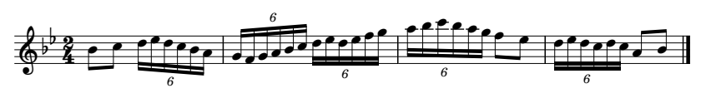

Image description:
Key signature: 2 flats
Time signature: 2 4
Bar 1: 4th octave B quaver, 5th octave C quaver, grouping of 6 doubled and all notes are semiquavers, 5th octave D, 5th octave E, 5th octave D, 5th octave C, 5th octave B, 5th octave A
Bar 2: 4th octave G, 4th octave F, 4th octave G, 4th octave A, 4th octave B, 5th octave C, 5th octave D, 5th octave E, 5th octave D, 5th octave E, 5th octave F, 5th octave G
Bar 3: grouping of 6 sign, 5th octave A, 5th octave B, 6th octave C, 5th octave B, 5th octave A, 5th octave G, 5th octave F quaver, 5th octave E quaver
Bar 4: grouping of 6, 5th octave D semiquaver, 5th octave E semiquaver, 5th octave D semiquaver, 5th octave C semiquaver, 5th octave D semiquaver, 5th octave C semiquaver, 4th octave A quaver, 4th octave B quaver, double barline.
<<#b4
a "jd_6_6'.zfedji (ghijdzfefgh
c _6'.!)y)!(gf _6'.z&zyzyij<k

If there are triplets among other irregular grouped notes, then the triplets should be indicated by the three-cell sign not the single cell sign.
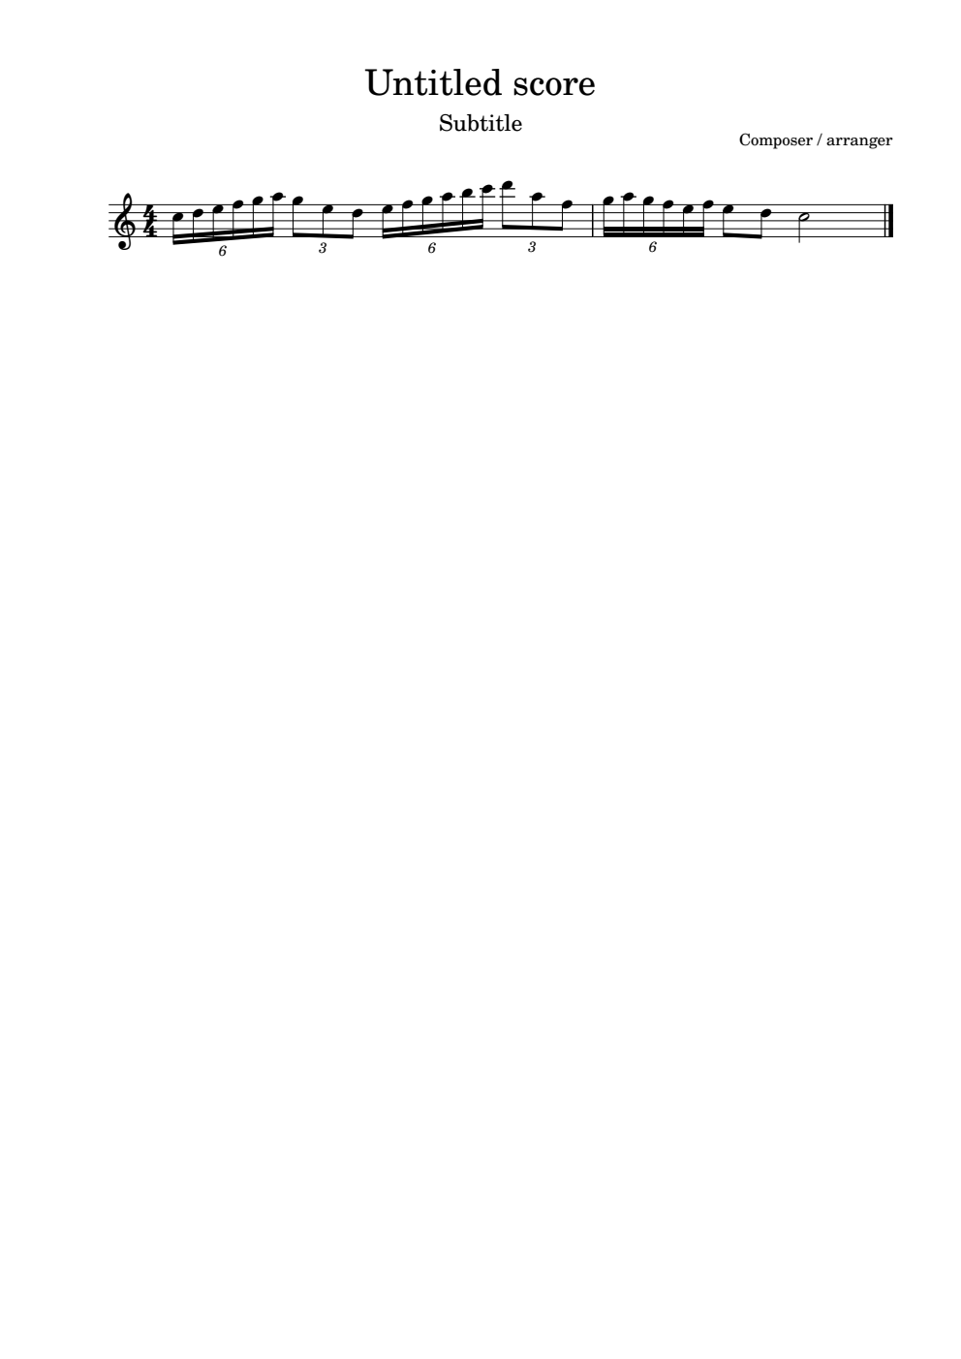

Image description:
Key signature: no sharps or flats
Time signature: 4 4
Bar 1: grouping of 6 semiquavers, 5th octave C, 5th octave D, 5th octave E, 5th octave F, 5th octave G, 5th octave A, grouping of 3 quavers, 5th octave G, 5th octave E, 5th octave D, grouping of 6 semiquavers, 5th octave E, 5th octave F, 5th octave G, 5th octave A, 5th octave B, 6th octave C, grouping of 3 quavers, 6th octave D, 5th octave A, 5th octave F
Bar 2: grouping of 6 semiquavers, 5th octave G, 5th octave A, 5th octave G, 5th octave F, 5th octave E, 5th octave F, 5th octave E quaver, 5th octave D quaver, 5th octave C minim, double barline.
#d4
a _6'.yz&=(!_3'.hfe_6'.&=(!)y_3';e.ig
b _6'.(!(=&=fen<k

Sometimes a number for an irregular grouping is not always present in print and the numeral is necessary with a three-cell sign. When the transcriber needs to provide the missing number then a dot 5 must precede the grouping sign. In the case of triplets, absence of a print numeral does not affect the braille as shown in the Weber Clarinet Quintet above.

Exercise 8.1
The excerpt below is from Fairy Tales for clarinet, viola and piano by Robert Schumann. Put it into braille and remember to number the bars and use octave signs as needed.
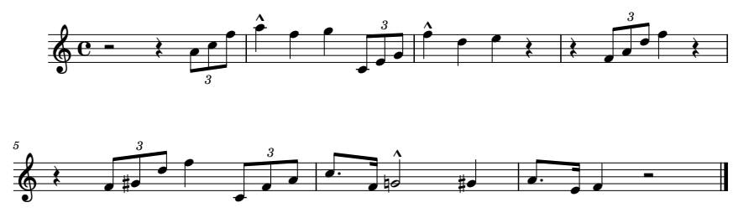

Image description:
Key signature: no sharps or flats
Time signature: common time
Bar 1: minim rest, crotchet rest, triplet, 4th octave A quaver, 5th octave C quaver, 5th octave F quaver
Bar 2: martellato, 5th octave A crotchet, 5th octave F crotchet, 5th octave G crotchet, triplet, 4th octave C quaver, 4th octave E quaver, 4th octave G quaver
Bar 3: martellato, 5th octave F crotchet, 5th octave D crotchet, 5th octave E crotchet, crotchet rest
Bar 4: crotchet rest, triplet, 4th octave F quaver, 4th octave A quaver, 5th octave D quaver, 5th octave F crotchet, crotchet rest
Bar 5: crotchet rest, triplet, 4th octave F quaver, 4th octave sharp G quaver, 5th octave D quaver, 5th octave F crotchet, triplet, 4th octave C quaver, 4th octave F quaver, 4th octave A quaver
Bar 6: 5th octave C dotted quaver, 4th octave F semiquaver, martellato, 4th octave natural G minim, 4th octave sharp G crotchet
Bar 7: 4th octave A dotted quaver, 4th octave E semiquaver, 4th octave F crotchet, minim rest, double barline.

Exercise 8.2
The extract below is from Golden Wedding. Put it into braille remembering to double the triplet sign, number the bars and use octave signs where needed.

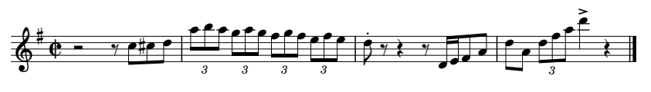

Image description:
Key signature: 1 sharp
Time signature: cut common
Bar 1: minim rest, quaver rest, 5th octave C quaver, 5th octave sharp C quaver, 5th octave D quaver
Bar 2: triplet, 5th octave A quaver, 5th octave B quaver, 5th octave A quaver, triplet, 5th octave G quaver, 5th octave A quaver, 5th octave G quaver, triplet, 5th octave F quaver, 5th octave G quaver, 5th octave F quaver, triplet, 5th octave E quaver, 5th octave F quaver, 5th octave E quaver
Bar 3: staccato, 5th octave D quaver, quaver rest, crotchet rest, quaver rest, 4th octave D semiquaver, 4th octave E semiquaver, 4th octave F quaver, 4th octave A quaver
Bar 4: 5th octave D quaver, 4th octave A quaver, triplet, 5th octave D quaver, 5th octave F quaver, 5th octave A quaver, accent, 6th octave D crotchet, crotchet rest, double barline.

Exercise 8.3
The excerpt below is from a Sonata by Brahms. Put it into braille.

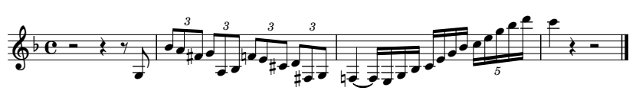

Image description:
Key signature: 1 flat
Time signature: common time
Bar 1: minim rest, crotchet rest, quaver rest, 3rd octave G quaver
Bar 2: triplet, 4th octave B quaver, 4th octave A quaver, 4th octave sharp F quaver, triplet, 4th octave G quaver, 3rd octave A quaver, 3rd octave B quaver, triplet, 4th octave natural F quaver, 4th octave E quaver, 4th octave sharp C quaver, triplet, 4th octave D quaver, 3rd octave sharp F quaver, 3rd octave G quaver.
Bar 3: 3rd octave natural F crotchet, tie, grouping of 4 semiquavers 3rd octave F, 3rd octave E, 3rd octave G, 3rd octave B, grouping of 4 semiquavers 4th octave C, 4th octave E, 4th octave G, 4th octave B, grouping of 5 semiquavers, 5th octave C, 5th octave E, 5th octave G, 5th octave B, 6th octave D
Bar 4: 6th octave C crotchet, crotchet rest, minim rest, double bar line.

Lesson 9 Print Repeats

Beginning and End Repeats
Print repeats are common in music. A repeat sign has two dots in the 2nd and 3rd space on the stave which either follow (beginning repeat) or precede (end repeat) a double barline: { }. In braille, the one indicating the start of a repeated passage is <7 (dots 1 2 6, dots 2 3 5 6). The repeat where the dots precede the double barline, indicating the end of the passage to be repeated is represented in braille by <2 (dots 1 2 6, dot 2 3). A repeat sign is part of the bar (measure) and therefore there is no space between the sign and bar to which it is attached. However, a space must follow a repeat sign as shown in the example The Jolly Miller. The first note following either of these signs must have an octave sign.
Below is the opening phrase of Good King Wenceslas showing a simple end repeat sign.
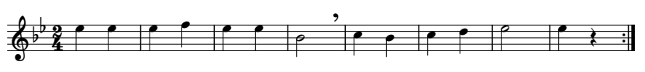

Image description:
Key signature: 2 flats
Time signature: 2 4
Bar 1: 5th octave E crotchet, 5th octave E crotchet
Bar 2: 5th octave E crotchet, 5th octave F crotchet
Bar 3: 5th octave E crotchet, 5th octave E crotchet
Bar 4: 4th octave B minim, breath mark
Bar 5: 5th octave C crotchet, 4th octave B crotchet
Bar 6: 5th octave C crotchet, 5th octave D crotchet
Bar 7: 5th octave E minim
Bar 8: 5th octave E crotchet, crotchet rest, end repeat sign.

<<#b4
a .$$ $] $$ "t>1 ?w ?: p $v<2

The example below is the soprano line of a choral arrangement of Prelude in C minor by Chopin which shows the use of the beginning and end repeat sign within the excerpt. Note the use of octave signs after the repeat sign and where the signs are placed in the braille.
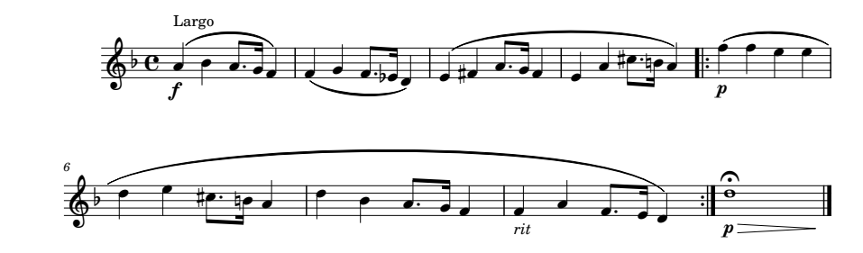
Image description:
Tempo Marking: Largo
Key signature: 1 flat
Time signature: common time
Bar 1: f, 4th octave A crotchet, slur, slur, 4th octave A crotchet, 4th octave A dotted quaver, 4th octave G semiquaver, slur, 4th octave F crotchet
Bar 2: 4th octave F crotchet, slur, slur, 4th octave G crotchet, 4th octave F dotted quaver, 4th octave flat E semiquaver, slur, 4th octave D crotchet
Bar 3: 4th octave E crotchet, slur, slur, 4th octave sharp F crotchet, 4th octave A dotted quaver, 4th octave G semiquaver, 4th octave F crotchet
Bar 4: 4th octave E crotchet, 4th octave A crotchet, 5th octave sharp C dotted quaver, 4th octave natural B semiquaver, slur, 4th octave A crotchet
Bar 5: start repeat, open bracket slur, p, 5th octave F crotchet, 5th octave F crotchet, 5th octave E crotchet, 5th octave E crotchet
Bar 6: 5th octave D crotchet, 5th octave E crotchet, 5th octave sharp C dotted quaver, 4th octave natural B semiquaver, 4th octave A crotchet
Bar 7: 5th octave D crotchet, 4th octave B crotchet, 4th octave A dotted quaver, 4th octave G semiquaver, 4th octave F crotchet
Bar 8: rit, 4th octave F crotchet, 4th octave A crotchet, 4th octave F dotted quaver, 4th octave E semiquaver, 4th octave D crotchet, close bracket slur, end repeat sign
Bar 9: p, hairpin decrescendo, 4th octave D semibreve, fermata over note, double barline.

,largo4 <.c
a >f"[ccwi'(c] ]cc\f'<&c: $cc%]i'(]
d "$[%d'*)c[ <7;b>p.]]$$ :$%d'*)[
g .:wi'(] >rit"][g'&:^2<2 >p>d.z<l<k

In the next example, the repeat sign occurs within a bar (measure). A music hyphen, dot 5, is used to separate the repeat sign from the rest of the bar. This shows that the rest of the bar will follow after a space, since there must be a space after a repeat sign.

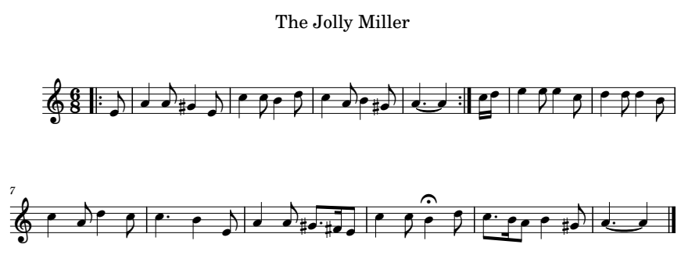

Image description:
Title: The Jolly Miller
Key signature: no sharps or flats
Time signature: 6 8
Bar 0: beginning repeat, 4th octave E quaver
Bar 1: 4th octave A crotchet, 4th octave A quaver, 4th octave sharp G crotchet, 4th octave E quaver
Bar 2: 5th octave C crotchet, 5th octave C quaver, 4th octave B crotchet, 5th octave D quaver
Bar 3: 5th octave C crotchet, 4th octave A quaver, 4th octave B crotchet, 4th octave sharp G quaver
Bar 4: 4th octave A dotted crotchet, tie, 4th octave A crotchet, end repeat, space, music hyphen, 5th octave C semiquaver, 5th octave D semiquaver
Bar 5: 5th octave E crotchet, 5th octave E quaver, 5th octave E crotchet, 5th octave C quaver
Bar 6: 5th octave D crotchet, 5th octave D quaver, 5th octave D crotchet, 4th octave B quaver
Bar 7: 5th octave C crotchet, 4th octave A quaver, 5th octave D crotchet, 5th octave C quaver
Bar 8: 5th octave C dotted crotchet, 4th octave B crotchet, 4th octave E quaver
Bar 9: 4th octave A crotchet, 4th octave A quaver, 4th octave sharp G dotted quaver, 4th octave sharp F semiquaver, 4th octave E quaver
Bar 10: 5th octave C crotchet, 5th octave C quaver, 4th octave B crotchet, fermata over note, 5th octave D quaver
Bar 11: 5th octave C dotted quaver, 4th octave B semiquaver, 4th octave A quaver, 4th octave B crotchet, 4th octave sharp G quaver
Bar 12: 4th octave A dotted crotchet, tie, 4th octave A crotchet, double barline.

,the ,jolly ,miller
#f8
j <7"f [i%\f .?dwe ?iw%h ['@c[<2" .yz
e .$f$d :e:j ?i.:d ?'wf [i%h'%=f
aj .?dw<le d')iw%h ['@c[<k

Voltas
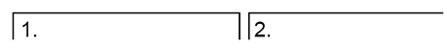

Image description: A volta is a bracket with the numeral 1 placed above the beginning of the first bar of the first time ending. The bracket continues over the bars to the repeat sign. The second time ending, which is directly after the repeat sign, has the number 2 place at the beginning of the bracket over the stave.
A volta gives an alternative ending and is commonly called first and second time endings.

Rules for brailling voltas:
- A volta is written as a lower number at the beginning of the bar, for example #1 or #2
- When brailled there is no space between the volta number and the bar to which it is connected.
- The first note after a volta sign must have an octave sign.
- If a sign immediately following a volta has dots 1, 2 or 3, then the volta number must be followed by a dot 3 separator. (See example Angels We Have Heard on High)
- Any punctuation used in print, like full stops and commas, are not brailled
- The bracket above the bar/s indicating the volta is not brailled
- If two or more numbers are used in print, then each number must have a numeric indicator unless it follows a hyphen (dots 3 6) then the number after the hyphen does not need a numeric indicator and spaces are not included between numbers.

Long Time Ago is an example of a simple first and second time ending.
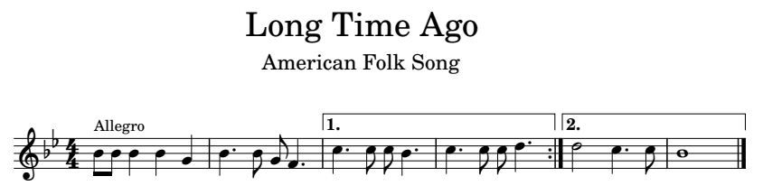

Image description:
Title: Long Time Ago
Subtitle: American Folk Song
Tempo marking: Allegro
Key signature: 2 flats
Time signature: 4 4
Bar 1: 4th octave B quaver, 4th octave B quaver, 4th octave B crotchet, 4th octave B crotchet, 4th octave G crotchet
Bar 2: 4th octave B dotted crotchet, 4th octave B quaver, 4th octave G quaver, 4th octave F dotted crotchet
Bar 3: first time ending, 5th octave C dotted crotchet, 5th octave C quaver, 5th octave C quaver, 4th octave B dotted crotchet
Bar 4: 5th octave C dotted crotchet, 5th octave C quaver, 5th octave C quaver, 5th octave D dotted crotchet, end repeated
Bar 5: second time ending, 5th octave D minim, 5th octave C dotted crotchet, 5th octave C quaver
Bar 6: 4th octave B semibreve, double barline.

,long ,time ,ago
,american ,folk ,song
,allegro4 <<#d4
a "jjww\ w'jh]' #1.?'ddw' ?'dd:'<2
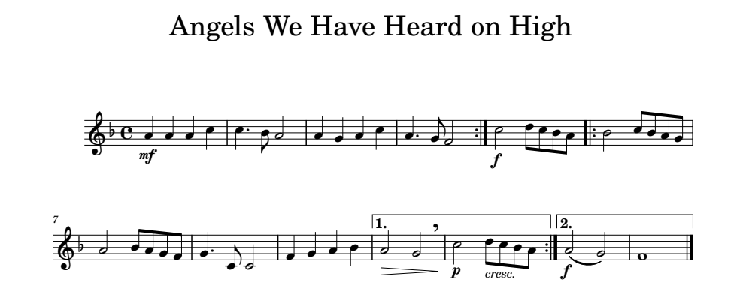
e #2.o?'d )<k

The example below demonstrates the use of dot 3 after the alternative ending signs.

Image description:
Title: Angels We Have Heard on High
Key signature: 1 flat
Time signature: common time
Bar 1: mf, 4th octave A crotchet, 4th octave A crotchet, 4th octave A crotchet, 5th octave C crotchet
Bar 2: 5th octave C dotted crotchet, 4th octave B quaver, 4th octave A minim
Bar 3: 4th octave A crotchet, 4th octave G crotchet, 4th octave A crotchet, 5th octave C crotchet
Bar 4: 4th octave A dotted crotchet, 4th octave G quaver, 4th octave F minim end repeat
Bar 5: f, 5th octave C minim, 5th octave D quaver 5th octave C quaver, 4th octave B quaver, 4th octave A quaver
Bar 6: beginning repeat sign 4th octave B minim, 5th octave C quaver, 4th octave B quaver, 4th octave A quaver, 4th octave G quaver
Bar 7: 4th octave A minim, 4th octave B quaver, 4th octave A quaver, 4th octave G quaver, 4th octave F quaver
Bar 8: 4th octave G dotted crotchet, 4th octave C quaver, 4th octave C minim
Bar 9: 4th octave F crotchet, 4th octave G crotchet, 4th octave A crotchet, 4th octave B crotchet
Bar 10: first time ending, hairpin decrescendo, 4th octave A minim, 4th octave G minim, breath mark
Bar 11: p, 5th octave C minim, cresc., 5th octave D quaver, 5th octave C quaver, 4th octave B quaver, 4th octave A quaver, end repeat sign
Bar 12: second time ending, f, 4th octave A minim, slur, 4th octave G minim
Bar 13: 4th octave F semibreve, double barline.

,angels ,we ,have ,heard
on ,high
<.c
a >mf"[[[? ?'js [\[? [' hq<2 >f.nedji
f <7"tdjih sjihg \'dn ]\[w #1'>d"sr>1
aa >p.n>cr'.edji<2 #2'>f"scr =<k

Exercise 9.1
This example is from Concerto Grosso No. 12 by Handel. The tempo marking, larghetto e piano, is quite long, so it should be put on its own centred line with the key and time signatures under it. This is to ensure that the reader can tell that the lines are centred. Make sure to put bar numbers at the beginning of each line and use the correct repeat signs. While the rhythms are not complicated in this excerpt be sure to use octave signs where needed as the melody does contain a lot of leaps between octaves.
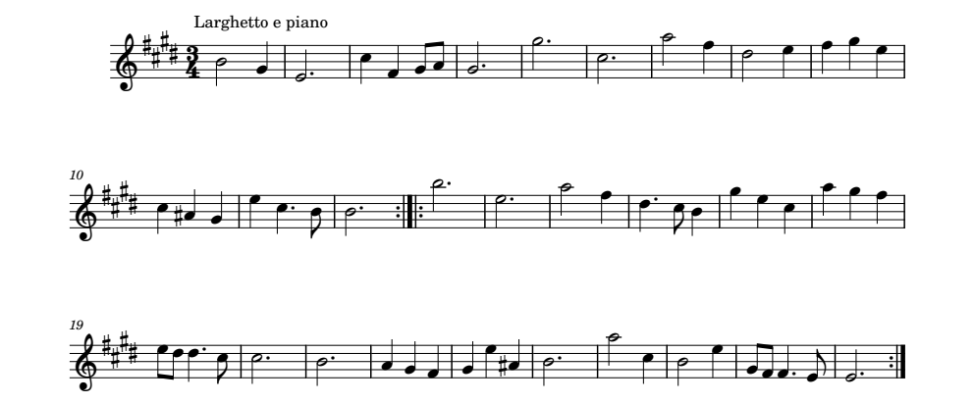

Image description:
Tempo marking: Larghetto e piano
Key signature: 4 sharps
Time signature: 3 4
Bar 1: 4th octave B minim, 4th octave G crotchet
Bar 2: 4th octave E dotted minim
Bar 3: 5th octave C crotchet, 4th octave F crotchet, 4th octave G quaver, 4th octave A quaver
Bar 4: 4th octave G dotted minim
Bar 5: 5th octave G dotted minim
Bar 6: 5th octave C dotted minim
Bar 7: 5th octave A minim, 5th octave F crotchet
Bar 8: 5th octave D minim, 5th octave E crotchet
Bar 9: 5th octave F crotchet, 5th octave G crotchet, 5th octave E crotchet
Bar 10: 5th octave C crotchet, 4th octave sharp A crotchet, 4th octave G crotchet
Bar 11: 5th octave E crotchet, 5th octave C dotted crotchet, 4th octave B quaver
Bar 12: 4th octave B dotted minim, end repeat sign
Bar 13: beginning repeat sign, 5th octave B dotted minim
Bar 14: 5th octave E dotted minim
Bar 15: 5th octave A minim, 5th octave F crotchet
Bar 16: 5th octave D dotted crotchet, 5th octave C quaver, 4th octave B crotchet
Bar 17: 5th octave G crotchet, 5th octave E crotchet, 5th octave C crotchet
Bar 18: 5th octave A crotchet, 5th octave G crotchet, 5th octave F crotchet
Bar 19: 5th octave E quaver, 5th octave D quaver, 5th octave D dotted crotchet, 5th octave C quaver
Bar 20: 5th octave C dotted minim
Bar 21: 4th octave B dotted minim
Bar 22: 4th octave A crotchet, 4th octave G crotchet, 4th octave F crotchet
Bar 23: 4th octave G crotchet, 5th octave E crotchet, 4th octave sharp A crotchet
Bar 24: 4th octave B dotted minim
Bar 25: 5th octave A minim, 5th octave C crotchet
Bar 26: 4th octave B minim, 5th octave E crotchet
Bar 27: 4th octave G quaver, 4th octave F quaver, 4th octave F dotted crotchet, 4th octave E quaver
Bar 28: 4th octave E dotted minim, end repeat sign.

Exercise 9.2
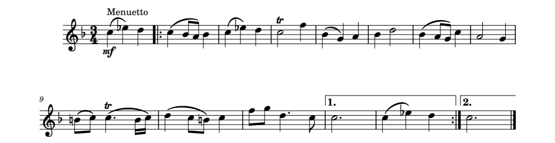
This excerpt is part of the oboe line from the Brandenburg Concerto No. 1 by Bach. Put it into braille.

Image description:
Tempo marking: Menuetto
Key signature: 1 flat
Time signature: 3 4
Bar 1: mf, 5th octave C crotchet, slur, 5th octave flat E crotchet, 5th octave D crotchet
Bar 2: beginning repeat, 5th octave C crotchet, slur, 4th octave B quaver, slur, 4th octave A quaver, 4th octave B crotchet
Bar 3: 5th octave C crotchet, slur, 5th octave flat E crotchet, 5th octave D crotchet
Bar 4: trill, 5th octave C minim, 5th octave F crotchet
Bar 5: 4th octave B crotchet, slur, 4th octave G crotchet, 4th octave A crotchet
Bar 6: 4th octave B crotchet, 5th octave D minim
Bar 7: 4th octave B crotchet, slur, 4th octave A quaver, slur, 4th octave G quaver, 5th octave C crotchet
Bar 8: 4th octave A minim, 4th octave G crotchet
Bar 9: 4th octave natural B quaver, slur, 5th octave C quaver, trill, 5th octave C dotted crotchet, slur, 4th octave B semiquaver, slur, 5th octave C semiquaver
Bar 10: 5th octave D crotchet, slur, 5th octave C quaver, slur, 4th octave natural B quaver, 5th octave C crotchet
Bar 11: 5th octave F quaver, 5th octave G quaver, 5th octave D dotted crotchet, 5th octave C quaver
Bar 12: first time ending, 5th octave C dotted minim
Bar 13: 5th octave C crotchet, slur, 5th octave flat E crotchet, 5th octave D crotchet, end repeat sign
Bar 14: second time ending, 5th octave C dotted minim, double barline.

Exercise 9.3
Put Mama’s Gonna Buy into braille. Remember the rule when there are volta numbers separated by a hyphen – there is no punctuation, and the second number does not need a numeric indicator. Do not forget to use the dot 3 separator if there is anything in dots 1 2 3 in the cell after a repeat sign.

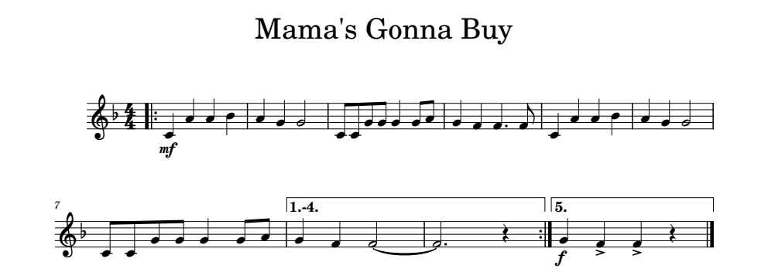
Image description:
Title: Mama’s Gonna Buy
Key signature: 1 flat
Time signature: 4 4
Bar 1: beginning repeat, mf, 4th octave C crotchet, 4th octave A crotchet, 4th octave A crotchet, 4th octave B crotchet
Bar 2: 4th octave A crotchet, 4th octave G crotchet, 4th octave G minim
Bar 3: 4th octave C quaver, 4th octave C quaver, 4th octave G quaver, 4th octave G quaver, 4th octave G crotchet, 4th octave G quaver, 4th octave A quaver
Bar 4: 4th octave G crotchet, 4th octave F crotchet, 4th octave F dotted crotchet, 4th octave F quaver
Bar 5: 4th octave C crotchet, 4th octave A crotchet, 4th octave A crotchet, 4th octave B crotchet
Bar 6: 4th octave A crotchet, 4th octave G crotchet, 4th octave G minim
Bar 7: 4th octave C quaver, 4th octave C quaver, 4th octave G quaver, 4th octave G quaver, 4th octave G crotchet, 4th octave G quaver, 4th octave A quaver
Bar 8: first – fourth time ending, 4th octave G crotchet, 4th octave F crotchet, 4th octave F minim, tie
Bar 9: 4th octave F dotted minim, crotchet rest, end repeat
Bar 10: fifth time ending, f, 4th octave G crotchet, accent, 4th octave F crotchet, accent, 4th octave F crotchet, crotchet rest, double barline.

Lesson 10 Braille Repeats
In braille there are several repeat devices that can be used to reduce the amount of reading and saving cells when bars or multiple bars are repeated in the print music.

The Braille Repeat Sign
The braille repeat sign, 7 (dots 2 3 5 6), is used to indicate an immediate repetition of a bar (measure) or a portion of a bar. This sign is never used for a passage longer than one bar.
Rules:
- The sign may only be used if the nuances and markings are the same.
- When a bar or part-bar is the same but in a different octave then the appropriate octave mark is placed before the repeat sign.
- If the exact repeat is modified by a change of dynamic or word-sign eg rit, and it applies to the entire repetition or beyond it, then the appropriate marking is placed before the repeat sign.
- If a tie is included in a repeat on the last note, then the tie is placed after the repeat sign.
- Braille repeats only apply to the contents of the bar so added signs such as double bar, final double barline, end repeat sign or a breath or break mark follow the repeat sign without a space.
- Where there are multiple repeats of a single bar, three or more, then the numeric sign follows the repeat sign without a space to indicate the number of repeats. The first note after this sign must have an octave sign.
The excerpt below is from a study by Cavallini. Notice that bar 1 is exactly the same as bar 2 and bar 3 is the same as bar 4. Instead of repeatedly brailling the exact same thing over and over the braille repeat sign can be used.
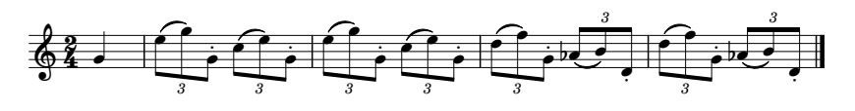

Image description:
Key signature: no sharps or flats
Time signature: 2 4
Bar 0: 4th octave G crotchet
Bar 1: triplet, 5th octave E quaver, slur, 5th octave G quaver, staccato, 4th octave G quaver, triplet, 5th octave C quaver, slur, 5th octave E quaver, staccato, 4th octave G quaver
Bar 2: triplet, 5th octave E quaver, slur, 5th octave G quaver, staccato, 4th octave G quaver, triplet, 5th octave C quaver, slur, 5th octave E quaver, staccato, 4th octave G quaver
Bar 3: triplet, 5th octave D quaver, slur, 5th octave F quaver, staccato, 4th octave G quaver, triplet, 5th octave flat A quaver, slur, 5th octave B quaver, staccato, 4th octave D quaver
Bar 4: triplet, 5th octave D quaver, slur, 5th octave F quaver, staccato, 4th octave G quaver, triplet, 5th octave flat A quaver, slur, 5th octave B quaver, staccato, 4th octave D quaver, double barline.

#b4
j "\ 2.fch8"h2.dcf8"h 7 2.ecg8"h2<icj8"e
d 7<k
The example below demonstrates how to use the repeat sign in conjunction with an octave sign and a change of dynamics.

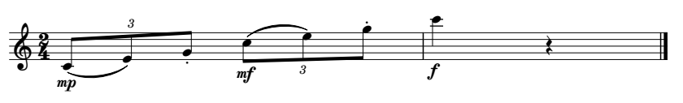

Image description:
Key signature: no sharps or flats
Time signature: 2 4
Bar 1: mp, triplet, 4th octave C quaver, slur, 4th octave E quaver, staccato, 4th octave G quaver, mf, triplet, 5th octave C quaver, slur, 5th octave E quaver, staccato, 5th octave G quaver
Bar 2: f, 6th octave C crotchet, crotchet rest, double barline.

#b4
a >mp'2"dcf8h>mf.7 >f;?v<k
The next example shows the repeat sign where there are ties across the bar. A repeat sign includes the tie within the bar but it does not include the tie on the last note. A tie sign will need to be placed after each repeat sign. Leaving the tie off the repeat sign would indicate to the reader that the next note needs to be articulated.
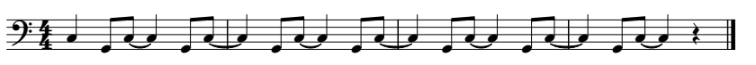

Image description:
Key signature: no sharps or flats
Time signature: 4 4
Bar 1: 3rd octave C crotchet, 2nd octave G quaver, 3rd octave C quaver, tie, 3rd octave C crotchet, 2nd octave G quaver, 3rd octave C quaver, tie
Bar 2: same as bar 1
Bar 3: same as bar 1
Bar 4: 3rd octave C crotchet, 2nd octave G quaver, 3rd octave C quaver, tie, 3rd octave C crotchet, crotchet rest, double barline.

#d4
a _?^h_d@c7@c 7@c 7@c ?^h_d@c?v<k

A common way in print to indicate multiple bars that are to be played the same is the use of this bar repeat sign (looks like a forward slash with a dot on either side of the slash):
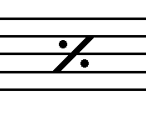

When this sign is used the bar repeat sign is used and then the number of repeats is placed after the sign as shown in the example below.
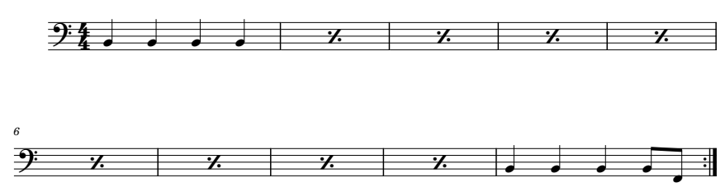

Image description:
Key signature: no sharps or flats
Time signature: 4 4
Bar 1: 2nd octave B crotchet, 2nd octave B crotchet, 2nd octave B crotchet, 2nd octave B crotchet
Bar 2 – 9: bar repeat sign
Bar 10: 2nd octave B crotchet, 2nd octave B crotchet, 2nd octave B crotchet, 2nd octave B quaver, 2nd octave F quaver, end repeat sign.

#d4
a ^ww7 7#h ^wwwjg<2

Braille Numeral Repeats
In instrumental music there are often repeated passages. There are two braille devices that allow the transcriber to show a repeated phrase without having to re-braille it. They are backward-numeral repeats and bar (measure)-number repeats.

Backward-Numeral Repeats
This repetition is a bar count back process for a passage of one or more full bars and are shown by brailling 2 numbers together between spaces. The first number tells the reader how many bars to count back from where they are in the music and the second number tells the reader how many bars to play. For example, #h#d (number 8 followed by number 4) tells the reader to count back 8 bars and then play 4 bars from that point. However, if there is no intervening music, for example, count back 4 bars and play 4 bars, then only one number is brailled.
Rules to be mindful of:
- this device is used for short passages, usually no more than 8 bars,
- the count back of bars should be limited too
- the original phrase and the count back point must be on the same braille page,
- where the passage is repeated without intervening music the repeat may be restated as many times as the passage itself is repeated.
- A numeral repeat only applies to the contents of the bar/s, so added signs like double barline, voltas and print repeat signs can be placed immediately after the numeral repeat marking.
- Numeral repeats in different octaves and dynamics can be shown before the numeral repeat sign. Be sure to order them correctly. A dynamic would come first followed by the octave sign.
Jingle Bells demonstrates the use of the backward-numeral repeat.

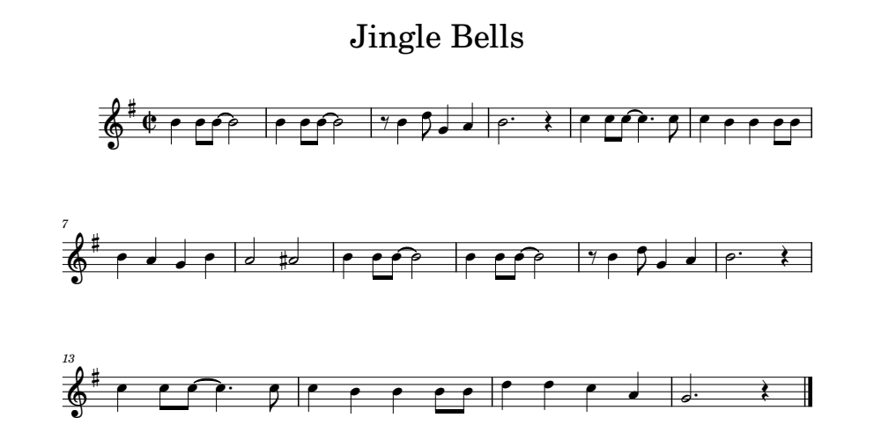
Image description:
Title: Jingle Bells
Key signature: 1 sharp
Time signature: cut common
Bar 1: 4th octave B crotchet, 4th octave B quaver, 4th octave B quaver, tie, 4th octave B minim
Bar 2: same as bar 1
Bar 3: quaver rest, 4th octave B crotchet, 5th octave D quaver, 4th octave G crotchet, 4th octave A crotchet
Bar 4: 4th octave B dotted minim, crotchet rest
Bar 5: 5th octave C crotchet, 5th octave C quaver, 5th octave C quaver, tie, 5th octave C dotted crotchet, 5th octave C quaver
Bar 6: 5th octave C crotchet, 4th octave B crotchet, 4th octave B crotchet, 4th octave B quaver, 4th octave B quaver
Bar 7: 4th octave B crotchet, 4th octave A crotchet, 4th octave G crotchet, 4th octave B crotchet
Bar 8: 4th octave A minim, 4th octave sharp A minim
Bar 9 – 14: same as bars 1 – 6
Bar 15: 5th octave D crotchet, 5th octave D crotchet, 5th octave C crotchet, 4th octave A crotchet
Bar 16: 4th octave G dotted minim, double barline.

,jingle ,bells
%_c
a "wjj@ct 7 xwe"\[ t'v ?dd@c?'d ?wwjj
g "w[\w s%s #h#f .::?[ r'v<k

The example below demonstrates the backward-numeral repeat without intervening music. It also shows a repeat with a change of dynamics in bar 13.
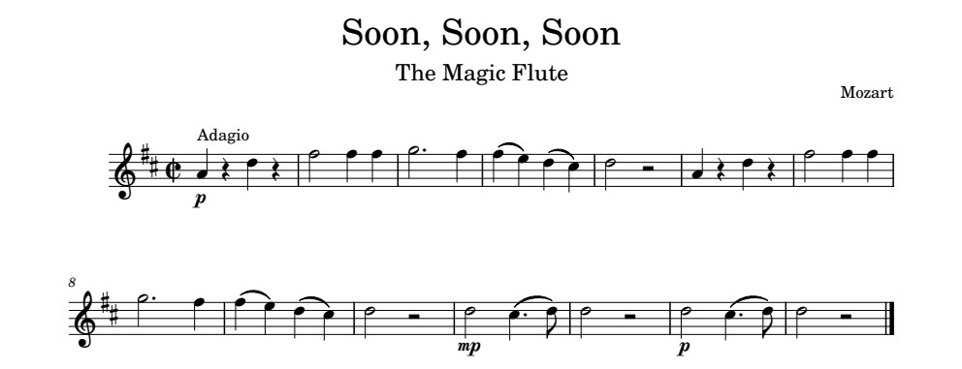

Image description:
Title: Soon, Soon, Soon
Subtitle: The Magic Flute
Composer: Mozart
Tempo Marking: Adagio
Key Signature: 2 sharps
Time Signature: cut common
Bar 1: p, 4th octave A crotchet, crotchet rest, 5th octave D crotchet, crotchet rest
Bar 2: 5th octave F minim, 5th octave F crotchet, 5th octave F crotchet
Bar 3: 5th octave G dotted minim, 5th octave F crotchet
Bar 4: 5th octave F crotchet, slur, 5th octave E crotchet, 5th octave D crotchet, slur, 5th octave C crotchet
Bar 5: 5th octave D minim, minim rest
Bar 6 – 10: the same as bars 1 – 5
Bar 11: mp, 5th octave D minim, 5th octave C dotted crotchet, slur, 5th octave D quaver
Bar 12: 5th octave D minim, minim rest
Bar 13: same as bar 11 but starts p
Bar 14: same as bar 12, double barline.

,soon1 ,soon1 ,soon
,the ,magic ,flute
,mozart
,adagio4 %%_c
a >p"[v.:v q]] r'] ]c$:c? ou #e
aa >mp.o?'ce .ou >p#b<k

Bar (Measure)-Number Repeats
This repeat is used to indicate a repetition of a single bar or multiple bars when the original is further back in the piece. The bar numbers are brailled between spaces and are written in the lower part of the cell. For example, if bar 2 was to be repeated, it would be written like this: #2(dots 3 4 5 6, dots 2 3). If, for example, bars 5 – 8 were to be repeated then it would be written with a literary hyphen (dots 3 6) between the numbers: #5-8 (dots 3 4 5 6, dots 2 6, dots 3 6, dots 2 3 6).
Things to be mindful of when using a bar-number repeat:
- It is not advisable to refer to an isolated bar that is far removed from the point of repetition. For example, if the piece was at bar 60 which is the same as bar 5, it would be advisable to rewrite the bar.
- There is no limit to the length of a repeated passage, however, it is advisable not to refer to a previous braille page unless the passage repeated is extensive and frequently repeated.
- While not a rule, if possible, a passage that is to be repeated should start a new line so that it is easily located by the reader.
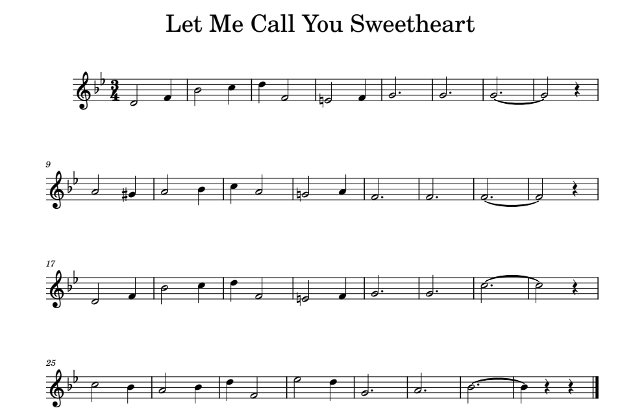

Image description:
Title: Let Me Call You Sweetheart
Key signature: 2 flats
Time signature: 3 4
Bar 1: 4th octave D minim, 4th octave F crotchet
Bar 2: 4th octave B minim, 5th octave C crotchet
Bar 3: 5th octave D crotchet, 4th octave F minim
Bar 4: 4th octave natural E minim, 4th octave F crotchet
Bar 5: 4th octave G dotted minim
Bar 6: 4th octave G dotted minim
Bar 7: 4th octave G dotted minim, tie
Bar 8: 4th octave G minim, crotchet rest
Bar 9: 4th octave A minim, 4th octave sharp G crotchet
Bar 10: 4th octave A minim, 4th octave B crotchet
Bar 11: 5th octave C crotchet, 4th octave A minim
Bar 12: 4th octave natural G minim, 4th octave A crotchet
Bar 13: 4th octave F dotted minim
Bar 14: 4th octave F dotted minim
Bar 15: 4th octave F dotted minim, tie
Bar 16: 4th octave F minim, crotchet rest
Bar 17: 4th octave D minim, 4th octave F crotchet
Bar 18: 4th octave B minim, 5th octave C crotchet
Bar 19: 5th octave D crotchet, 4th octave F minim
Bar 20: 4th octave natural E minim, 4th octave F crotchet
Bar 21: 4th octave G dotted minim
Bar 22: 4th octave G dotted minim
Bar 23: 5th octave C dotted minim, tie
Bar 24: 5th octave C minim, crotchet rest
Bar 25: 5th octave C minim, 4th octave B crotchet
Bar 26: 4th octave A minim, 4th octave B crotchet
Bar 27: 5th octave D crotchet, 4th octave F minim
Bar 28: 5th octave E minim, 5th octave D crotchet
Bar 29: 4th octave G dotted minim
Bar 30: 4th octave A dotted minim
Bar 31: 4th octave B dotted minim, tie
Bar 32: 4th octave B crotchet, crotchet rest, crotchet rest, double barline.

,let ,me ,call ,you
,sweetheart
<<#c4
a "o] t? :"q *p] r' 7 7@c rv s%\ sw ?s
ab *"r: q' 7 7@c qv #1-6 .n'@c nv nw sw
bg .:"q .p: "r' s' t'@c wvv<k

Exercise 10.1
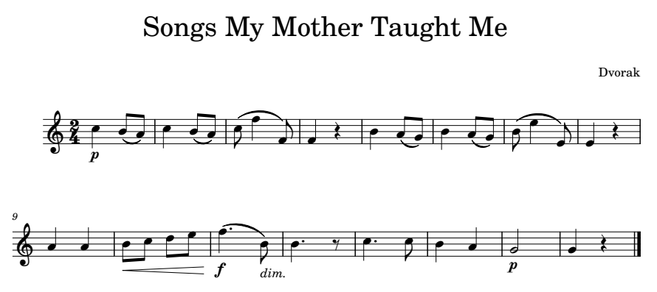
Put the piece below into braille using the appropriate braille repeat.

Image description:
Title: Songs My Mother Taught Me
Composer: Dvorak
Key signature: no sharps or flats
Time signature: 2 4
Bar 1: p, 5th octave C crotchet, 4th octave B quaver, slur, 4th octave A quaver
Bar 2: 5th octave C crotchet, 4th octave B quaver, slur, 4th octave A quaver
Bar 3: 5th octave C quaver, slur, 5th octave F crotchet, slur, 4th octave F quaver
Bar 4: 4th octave F crotchet, crotchet rest
Bar 5: 4th octave B crotchet, 4th octave A quaver, slur, 4th octave G quaver
Bar 6: 4th octave B crotchet, 4th octave A quaver, slur, 4th octave G quaver
Bar 7: 4th octave B quaver, slur, 5th octave E crotchet, slur, 4th octave E quaver
Bar 8: 4th octave E crotchet, crotchet rest
Bar 9: 4th octave A crotchet, 4th octave A crotchet
Bar 10: hairpin crescendo, 4th octave B quaver, 5th octave C quaver, 5th octave D quaver, 5th octave E quaver
Bar 11: f, 5th octave F dotted crotchet, slur, dim, 4th octave B quaver
Bar 12: 4th octave B dotted crotchet, quaver rest
Bar 13: 5th octave C dotted crotchet, 5th octave C quaver
Bar 14: 4th octave B crotchet, 4th octave A crotchet
Bar 15: p, 4th octave G minim
Bar 16: 4th octave G crotchet, crotchet rest, double barline.

Exercise 10.2
The excerpt below is a study for clarinet. Use the bar repeat sign to save cells. Remember to group the semiquavers.
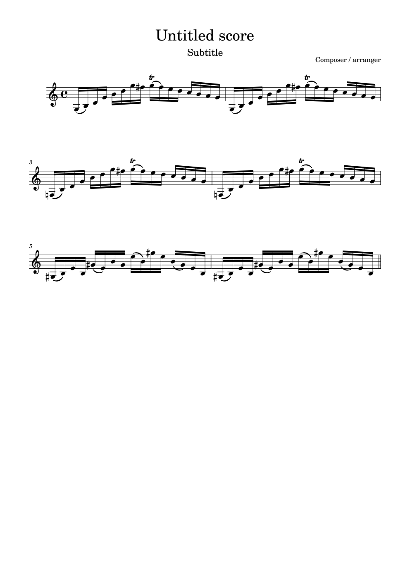
Image description:
Key signature: no sharps or flats
Time signature: common time
All note values in excerpt are semiquavers.
Bar 1: 3rd octave G, slur, 3rd octave B, 4th octave D, 4th octave G, 4th octave B, 5th octave D, 5th octave G, 5th octave sharp F, trill, 5th octave G, slur, 5th octave F, 5th octave E, 5th octave D, 5th octave C, 4th octave B, 4th octave A, 4th octave G
Bar 2: 3rd octave G, slur, 3rd octave B, 4th octave D, 4th octave G, 4th octave B, 5th octave D, 5th octave G, 5th octave sharp F, trill, 5th octave G, slur, 5th octave F, 5th octave E, 5th octave D, 5th octave C, 4th octave B, 4th octave A, 4th octave G
Bar 3: 3rd octave natural F, slur, 3rd octave B, 4th octave D, 4th octave G, 4th octave B, 5th octave D, 5th octave G, 5th octave sharp F, trill, 5th octave G, slur, 5th octave F, 5th octave E, 5th octave D, 5th octave C, 4th octave B, 4th octave A, 4th octave G
Bar 4: 3rd octave natural F, slur, 3rd octave B, 4th octave D, 4th octave G, 4th octave B, 5th octave D, 5th octave G, 5th octave sharp F, trill, 5th octave G, slur, 5th octave F, 5th octave E, 5th octave D, 5th octave C, 4th octave B, 4th octave A, 4th octave G
Bar 5: 3rd octave sharp G, slur, 3rd octave B, 4th octave E, 3rd octave B, 4th octave sharp G, slur, 4th octave E, 4th octave B, 4th octave G, 5th octave E, slur, 4th octave B, 5th octave sharp G, 5th octave E, 4th octave B, slur, 4th octave G, 4th octave E, 3rd octave B
Bar 6: 3rd octave sharp G, slur, 3rd octave B, 4th octave E, 3rd octave B, 4th octave sharp G, slur, 4th octave E, 4th octave B, 4th octave G, 5th octave E, slur, 4th octave B, 5th octave sharp G, 5th octave E, 4th octave B, slur, 4th octave G, 4th octave E, 3rd octave B

Exercise 10.3
Put the piece below into braille. Use the backward-numeral repeat for this excerpt.
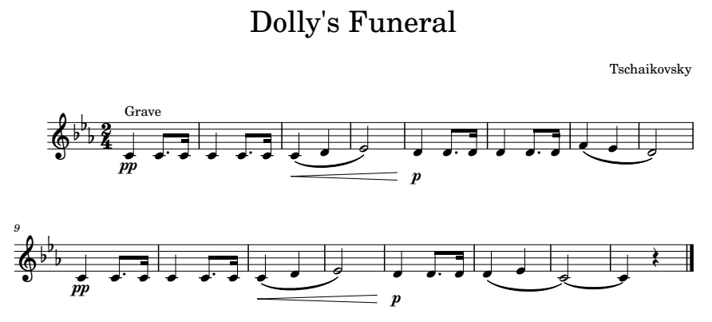

Image description:
Title: Dolly’s Funeral
Composer: Tschaikovsky
Tempo marking: Grave
Key signature: 3 flats
Time signature: 2 4
Bar 1: pp, 4th octave C crotchet, 4th octave C dotted quaver, 4th octave C semiquaver
Bar 2: 4th octave C crotchet, 4th octave C dotted quaver, 4th octave C semiquaver
Bar 3: hairpin crescendo, 4th octave C crotchet, slur, 4th octave D crotchet, slur
Bar 4: 4th octave E minim
Bar 5: p, 4th octave D crotchet, 4th octave D dotted quaver, 4th octave D semiquaver
Bar 6: 4th octave D crotchet, 4th octave D dotted quaver, 4th octave D semiquaver
Bar 7: 4th octave F crotchet, slur, 4th octave E, slur
Bar 8: 4th octave D minim
Bar 9: pp, 4th octave C crotchet, 4th octave C dotted quaver, 4th octave C semiquaver
Bar 10: 4th octave C crotchet, 4th octave C dotted quaver, 4th octave C semiquaver
Bar 11: hairpin crescendo, 4th octave C crotchet, slur, 4th octave D crotchet, slur
Bar 12: 4th octave E minim
Bar 13: p, 4th octave D crotchet, 4th octave D dotted quaver, 4th octave D semiquaver
Bar 14: 4th octave D crotchet, slur, 4th octave E crotchet, slur
Bar 15: 4th octave C minim, tie
Bar 16: 4th octave C crotchet, crotchet rest, double barline.

Exercise 10.4
Put the piece below into braille. It uses the backward-numeral repeat and the Bar-Number repeat.
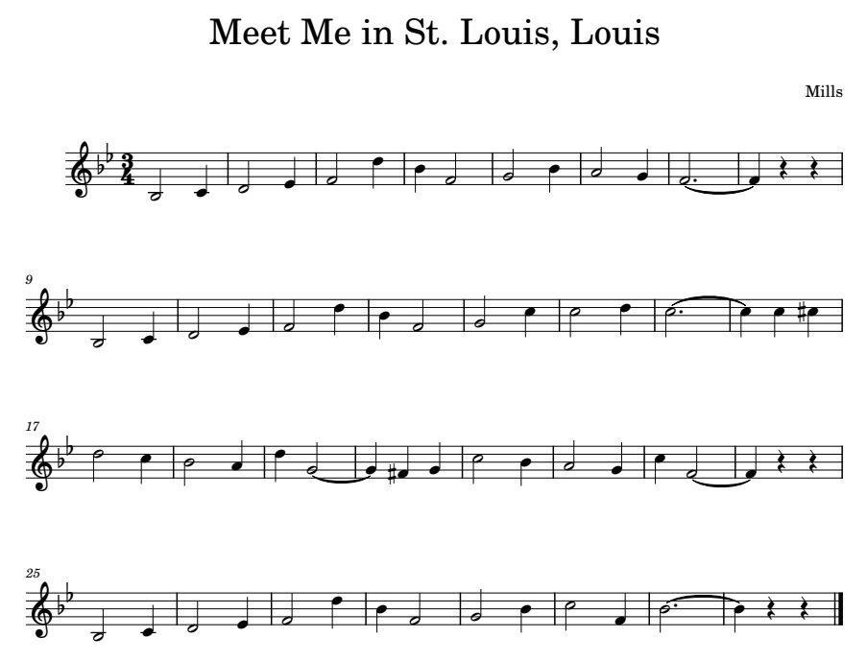

Image description:
Title: Meet Me in St. Louis, Louis
Composer: Mills
Key signature: 2 flats
Time signature: 3 4
Bar 1: 3rd octave B minim, 4th octave C crotchet
Bar 2: 4th octave D minim, 4th octave E crotchet
Bar 3: 4th octave F minim, 5th octave D crotchet
Bar 4: 4th octave B crotchet, 4th octave F minim
Bar 5: 4th octave G minim, 4th octave B crotchet
Bar 6: 4th octave A minim, 4th octave G crotchet
Bar 7: 4th octave F dotted minim, tie
Bar 8: 4th octave F crotchet, crotchet rest, crotchet rest
Bar 9: 3rd octave B minim, 4th octave C crotchet
Bar 10: 4th octave D minim, 4th octave E crotchet
Bar 11: 4th octave F minim, 5th octave D crotchet
Bar 12: 4th octave B crotchet, 4th octave F minim
Bar 13: 4th octave G minim, 5th octave C crotchet
Bar 14: 5th octave C minim, 5th octave D crotchet
Bar 15: 5th octave C dotted minim, tie
Bar 16: 5th octave C, 5th octave C octave, 5th octave sharp C crotchet
Bar 17: 5th octave D minim, 5th octave C crotchet
Bar 18: 4th octave B minim, 4th octave A crotchet
Bar 19: 5th octave D crotchet, 4th octave G minim, tie
Bar 20: 4th octave G crotchet, 4th octave sharp F crotchet, 4th octave G crotchet
Bar 21: 5th octave C minim, 4th octave B crotchet
Bar 22: 4th octave A minim, 4th octave G crotchet
Bar 23: 5th octave C crotchet, 4th octave F minim, tie
Bar 24: 4th octave F crotchet, crotchet rest, crotchet rest
Bar 25: 3rd octave B minim, 4th octave C crotchet
Bar 26: 4th octave D minim, 4th octave E crotchet
Bar 27: 4th octave F minim, 5th octave D crotchet
Bar 28: 4th octave B crotchet, 4th octave F minim
Bar 29: 4th octave G minim, 4th octave B crotchet
Bar 30: 5th octave C minim, 4th octave F crotchet
Bar 31: 4th octave B dotted minim, tie
Bar 32: 4th octave B crotchet, crotchet rest, crotchet rest, double barline.

Lesson 11 Tying It All Together
Congratulations on making it to this point. This lesson has no new content for you to learn. It is time to put all the information you have learned in the last ten lessons into producing pieces of music. There will be five pieces for you to put into braille as the final step in completing the beginner course in music braille.
Below is an order of signs in relationship to the note that we have covered. The first section gives the order of signs before a note and the second section is for the order of signs that follow a note. This chart may help you in completing the exercises.
Preceding a note:
    - forward repeat sign
    - first or second ending sign
    - opening bracket slur
    - simple word-sign expression (p, f, mf etc)
    - triplet or irregular grouping sign
    - accidental for ornament
    - ornament
    - signs of expressions
        - staccato
        - accent
        - tenuto
        - any other of these signs
    - accidental
    - octave mark

Following a note:
    - dot
    - fermata
    - single slur or opening double slur
    - closing bracket slur
    - tie
    - termination sign for a hairpin
    - breath marking
    - backward repeat sign

Exercise 11.1
The piece below is the melody of the song The Blue-Tail Fly. It features an anacrusis (or up-beat) so make sure to number the bars correctly, crotchet triplets, fermata (pause) and a sectional double barline. And as always, don’t forget your octave signs.
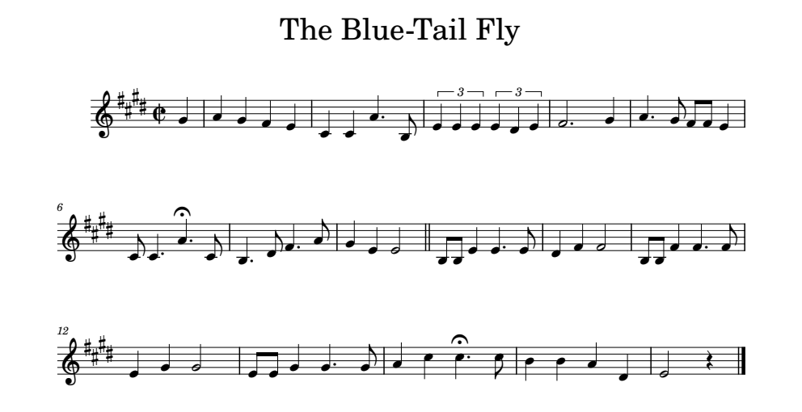

Image description:
Title: The Blue-Tail Fly
Key signature: 4 sharps
Time signature: cut common
Bar 0: 4th octave G crotchet
Bar 1: 4th octave A crotchet, 4th octave G crotchet, 4th octave F crotchet, 4th octave E crotchet
Bar 2: 4th octave C crotchet, 4th octave C crotchet, 4th octave A dotted crotchet, 3rd octave B quaver
Bar 3: triplet, 4th octave E crotchet, 4th octave E crotchet, 4th octave E crotchet, triplet, 4th octave E crotchet, 4th octave D crotchet, 4th octave E crotchet
Bar 4: 4th octave F dotted minim, 4th octave G crotchet
Bar 5: 4th octave A dotted crotchet, 4th octave G quaver, 4th octave F quaver, 4th octave F quaver, 4th octave E crotchet
Bar 6: 4th octave C quaver, 4th octave C dotted crotchet, 4th octave A dotted crotchet, fermata over note, 4th octave C quaver
Bar 7: 3rd octave B dotted crotchet, 4th octave D quaver, 4th octave F dotted crotchet, 4th octave A quaver
Bar 8: 4th octave G crotchet, 4th octave E crotchet, 4th octave E minim, sectional double barline
Bar 9: 3rd octave B quaver, 3rd octave B quaver, 4th octave E crotchet, 4th octave E dotted crotchet, 4th octave E quaver
Bar 10: 4th octave D crotchet, 4th octave F crotchet, 4th octave F minim
Bar 11: 3rd octave B quaver, 3rd octave B quaver, 4th octave F crotchet, 4th octave F dotted crotchet, 4th octave F quaver
Bar 12: 4th octave E crotchet, 4th octave G crotchet, 4th octave G minim
Bar 13: 4th octave E quaver, 4th octave E quaver, 4th octave G crotchet, 4th octave G dotted crotchet, 4th octave G quaver
Bar 14: 4th octave A crotchet, 5th octave C crotchet, 5th octave C dotted crotchet, fermata over note, 5th octave C quaver
Bar 15: 4th octave B crotchet, 4th octave B crotchet, 4th octave A crotchet, 4th octave D crotchet
Bar 16: 4th octave E minim, crotchet rest, double barline.

Exercise 11.2
While the music notation in this piece is simple, be careful of the time signature changes with the use of the sectional double barline.
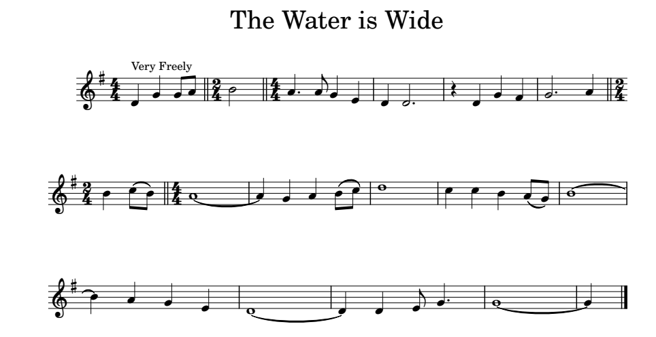

Image description:
Title: The Water is Wide
Tempo marking: Very Freely
Key signature: 1 sharp
Time signature: 4 4
Bar 0: 4th octave D crotchet, 4th octave G crotchet, 4th octave G quaver, 4th octave A quaver, sectional double barline
Bar 1: time signature change to 2 4, 4th octave B minim, sectional double barline
Bar 2: time signature change to 4 4, 4th octave A dotted crotchet, 4th octave A quaver, 4th octave G crotchet, 4th octave E crotchet
Bar 3: 4th octave D crotchet, 4th octave D dotted minim
Bar 4: crotchet rest, 4th octave D crotchet, 4th octave G crotchet, 4th octave F crotchet
Bar 5: 4th octave G dotted minim, 4th octave A crotchet, sectional double barline
Bar 6: time signature change to 2 4, 4th octave B crotchet, 5th octave C quaver, slur, 4th octave B quaver, sectional double barline
Bar 7: time signature change to 4 4, 4th octave A semibreve, tie
Bar 8: 4th octave A crotchet, 4th octave G crotchet, 4th octave A crotchet, 4th octave B quaver, slur, 5th octave C quaver
Bar 9: 5th octave D semibreve
Bar 10: 5th octave C crotchet, 5th octave C crotchet, 4th octave B crotchet, 4th octave A quaver, slur, 4th octave G quaver
Bar 11: 4th octave B semibreve, tie
Bar 12: 4th octave B crotchet, 4th octave A crotchet, 4th octave G crotchet, 4th octave E crotchet
Bar 13: 4th octave D semibreve, tie
Bar 14: 4th octave D crotchet, 4th octave D crotchet, 4th octave E quaver, 4th octave G dotted crotchet
Bar 15: 4th octave G semibreve, tie
Bar 16: 4th octave G crotchet, double barline.

Exercise 11.3
The excerpt below is a clarinet melody from Symphony No. 4 in B flat by Beethoven, put it into braille. Be careful of all the ties and slurs. There are no bracket slurs used in this exercise. Bar 6 uses a double dotted quaver. It is treated no differently than a single dotted note, just add another dot 3.
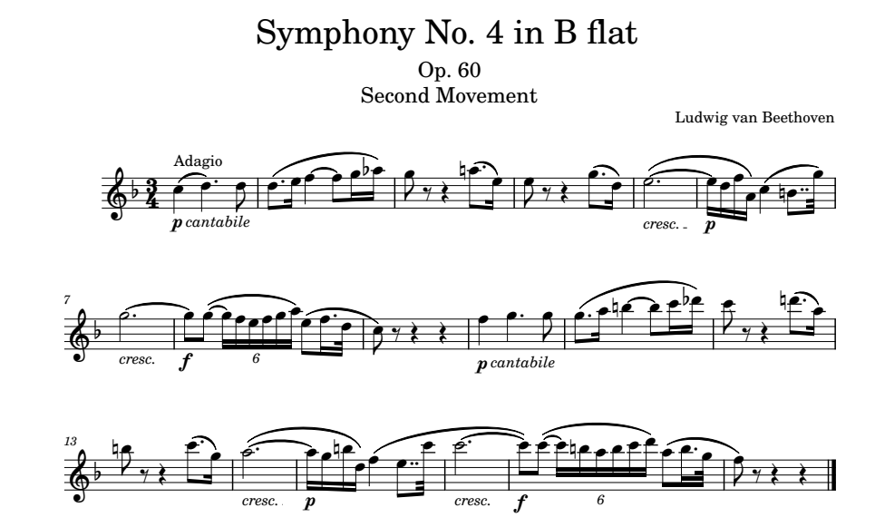
Image description:
Title: Symphony No. 4 in B flat
Subtitle: Op. 60
Subtitle: Second Movement
Composer: Ludwig van Beethoven
Tempo Marking: Adagio
Key signature: 1 flat
Time signature: 3 4
Bar 1: cantabile, p, 5th octave C crotchet, slur, 5th octave D dotted crotchet, 5th octave D quaver
Bar 2: 5th octave D dotted quaver, slur, 5th octave E semiquaver, slur, 5th octave F crotchet, tie, 5th octave F quaver, slur, 5th octave G semiquaver, slur, 5th octave flat A semiquaver
Bar 3: 5th octave G quaver, quaver rest, crotchet rest, 5th octave natural A dotted quaver, slur, 5th octave E semiquaver
Bar 4: 5th octave E quaver, quaver rest, crotchet rest, 5th octave G dotted quaver, slur, 5th octave D semiquaver
Bar 5: cresc, 5th octave E dotted minim, tie
Bar 6: p, grouping of 4 semiquavers, 5th octave E, slur, 5th octave D, slur, 5th octave F, slur, 4th octave A, 5th octave C crotchet, slur, 4th octave natural B double dotted quaver, slur, 5th octave G demisemiquaver
Bar 7: cresc, 5th octave G dotted minim, tie
Bar 8: f, 5th octave G quaver, 5th octave G quaver, tie, grouping of 6 semiquavers 5th octave G, slur, 5th octave F, slur, 5th octave E, slur, 5th octave F, slur, 5th octave G, slur, 5th octave A, 5th octave E quaver, slur, 5th octave F dotted semiquaver, slur, 5th octave D demisemiquaver, slur
Bar 9: 5th octave C quaver, quaver rest, crotchet rest, crotchet rest
Bar 10: cantabile, p, 5th octave F crotchet, 5th octave G dotted crotchet, 5th octave G quaver
Bar 11: 5th octave G dotted quaver, slur, 5th octave A semiquaver, slur, 5th octave natural B crotchet, tie, 5th octave B quaver, slur, 6th octave C semiquaver, slur, 6th octave flat D semiquaver
Bar 12: 6th octave C quaver, quaver rest, crotchet rest, 5th octave natural D dotted quaver, slur, 5th octave A semiquaver
Bar 13: 5th octave natural B quaver, quaver rest, crotchet rest, 6th octave C dotted quaver, slur, 5th octave G semiquaver
Bar 14: cresc, 5th octave A dotted minim, tie
Bar 15: p, grouping of 4 semiquavers, 5th octave A, slur, 5th octave G slur, 5th octave natural B, slur, 5th octave D, 5th octave F crotchet, slur, 5th octave E double dotted quaver, slur, 6th octave C demisemiquaver, slur
Bar 16: cresc, 6th octave C dotted minim, tie
Bar 17: f, 6th octave C quaver, 6th octave C quaver, tie, grouping of 6 semiquavers 6th octave C, slur, 5th octave natural B, slur, 5th octave A, slur, 5th octave B, slur, 6th octave C, slur, 6th octave D, 5th octave A quaver, slur, 5th octave B dotted semiquaver, slur, 5th octave G demisemiquaver, slur
Bar 18: 5th octave F quaver, quaver rest, crotchet rest, crotchet rest, double barline.

Exercise 11.4
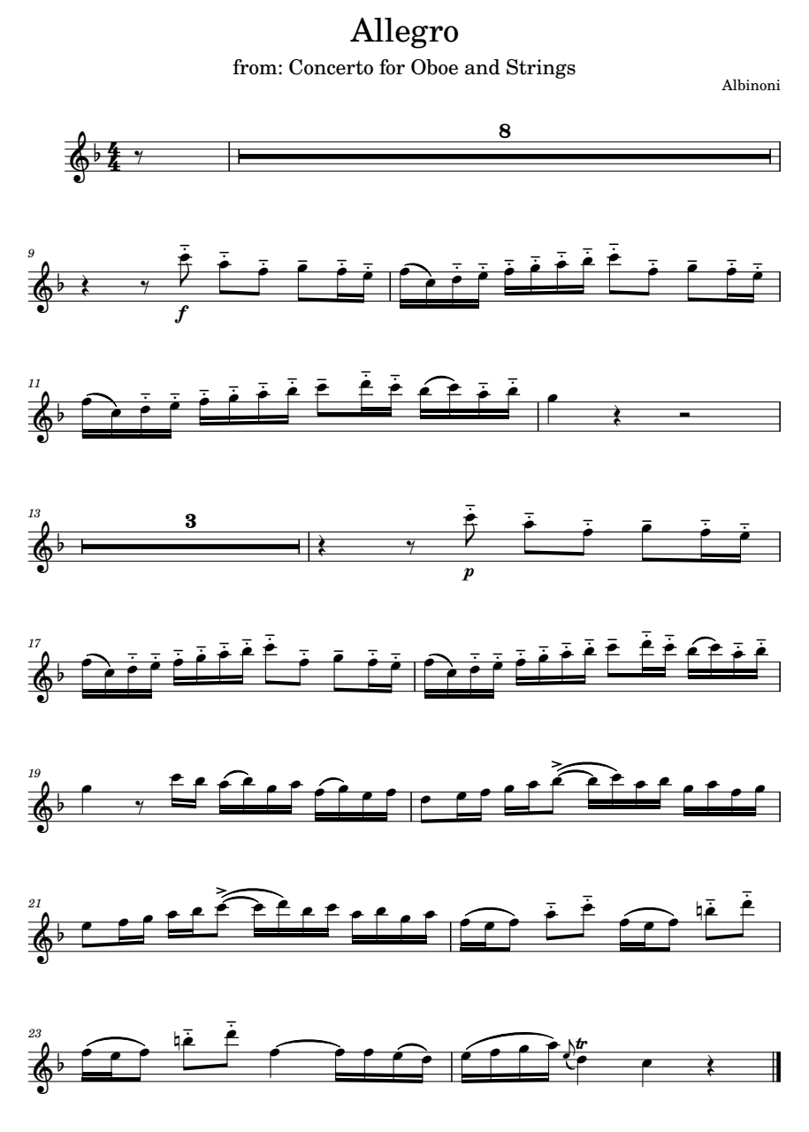
Put the excerpt below into braille. Be careful of the articulations and use the doubling rule where possible. Make sure to study the piece to see if braille repeats can be used.
Image description:
Title: Allegro
Subtitle: from: Concerto for Oboe and Strings
Composer: Albinoni
Key Signature: 1 flat
Time Signature: 4 4
Bar 0: quaver rest
Bar 1 – 8: whole bars rest
Bar 9: crotchet rest, quaver rest, f, mezzo-staccato, 6th octave C quaver, mezzo-staccato, 5th octave A quaver, mezzo-staccato, 5th octave F quaver, tenuto, 5th octave G quaver, mezzo-staccato, 5th octave F semiquaver, mezzo-staccato, 5th octave E semiquaver
Bar 10: group of 4 semiquavers, 5th octave F, slur, 5th octave C, mezzo-staccato, 5th octave D, mezzo-staccato 5th octave E, group of 4 semiquavers, mezzo-staccato, 5th octave F, mezzo-staccato, 5th octave G, mezzo-staccato, 5th octave A, mezzo-staccato, 5th octave B, mezzo-staccato, 6th octave C quaver, mezzo-staccato, 5th octave F quaver, tenuto, 5th octave G quaver, mezzo-staccato, 5th octave F semiquaver, mezzo-staccato, 5th octave E semiquaver
Bar 11: group of 4 semiquavers, 5th octave F, slur, 5th octave C, mezzo-staccato, 5th octave D, mezzo-staccato 5th octave E, group of 4 semiquavers, mezzo-staccato, 5th octave F, mezzo-staccato, 5th octave G, mezzo-staccato, 5th octave A, mezzo-staccato, 5th octave B, tenuto, 6th octave C quaver, mezzo-staccato, 6th octave D semiquaver, mezzo-staccato, 6th octave C semiquaver, grouping of 4 semiquavers, 5th octave B, slur, 6th octave C, mezzo-staccato, 5th octave A, mezzo-staccato, 5th octave B
Bar 12: 5th octave G crotchet, crotchet rest, minim rest
Bar 13 – 15: bars rest
Bar 16: crotchet rest, quaver rest, p, mezzo-staccato, 6th octave C quaver, mezzo-staccato, 5th octave A quaver, mezzo-staccato, 5th octave F quaver, tenuto, 5th octave G quaver, mezzo-staccato, 5th octave F semiquaver, mezzo-staccato, 5th octave E semiquaver
Bar 17: group of 4 semiquavers, 5th octave F, slur, 5th octave C, mezzo-staccato, 5th octave D, mezzo-staccato, 5th octave E, group of 4 semiquavers, mezzo-staccato, 5th octave F, mezzo-staccato, 5th octave G, mezzo-staccato, 5th octave A, mezzo-staccato, 5th octave B, mezzo-staccato, 6th octave C quaver, mezzo-staccato, 5th octave F quaver, tenuto, 5th octave G quaver, mezzo-staccato, 5th octave F semiquaver, mezzo-staccato, 5th octave E semiquaver
Bar 18: group of 4 semiquavers, 5th octave F, slur, 5th octave C, mezzo-staccato, 5th octave D, mezzo-staccato 5th octave E, group of 4 semiquavers, mezzo-staccato, 5th octave F, mezzo-staccato, 5th octave G, mezzo-staccato, 5th octave A, mezzo-staccato, 5th octave B, tenuto, 6th octave C quaver, mezzo-staccato, 6th octave D semiquaver, mezzo-staccato, 6th octave C semiquaver, grouping of 4 semiquavers, 5th octave B, slur, 6th octave C, mezzo-staccato, 5th octave A, mezzo-staccato, 5th octave B
Bar 19: 5th octave G crotchet, quaver rest, 6th octave C semiquaver, 5th octave B semiquaver, grouping of 4 semiquavers, 5th octave A, slur, 5th octave B, 5th octave G, 5th octave A, grouping of 4 semiquavers, 5th octave F, slur, 5th octave G, 5th octave E, 5th octave F
Bar 20: 5th octave D quaver, 5th octave E semiquaver, 5th octave F semiquaver, 5th octave G semiquaver, 5th octave A semiquaver, accent, 5th octave B quaver, tie, grouping of 4 semiquavers, 5th octave B, slur, 6th octave C, 5th octave A, 5th octave B, grouping of 4 semiquavers, 5th octave G, 5th octave A, 5th octave F, 5th octave G
Bar 21: 5th octave E quaver, 5th octave F semiquaver, 5th octave G semiquaver, 5th octave A semiquaver, 5th octave B semiquaver, accent, 6th octave C quaver, tie, grouping of 4 semiquavers, 6th octave C, slur, 6th octave D, 5th octave B, 6th octave C, grouping of 4 semiquavers, 5th octave A, 5th octave B, 5th octave G, 5th octave A
Bar 22: 5th octave F semiquaver, slur, 5th octave E semiquaver, slur, 5th octave F quaver, mezzo-staccato, 5th octave A quaver, mezzo-staccato, 6th octave C quaver, 5th octave F semiquaver, slur, 5th octave E semiquaver, slur, 5th octave F quaver, mezzo-staccato, 5th octave natural B quaver, mezzo-staccato 6th octave D quaver
Bar 23: 5th octave F semiquaver, slur, 5th octave E semiquaver, slur, 5th octave F quaver, mezzo-staccato, 5th octave natural B quaver, mezzo-staccato, 6th octave D quaver, 5th octave F crotchet, tie, grouping of 4 semiquavers, 5th octave F, 5th octave F, 5th octave E, slur, 5th octave D
Bar 24: grouping of 4 semiquavers, 5th octave E, slur, 5th octave F, slur, 5th octave G, slur, 5th octave A, long appoggiatura, 5th octave E quaver, slur, trill, 5th octave D crotchet, 5th octave C crotchet, crotchet rest, double barline.

Exercise 11.5
Put the piece below into braille. Use braille repeats where possible.
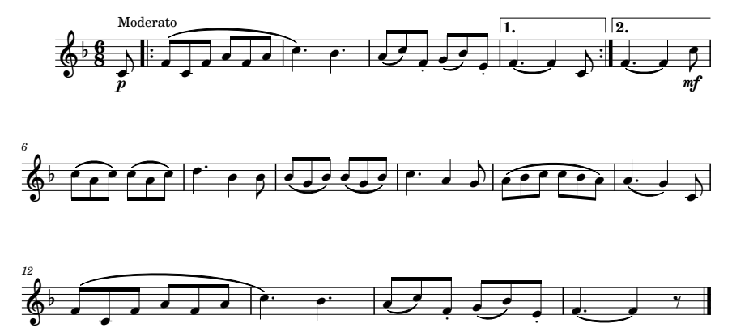

Image description:
Tempo marking: Moderato
Key signature: 1 flat
Time signature: 6 8
Bar 0: p, 4th octave C quaver
Bar 1: Beginning repeat, 4th octave F quaver, slur, 4th octave C quaver, slur, 4th octave F quaver, slur, 4th octave A quaver, slur, 4th octave F quaver, slur, 4th octave A quaver, slur
Bar 2: 5th octave C dotted crotchet, 4th octave B dotted crotchet
Bar 3: 4th octave A quaver, slur, 5th octave C quaver, staccato, 4th octave F quaver, 4th octave G quaver, slur, 4th octave B quaver, staccato, 4th octave E quaver,
Bar 4: volta 1st time ending, 4th octave F dotted crotchet, tie, 4th octave F crotchet, 4th octave C quaver, end repeat sign
Bar 5: volta 2nd time ending, 4th octave F dotted crotchet, tie, 4th octave F crotchet, mf, 5th octave C quaver
Bar 6: 5th octave C quaver, slur, 4th octave A quaver, slur, 5th octave C quaver, 5th octave C quaver, slur, 4th octave A quaver, slur, 5th octave C quaver
Bar 7: 5th octave D dotted crotchet, 4th octave B crotchet, 4th octave B quaver
Bar 8: 4th octave B quaver, slur, 4th octave G quaver, slur, 4th octave B quaver, 4th octave B quaver, slur, 4th octave G quaver, slur, 4th octave B quaver
Bar 9: 5th octave C dotted crotchet, 4th octave A crotchet, 4th octave G quaver
Bar 10: 4th octave A quaver, slur, 4th octave B quaver, slur, 5th octave C quaver, slur, 5th octave C quaver, slur, 4th octave B quaver, slur, 4th octave A quaver
Bar 11: 4th octave A dotted crotchet, slur, 4th octave G crotchet, 4th octave C quaver
Bar 12: 4th octave F quaver, slur, 4th octave C quaver, slur, 4th octave F quaver, slur, 4th octave A quaver, slur, 4th octave F quaver, slur, 4th octave A quaver, slur
Bar 13: 5th octave C dotted crotchet, 4th octave B dotted crotchet
Bar 14: 4th octave A quaver, slur, 5th octave C quaver, staccato, 4th octave F quaver, 4th octave G quaver, slur, 4th octave B quaver, staccato, 4th octave E quaver
Bar 15: 4th octave F dotted crotchet, tie, 4th octave F crotchet, quaver rest, double barline.

Appendices

Appendix 1

Summary of Signs

Notes and Note Names
Name | Symbol | Rests |  | C | D | E | F | G | A | B
Quaver (8th note) or  Semihemidemisemiquaver (128th note) | e |  | x | D | E | F | G | H | I | j
Crotchet (quaver note) or  Hemidemisemiquaver (64th note) | q |  | V | ? | : | $ | ] | \ | [ | w
Minim (half note) or  Demisemiquaver (32nd note) | h |  | U | N | O | P | Q | R | S | t
Semibreve (whole note) or  Semiquaver (16th note) | w  s |  | M | Y | Z | & | = | ( | ! | )

Dot after a note (to add value) ' (dot 3)

Octave Signs

 | 1st Octave | @ | dot 4
 | 2nd Octave | ^ | dots 4, 5
 | 3rd Octave | _ | dots 4, 5, 6
 | 4th Octave | " | dot 5
 | 5th Octave | . | dot 4, 6
 | 6th Octave | ; | dots 5, 6
 | 7th Octave | , | dot 6

Key and Time Signatures

Accidentals
Sharp | % | dots 1 4 6
Double Sharp | %% | dots 1 4 6 dots 1 4 6
Flat | < | dots 1 2 6
Double Flat | << | dots 1 2 6 dots 1 2 6
Natural | * | dots 1 6

Examples of Key Signatures:
3 sharps | %%% | Dots 1 4 6, dots 1 4 6, dots 1 4 6
3 flats | <<< | Dots 1 2 6, dots 1 2 6, dots 1 4 6
4 sharps | #d% | Dots 3 4 5 6, dots 1 4 5, dots 1 4 6
4 flats | #d< | Dots 3 4 5 6, dots 1 4 5, dots 1 2 6

Time Signatures
Four-four time | #d4  (dots 3 4 5 6, dots 1 4 5, dots 2 5 6) | 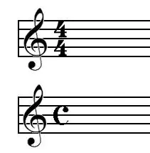
Six-eight time | #f8  (dots 3 4 5 6, dots 1 2 4, dots 2 3 6) | 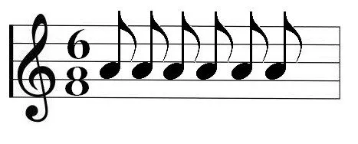
Common Time | .c  (dots 4 6, dots 1 4)
Cut Common Time | _c  (dots 4 5 6, dots 1 4) | 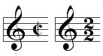

Barlines
Barline | space |  | 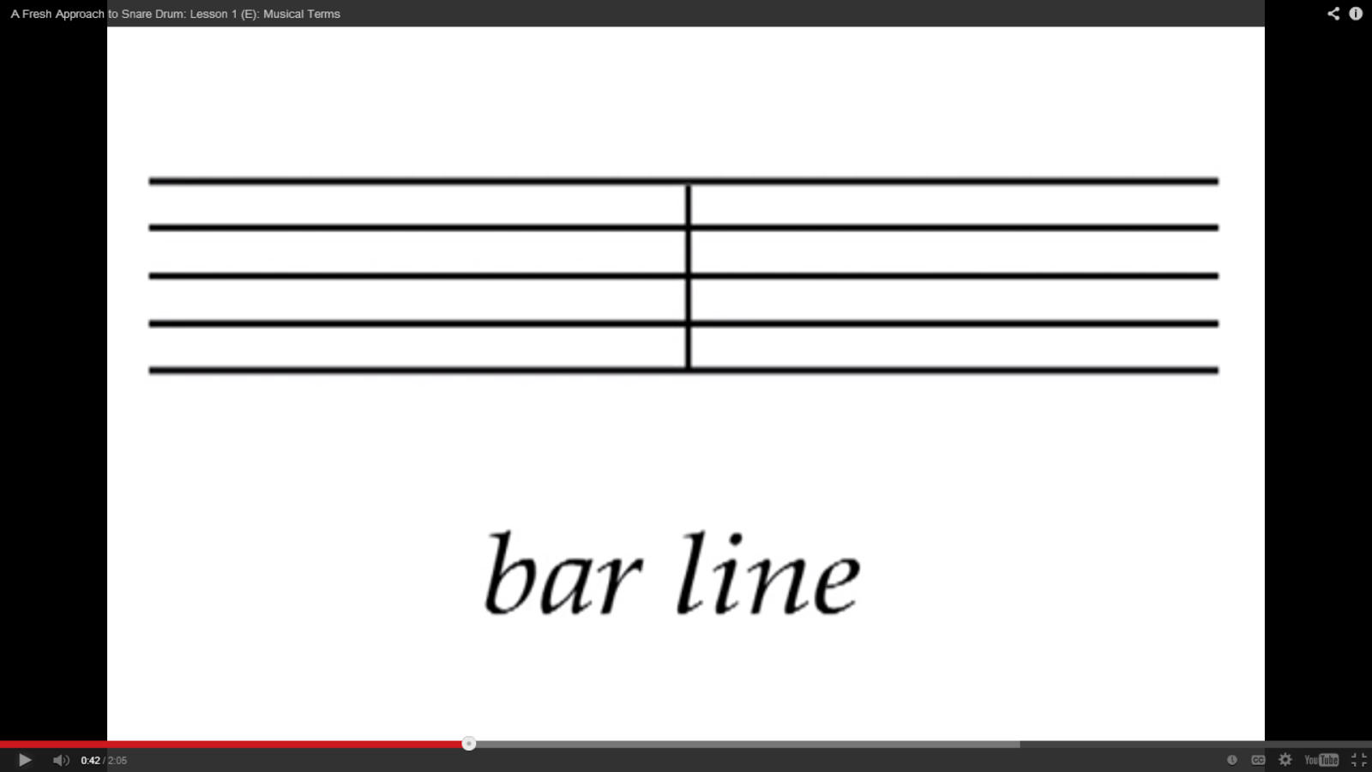
Double barline (Final) | <k | dots 1 2 6, dots 1 3 | 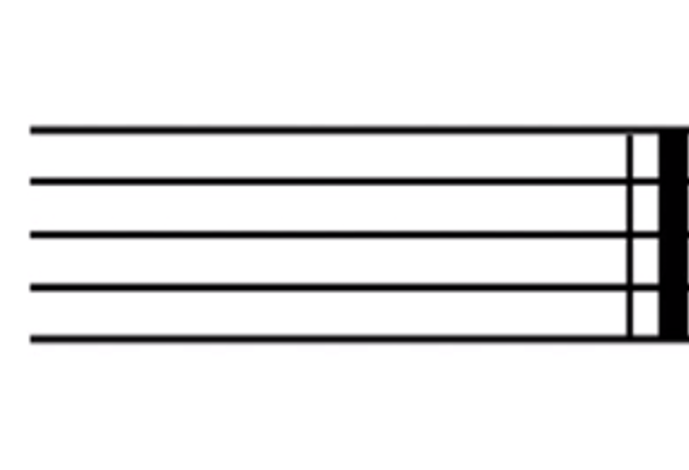
Sectional double barline | <k' | dots 1 2 6, dots 1 3, dot 3 | 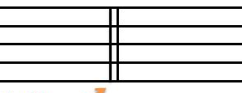
Start Repeat (double bar followed by dots) | <7 | dots 1 2 6,  dots 2 3 5 6 | 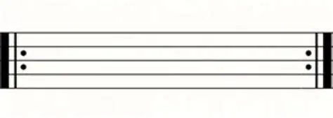
End Repeat (double bar preceded by dots) | <2 | dots 1 2 6, dots 2 3

Ties and Slurs
Tie @c (dot 4, dot 1 4)
Slur c (dot 1 4)
Bracket Slur ;b ^2 (Open bracket dot 5 6, dot 1 2) (Close bracket dot 4 5, dot 2 3)

Dynamics and Expressive Markings
Word sign > dots 3 4 5
pianissimo pp >pp dots 3 4 5, dots 1 2 3 4, dots 1 2 3 4
piano p >p dots 3 4 5, dots 1 2 3 4
mezzo piano mp >mp dots 3 4 5, dots 1 3 4, dots 1 2 3 4
mezzo forte mf >mf dots 3 4 5, dots 1 3 4, dots 1 2 4
forte f >f dots 3 4 5, dots 1 2 4
fortissimo ff >ff dots 3 4 5, dots 1 2 4, dots 1 2 4
crescendo cresc. >cr' dots 3 4 5, dots 1 4, dots 1 2 3 5, dot 3
decrescendo decresc. >decr' dots 3 4 5, dots 1 4 5, dots 1 5, dots 1 4, dots 1 2 3 5, dot 3
hairpin crescendo >c dots 3 4 5, dots 1 4
hairpin crescendo terminator >3 dots 3 4 5, dots 2 5
hairpin decrescendo >d dots 3 4 5, dots 1 4 5
hairpin decrescendo terminator >4 dots 3 4 5, dots 2 5 6

Irregular Note Groupings
Single-cell sign for Triplet 2 (dot 2 3)
Three-cell sign for triplet _3' (dot 4 5 6, dot 2 5, dot 3)
Group of two notes (or more) _2' (dot 4 5 6, dot 2 3, dot 3)

Nuances that Precede the Note
Staccato | 8 | dot 2 3 6 | 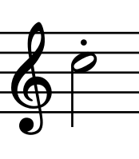
Staccatissimo | ,8 | dot 6, dot 2 3 6 | 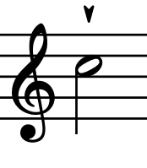
Mezzo-staccato | "8 | dot 5, dot 2 3 6 | 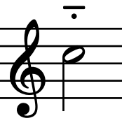
Tenuto (agogic accent) | _8 | dot 4 5 6, dot 2 3 6 | 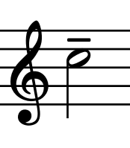
Accent | .8 | dot 4 6, dot 2 3 6 | 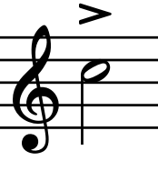
Expressive accent | ^8 | dot 4 5, dot 2 3 6 | 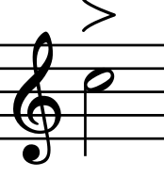
Reversed Accent | @8 | dot 4, dot 2 3 6 | 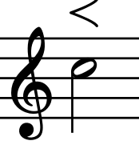
Martellato | ;8 | dot 5 6, dot 2 3 6 | 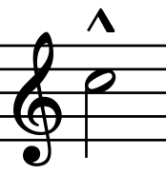
Swell | *' | dot 1 6, dot 3 | 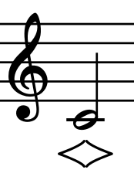

Nuances that Follow the Note
Fermatas (hold or pause)
- above or under a note | <l | dot 1 2 6, dot 1 2 3 | 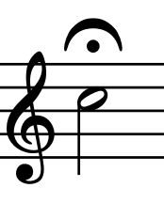
- between notes | "<l | dot 5,  dot 1 2 6, dot 1 2 3 | 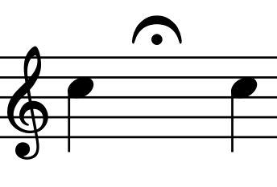
- above or below a barline | _<l | dot 4 5 6,  dot 1 2 6, dot 1 2 3 | 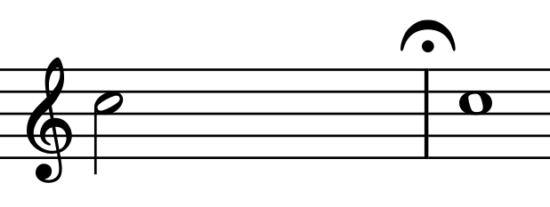
- above or below a sectional double barline | <k'<l | dot 1 2 6, dot 1 3, dot 3  dot 1 2 6, dot 1 2 3 | 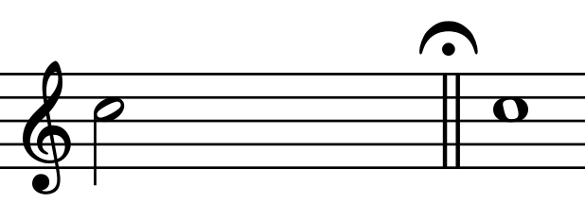
- above or below a double bar | <k<l | dot 1 2 6, dot 1 3,  dot 1 2 6, dot 1 2 3 | 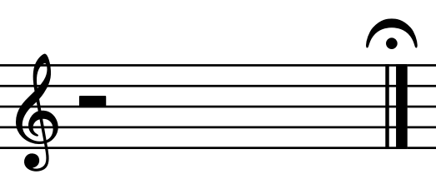
- squared shape | ;<l | dot 5 6  dot 1 2 6, dot 1 2 3 | 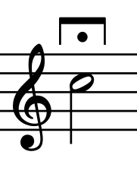
- tent-shaped | ^<l | dot 4 5  dot 1 2 6, dot 1 2 3 | 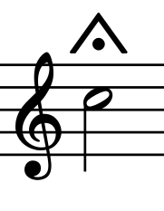

Breath or Break Marks
Breath marks | >1 | dot 3 4 5, dot 2 | 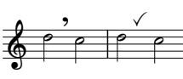
Break marks | ,/ | dot 6, dot 3 4 | 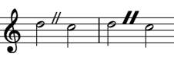

Ornaments
Appoggiaturas
Long appoggiatura | "5 | dot 5, dot 2 6 | 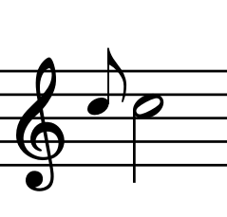
Short appoggiatura | 5 | dot 2 6 | 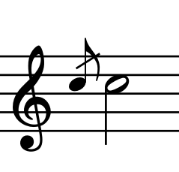
Trills
Trill | 6 | dot 2 3 5 | 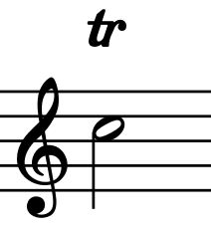
Inflected trill (with a flat) | <6 | dot 1 2 6, dot 2 3 5 | 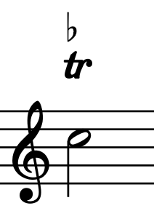
Inflected trill (with a sharp) | %6 | dot 1 4 6, dot 2 3 5 | 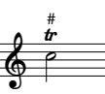
Turns
Turn between notes | 4 | dot 2 5 6 | 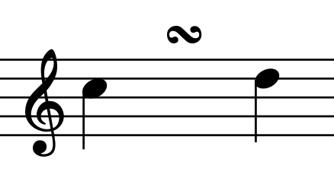
Turn above or below a note | ,4 | dot 6, dot 2 5 6 | 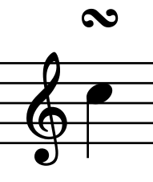
Inverted turn between notes | 4l | dot 2 5 6, dot 1 2 3 | 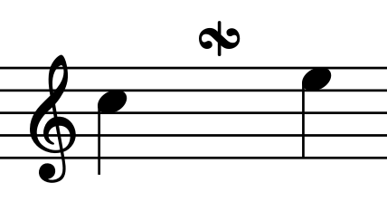
Inverted turn above or below a note | ,4l | dot 6, dot 2 5 6, dot 1 2 3 | 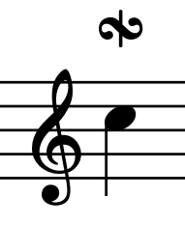
Turn with inflected upper note (sharp) | %4 | dot 1 4 6, dot 2 5 6 | 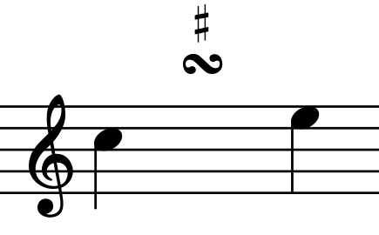
Turn with inflected upper note (flat) | <4 | dot 1 2 6, dot 2 5 6 | 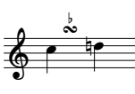
Turn with inflected lower note (sharp) | ,%4 | dot 6, dot 1 4 6, dot 2 5 6 | 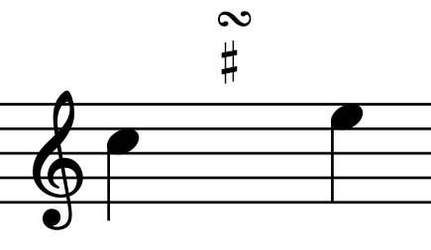
Turn with inflected lower note (flat) | ,<4 | dot 6, dot 1 2 6, dot 2 5 6 | 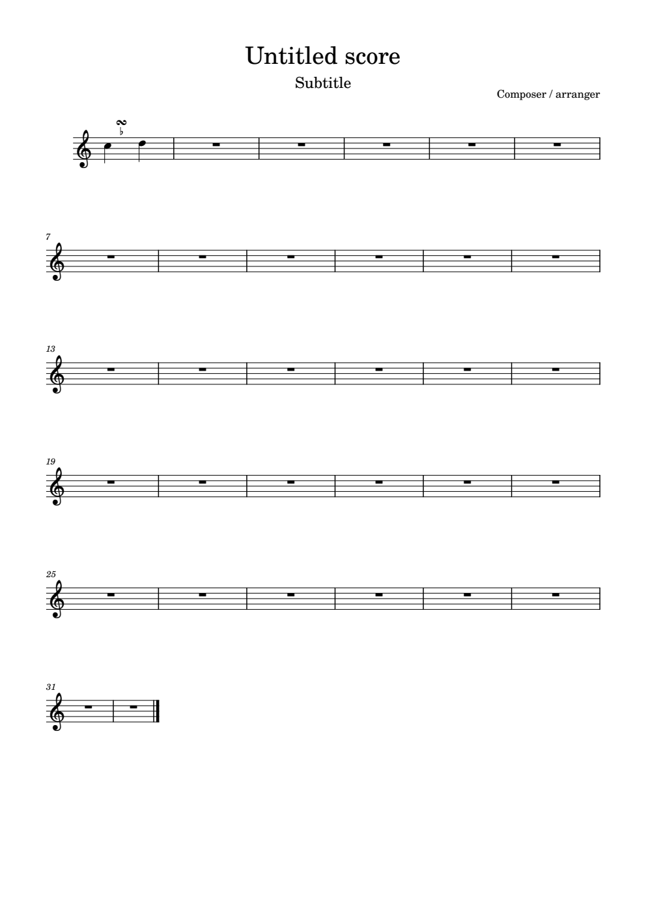
Turn with both notes inflected | <,%4 | dot 1 2 6, dot 6, dot 1 4 6,  dot 2 5 6 | 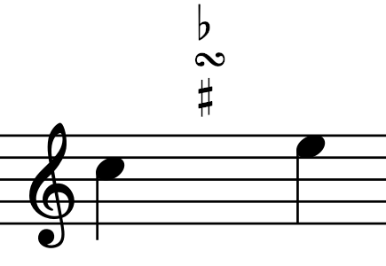
Mordents
Upper mordent | "6 | dot 5, dot 2 3 5 | 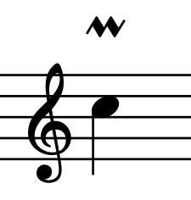
Extended upper mordent | ;6 | dot 5 6, dot 2 3 5 | 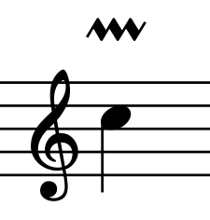
Lower mordent | "6l | dot 5, dot 2 3 5, dot 1 2 3 | 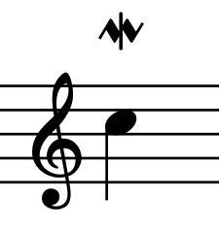
Extended lower mordent | ;6l | dot 5 6, dot 2 3 5, dot 1 2 3 | 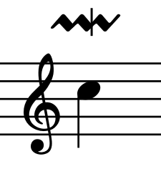
Inflected upper mordent (flat) | <"6 | dot 1 2 6, dot 5, dot 2 3 5 | 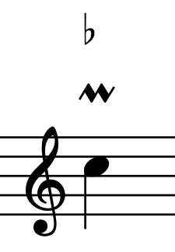
Inflected upper mordent (sharp) | %"6 | dot 1 4 6, dot 5, dot 2 3 5 | 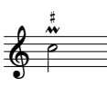
Inflected lower mordent | %"6l | dot 1 4 6, dot 5, dot 2 3 5, dot 1 2 3 | 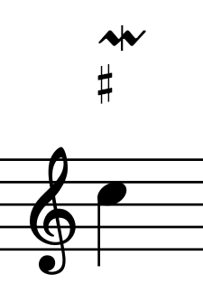
Inflected lower mordent (flat) | <;6l | dot 1 2 6, dot 5 6, dot 2 3 5, dot 1 2 3 | 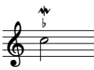
Glissando
Straight or wavy line between two successive notes | @a | 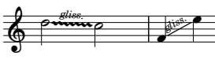  dot 4, dot 1

Print Repeats

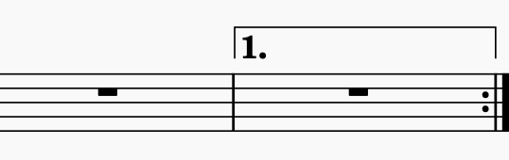
Volta

First time ending #1 (dots 3 4 5 6, dot 2)

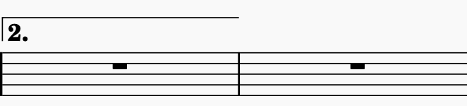
Second time ending #2 (dots 3 4 5 6, dots 2 3)

(also see barlines)

Braille Repeats
Braille repeat sign 7 (dots 2 3 5 6)
Backward-Numeral repeat #d#b (dots 3 4 5 6, dots 1 4 5, dots 3 4 5 6, dots 1 2)
Bar-Number repeats #5-8 (dots 3 4 5 6, dots 2 6, dots 3 6, dots 2 3 6)

